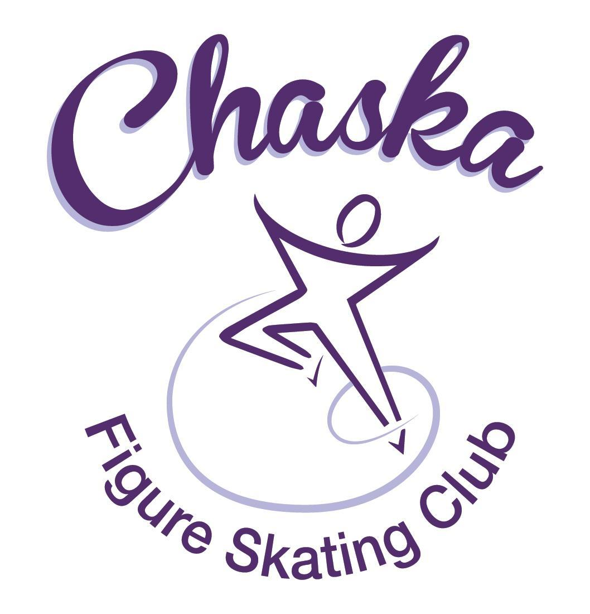 Chaska Figure Skating Club
Board Meeting Minutes
Tuesday, April 11, 2023

Meeting called to order by President Jenn Gizinski at 7:07p.m. Quorum was declared.
Board Members present: Jenn Gizinski, Barb Houts-Swanson, Amanda Braun, Jenn Gionfriddo, Tracy Koepsell, Erin Swanson, and Liz Nyhammer
Board Members absent: Elizabeth Matvick, Denelle Kamerud
Others present: Jess Kasprzak
President’s Report: No report.
Vice President’s Report: No report.
Secretary’s Report:
- March Meeting Minutes – emailed
  - Motion made, seconded and carried unanimously to approve the March 2023 Board Meeting Minutes as submitted.

SkateSafe: No report.

Communication: No report.
Membership: Report emailed.

Aspire Introductory
Annalee Koepsell
Nina Kondajji

Reciprocal
Brooke Johnson

Current Membership Totals for 2022-23
Home Club: 38
Aspire Introductory: 10
Aspire: 12
Associate: 1
Reciprocal: 5
Collegiate: 9
Subsequent: 3
Sustaining: 10
Home Club Coaches: 12
Associate Coaches: 2

- Motion made, seconded and carried unanimously to approve the new members as submitted.

Social: No report.

Junior Board:
- Working on next newsletter
- End-of-year event location: Grand Slam

Fundraising:
- Silent auction sales ended at $953.00
- Gerten’s plant sales:
  - Closed with $8,825.30 in sales. CFSC will get 30% of plant sales and 15% of card sales.
  - 34 total families participated. Will compare the member list when that is sent and will communicate with Amanda for buy-outs.
  - Pick up is the afternoon of May 6th. A sign-up for volunteers will be coming this week.
- Upcoming Dining Events:
  - Jersey Mike’s (Chanhassen location) is set up for April 18, 4pm-8pm
  - Noodles (Chanhassen location) is set up for May 16, 4pm-8pm

Volunteer Coordinator:
- Volunteer hours tracking document has been updated, through ice show.

Aspire Liaison:
- Meeting held 4/10, 4 families in attendance. Good questions and conversation.

TCFSA:
- Majority of April meeting conversation consisted of future competition desires; nothing changed

Marketing/PR: No report.

Treasurer’s Report: Reports emailed.
- Proposal to invest $50,000.00 into a 9 month Certificate of Deposit, see attached rates from Old National and cash summary. Would then move funds from checking to savings to leave us with $25,000.00 in checking.
  - Motion made, seconded and carried unanimously to approve investing $60,000.00 into a Certificate of Deposit with most reasonable time duration and interest rate, which will be determined.
- Proposal to add a 10 pack Aspire session promo pass for $130.00.
- Proposal to add a 5 pack Aspire session promo pass for $75.00.
- Proposal to increase the surcharge for Aspire lessons from $3.00 to $5.00.
  - Motion made, seconded and carried unanimously to approve adding a 10 pack Aspire session promo pass for $130.00, adding a 5 pack Aspire session promo pass for $75.00, and increasing the surcharge for Aspire lessons from $3.00 to $5.00.

Ice Coordinator: Report emailed.
- Spring contracts are $23,338, plus late fees of $90 and RM buy-outs of $840.
- We have 33 skaters doing AYCS. Two skaters have purchased a 10-session promo pass.
- Spring Aspire contracts are $4774, with 6 skaters doing All-Aspire.
- March buy-ins were $684 for regular sessions, and $57 for Aspire sessions.
- Spring exhibition income so far is $442.50 ($247.50 individual, $195 group).
- We have only 2 open RM slots remaining in May.

Test Chair:
- Working on SOTN test session; appears to be a small group so far.

Pro Liaison: No update.

Star of the North: Verbal update.
- Registration is closed: 105 skaters with 235 starts as of 4/9.
- 1 hour practice ice from 7:40am – 8:40am
- Competition to run from 9:00am – 6:51pm
- Volunteer & hospitality needs sent out
- In need of tables and chairs (Southwest rental can provide tables and chairs for a cost)
  - Motion made, seconded and carried unanimously to approve the rental of table and chairs, as needed for SOTN competition
- Request to reserve ice on Rink 1 and Rink 2 for 2024 SOTN competition.
NEW INFO:

RECURRING INFO:
- Friday, 4/21 (test session) and Saturday, 4/22 (competition)
- Dates to consider for 2024 competition: Fri, 4/26 – Sun, 4/28

Ice Show:
- Survey results attached
  - Common theme (again): Lights make it difficult to see the skaters.
    - Consider adjustment to lighting options
    - Consider changing curtains
  - Show Photos
    - Nice to have front and back shots
    - Prices for prints and digital photos are high
  - Feedback on the time it took for cast picture after Saturday show
  - Pull a group together to discuss show feedback and planning

Policy and Procedure Updates:
- Contracting for Ice Policy was updated & the following verbiage was also updated: “moves in the field” updated to “skating skills” and removed reference to rate table as the rate table had previously been removed.

Old Business:

- Rink Monitor/Skater Check in Process Improvement Plan: Using the show program for the rink monitors to identify the kids better. Positive feedback provided by rink monitors who have utilized the programs photos. Continue discussing in future meetings.

- Long Term Planning (LTP) – LTP Committee: Mary Ament-Johnson, Jenn Gionfriddo, Lauren Gizinski, Kristie Mitchell, Stan Houston. Long Range Plan has been updated. Long Range Plan Link

- Scholarship Fund Delegation: Idea: Delegate funds to go towards the Gold Medalists gifts or plaque/trophy case. Potentially price out display cases.

- USFS Checklist for Success: Review preliminary results/compare to last year’s results; choose an item or 2 to work on.

- Spring Banquet: Discuss venue/time/date & club subsidizing part of the costs for club members
- Motion made, seconded and carried unanimously to charge $10 for club member skater tickets and the club subsidizes the remainder of the cost, non-skaters to pay full price of $45 for all other tickets.
- Date: May 21st
- Time: 10:30am – 1:00pm
- Location: Hazeltine

Adjournment: Motion made, seconded and carried unanimously to adjourn at 9:14pm.

Respectfully submitted,

Liz Nyhammer, Secretary

