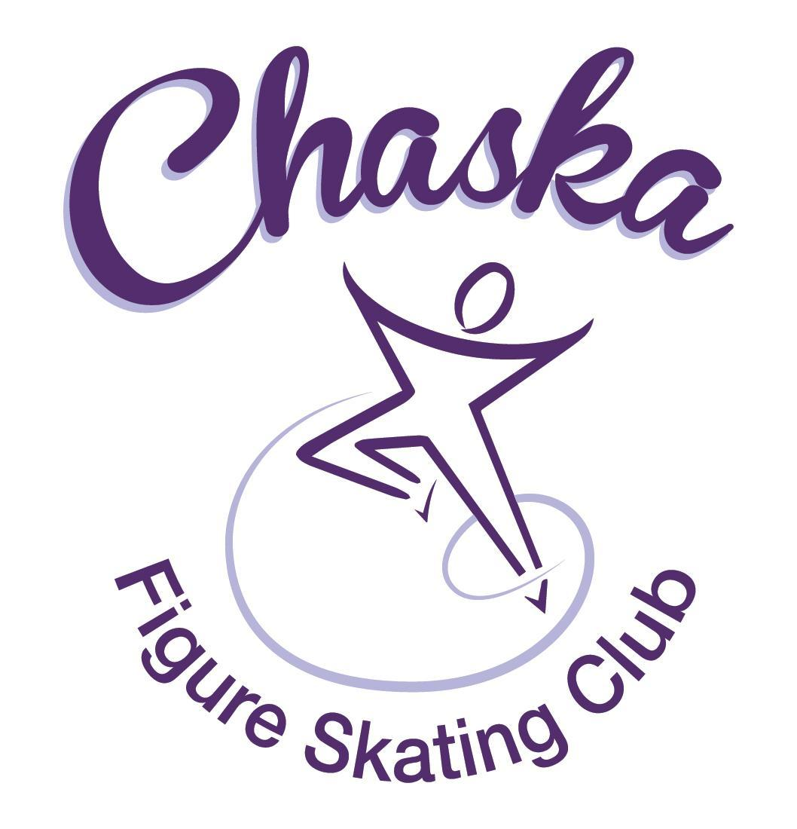 Chaska Figure Skating Club
Board Meeting Minutes
Tuesday, August 9, 2022

Meeting called to order by President Jenn Gizinski at 7:01 p.m. Quorum was declared.
Board Members present: Jenn Gizinski, Barb Houts-Swanson, Denelle Kamerud. Elizabeth Matvick, Amanda Braun, Jenn Gionfriddo, Kristie Mitchell, Tracy Koepsell and Liz Nyhammer.
Board Members absent:
Others present: Jess Kasprzak and Erin Swanson
Meet and Greet: None.
President’s Report: No report.
Vice President’s Report: No report.
Secretary’s Report: Motion made, seconded and carried unanimously to approve the July 2022 Board Meeting Minutes as submitted. Motion made, seconded and carried unanimously to approve the closed Board Meeting Minutes from July 12, 2022 as submitted.
SkateSafe:
- All compliance requirements must be completed by July 1, or by your current training’s expiration date, whichever comes first. Board & Key Volunteers, please submit SkateSafe training and background check documentation to group email upon receipt.
- Two current reports under review with USCSS.
Communication: No update.
Membership: Membership report emailed.

- Motion made, seconded and carried unanimously to approve the new members as submitted.

Aspire
Ariah Jaremko
Sydney Churchill
Hope Reddig

Home Club
Alicia Diaz-Ortiz
Isabella Dong

Current Membership Totals for 2022-23
Home Club: 34
Aspire Introductory: 3
Aspire: 8
Associate: 0
Reciprocal: 1
Collegiate: 3
Subsequent: 1
Sustaining: 8
Home Club Coaches: 10
Associate Coaches: 1

Ending Membership Totals for 2021-22
Home Club: 52
Aspire Introductory: 16
Aspire Junior: 9
Associate: 2
Reciprocal: 0
Collegiate: 4
Subsequent: 2
Sustaining: 8
Home Club Coaches: 12
Associate Coaches: 4

Ending Membership Totals for 2020-21
Home Club: 50
Aspire Introductory: 12
Aspire Junior: 5
Associate: 0
Reciprocal 2020: 2
Reciprocal 2021: 6
Collegiate: 4
Sustaining: 8
Home Club Coaches: 13
Associate Coaches: 2

Ending Membership Totals for 2019-20
Home Club: 36
Introductory: 13
Junior Club: 9
Associate: 0
Reciprocal: 2
Collegiate: 3
Sustaining: 8
Home Club Coaches: 11
Associate Coaches: 3

Social: Discussing a fall festival, date and details to be confirmed.

Junior Board: Preparing a document for Parent/Skater Meeting

Fundraising:
- Glow Run: Proposed date is 9/24
- Gerten’s: Sale is currently open (8/8 – 9/1)
- Holiday Boutique: 11/19, 9-3pm
- Garage Sale: 9/14 – 9/17

Volunteer Coordinator:
- Updated volunteer hours tracking document has been updated.
- Request received to waive the 2021-2022 (July-June) volunteer fee for a family who stopped skating in March 2022.
  - Motion made, seconded and carried unanimously to not waive the 2021-2022 (July-June) volunteer fee for a family who stopped skating in March 2022.

ASPIRE Liaison: No report.

TCFSA: No report.

Marketing/PR:
- Looking into banner sponsor updating; options with vendor.
- Discuss possible date options for annual club photo.
  - Potential date: 10/30, following the fall exhibition (on ice).
  - Elizabeth will check on availability with photographer.

Treasurer’s Report: Reports emailed.
- River City Days: Tips: $218.35, Qdoba: $878.00, Maui Wowi: $1,033.00
  - Total: $2,129.35

Ice Coordinator: Report emailed.
- Discuss/vote on how to proceed with missed rink monitor sessions for suspended skater family.
  - Motion made, seconded and carried unanimously to review in a closed meeting.
- Discuss/vote on how to proceed with request from a former family regarding their contract & bill.
  - Motion made, seconded and carried unanimously to not charge the remainder of the contract and buyout fee to a former family.
  - Treasurer will communicate decision to the family.

Test Chair:
- Virtual session underway.

Pro Liaison: No report.

Star of the North: No report.

Ice Show: No report.

Policy and Procedure Updates: No updates.

Old Business:

- Rink Monitor/Skater Check in Process: Going to try to use the show program for the rink monitors to identify the kids better. Positive feedback provided by rink monitors who have utilized the programs photos. Continue discussing in future meetings.

- Long Term Planning (LRP) Committee: Mary Ament-Johnson, Jenn Gionfriddo, Lauren Gizinski, Kristie Mitchell, Stan Houston. Long Range Plan has been updated. Table for future meeting.

- Idea: Delegate funds to go towards the Gold Medalists gifts or plaque/trophy case. Potential price out display cases. Table for future meeting.

- Locker Room Lock: Sent/further discussion – need to reach out again. Table for future meeting.

- Ad Hoc Bylaws Review: Not done yet. Table for future meeting.

- USFS Checklist for Success: Table for future meeting.

- Parent Skater Meeting Agenda:
- Being worked on for first meeting on 8/15. Second meeting on 9/1.

- Club Jacket Logo:
- Decision to stay with embroidery. Jacket style to consider in the future: JT811 [slightly thicker and has thumb holes]. One skater has this style, as it was a substitute style from a past order.

New Business:

- National Skating Month: Potentially partner with CCC to celebrate National Skating Month on 1/22/2023.

- GoMotion Website Option: Amanda had a meeting with GoMotion to discuss in depth from a financial perspective. Goal is to have a way to easily update website as well as simplified navigation. Positive feedback included: coordinating app is an option, integrated social feeds, coaches corner, calendar, and ease of navigation.
- Motion made, seconded and carried unanimously to approve the implementation and fees associated with implementation of GoMotion.

Adjournment: Motion made, seconded and carried unanimously to adjourn at 8:35 pm.

Respectfully submitted,

Liz Nyhammer, Secretary

