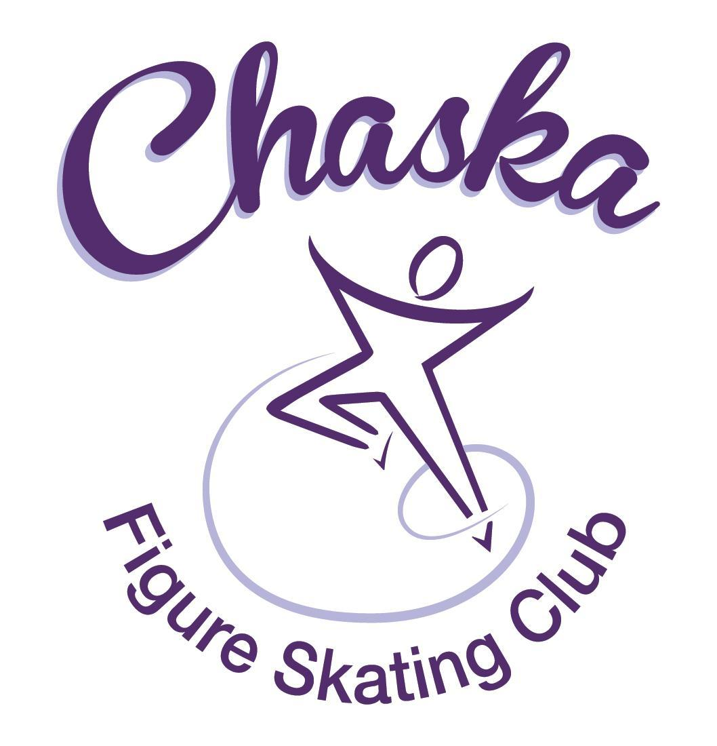 Chaska Figure Skating Club
Board Meeting Minutes
Tuesday, August 8, 2023

Meeting called to order by President Jenn Gizinski at 7:07p.m. Quorum was declared.
Board Members present: Jenn Gizinski, Elizabeth Matvick, Amanda Braun, Barb Houts-Swanson, Jenn Gionfriddo, Liz Nyhammer, Tracy Koepsell, Erin Swanson, Amy Nunn
Board Members absent:
Others present:
President’s Report: No report.
Vice President’s Report: No report.
Secretary’s Report:
- July Meeting Minutes – emailed
  - Motion made, seconded and carried unanimously to approve the July 2023 Board Meeting Minutes as submitted.

SkateSafe:
- All board members & key positions that have action items to complete, please watch due dates and take action.

Communication: No report.
Membership: Report emailed.

Associate Coach
Garrett Kling
Current Membership Totals for 2023-24
Home Club: 37
Subsequent: 4
Aspire Introductory: 6
Aspire: 6
Associate: 1
Collegiate Associate: 1
Reciprocal: 5
Collegiate: 9
Sustaining: 7
Home Club Coaches: 10
Associate Coaches: 4

- Motion made, seconded and carried unanimously to approve the membership as submitted for Garrett Kling as Associate Coach.

Social: Report emailed.
- Evereve Social/Fundraising Event
  - Sunday, 10/8, 3-5:30pm.
  - Save the date will be sent, followed by additional details.

Junior Board: No report.

Fundraising:
- River City Days:
  - No official word on earnings. Traffic was low; business was slow, very similar food vendors. Food vendors were away from other vendors. For reference, Maui Wowi decided to not show up on Sunday.
    - Tracy to reach out to understand final funding and how tips will be applied.
- Gerten’s plant sales scheduling is open:
  - Sale open, with delivery on 9/15.
- Holiday Boutique:
  - CCC room reserved for 11/18/23, 9am-3pm
  - CCC room rates went up significantly ($70 per hour), so vendor fees were raised.
  - Registration is now open for vendors
  - Will know the Wednesday prior if set up can occur on Friday, 11/17.

Volunteer Coordinator: No report.
- Working to update status report and will be shared.

Aspire Liaison: No report.

TCFSA:
- No July meeting.

Marketing/PR: No report.

Treasurer’s Report: Reports emailed.
- Motion made, seconded and carried unanimously to waive a volunteer buyout fee from the 2021-2022 membership year for past due balance.

Ice Coordinator: Report emailed.
- Summer contracts are $ 23,921, including late fees, RM buy-outs, and 2 promo passes. We have 34 skaters doing AYCS. June buy-ins were $656, and July buy-ins were $525, for a total so far of $25,102.
- Summer Aspire contracts are $ 4325, which includes one promo pass. We have 5 skaters doing All-Aspire. June Aspire buy-ins were $57, and none in July, for a total of $4382.
- Summer exhibition was scheduled for Monday, 8-21-23 from 7:15 – 8:30 PM.
- Exhibition is Monday, August 21. Sanction has been received.
- The ice schedule is pretty much set for the school year. We will be having 2 ->2.25 hours of ice on Sunday afternoons, 2 ->1.5 hours on Mondays, 3.5 hours on Tuesdays, 3 -> 1.25 hours on Wednesday, 3 hours on Thursdays, 2.25 hours Saturdays, plus .5 hours for power/edge class on Saturdays.
- Questions/answers/discussion regarding ice times are as follows:
- Do we want ice on Saturday, December 23?
  - Yes, Ice Coordinator to cancel, also cancel December 31.
- On Saturday of the ice show, March 16, do we want power/edge class?
  - No power/edge class on 3/16.
    - If not, what time do we want club ice (9:00 – 12:00 will be available)?
      - 10:00-11:00
- For spring, do we want to change Wednesdays in Chaska to three 60-minute sessions instead of four 45-minute sessions? Same amount of time, but it decreases number of rink monitors needed.
  - More observation and discussion needed.
- Do we want to consider having Tuesday Aspire session 6:00 – 6:45 instead of 6:45 – 7:30?
  - More discussion needed.
5. Jenn and Barb made an executive decision for fall to set up Wednesdays in Waconia as a 45-minute session plus a 30-minute session, anticipating that the Aspire group would not likely want to stay/skate for 1.25 hours. We can change this for winter if people would prefer.
6. Ask families who had rink monitor adjustments or conflicts, due to the rink closure, to pick up an extra rink monitor session in the fall.
- Sanctions have been received for the holiday exhibition and the spring exhibition.
- 6/13/23: Ice coordinator to schedule ice for private lessons with Philip.
Test Chair:
- Amy and Jenn to update test form and class descriptions to align with new level names.
  - Within the online registration, need to consider adding additional ‘slots’ for re-tests
- Tentative test sessions: Oct 27, Dec 8.
- Discuss judge compensation for test sessions.
- Plan to make a virtual test session schedule for the year.
- Club needs to send a communication reminding coaches that testing guidelines must be adhered to. (e.g. cannot have more than maximum allowed people on ice; but also cannot ask skaters and coaches to leave the ice, cannot ask skaters/coaches to not play music because a test is going on)

Pro Liaison:
- BALLET INSTRUCTION:
  - The coaches would like to pursue setting up a dance class for club skates through Jenny Pantano with Chaska Dance Center. Initially this would be ballet and lyrical, with the potential to add other types of dance in the future if there is interest. Jenny is willing to do the SafeSkate training and had a background check last September. She'll look into getting a copy of that for us. Her rate (including room rental at CCC - generally the theater) is $45 for four 45-minute weekly classes, and it sounds like she's pretty flexible on if we would want to offer monthly/quarterly sessions. I was thinking of lining them up with our quarterly contract periods. She would prefer to have the registration through the Chaska Dance Center, but is open to the possibility of the club handling registration if the board prefers. Skaters would also need to sign a waiver. Potential times would be:

    - Sundays 12:45 - 1:30 pm (instructor Jenny)
    - Mondays 6:00 - 6:45 pm (instructor Jenny)
    - Thursday 6:00 - 6:45 pm (instructor TBD)
    - Saturday 12:15 - 1:00 pm (instructor Jenny)

  - The coaches would prefer Jenny as the instructor and thought a weeknight would be preferred (so Monday), but Jenny thought the weekend would be better for getting a room at the CCC. She would also like to have 10-15 skaters at a minimum. Maybe we could survey the club to gauge interest and find out what day/time would work best.
  - Liz to reach out to CCC to see what rooms are available for the potential time slots above. Liz to share findings with Eric & Mary.

Star of the North: No update.

Ice Show:
- 2024 Dates: March 16th & 17th
- Tracy is reaching out to the photographer
  - Elizabeth will also reach out to Perkins Media regarding live photos for Ice Show and SOTN.

Policy and Procedure Updates:
- No update

Old Business:
- Rink Monitor/Skater Check in Process Improvement Plan: Using the show program for the rink monitors to identify the kids better. Positive feedback provided by rink monitors who have utilized the programs photos. Continue discussing in future meetings.
- Long Term Planning (LTP) – LTP Committee: Mary Ament-Johnson, Jenn Gionfriddo, Lauren Gizinski, Kristie Mitchell, Stan Houston. Long Range Plan has been updated. Long Range Plan Link
- Scholarship Fund Delegation: Idea: Delegate funds to go towards the Gold Medalists gifts or plaque/trophy case. Potentially price out display cases.
- USFS Checklist for Success: Feedback shared with board in July.
- Any items to work on for the year?
- Calendar of Events: Would like to get dates set for as many of our regular events for the 2023-24 yr as possible to be able to add them to our calendar for families to be able to plan. (exhibitions, club photo, banquet, etc.)
  - September 13th – 16th: 2023 Garage Sale Dates
  - June 12th – 13th: 2024 Summer Camp Dates
- Parent/Skater Meetings: Any details other than our normal topics to cover?
  - Meeting 1 of 2: Wednesday, 8/23, 6:00 – 7:00pm @ Waconia
  - Meeting 2 of 2: Monday, 9/11, 6:00 – 7:00pm @ Chaska
  - Club treasurer has requested time to present on RaiseRight during the meetings.
  - Items to highlight: ear bud policy, cell phone policy, testing guidelines

New Business:
- Fall Kick-Off: 9/9
  - Breakfast during club ice, followed by spirit week; details to follow.

Adjournment: Motion made, seconded and carried unanimously to adjourn at 9:02pm.

Respectfully submitted,

Liz Nyhammer, Secretary

