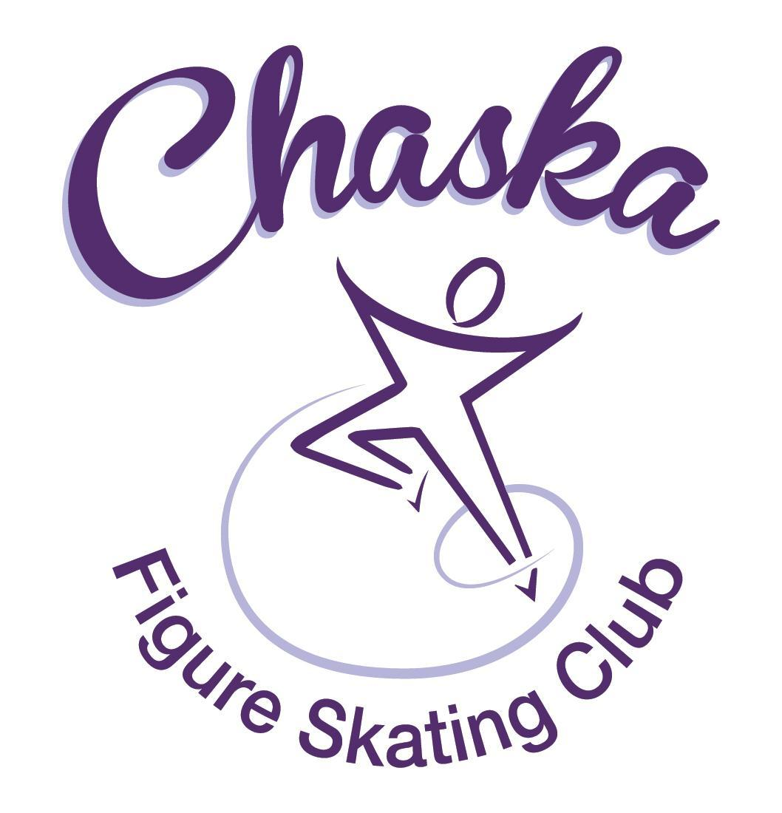 Chaska Figure Skating Club
Board Meeting Minutes
Tuesday, December 13, 2022

Meeting called to order by President Jenn Gizinski at 7:02p.m. Quorum was declared.
Board Members present: Jenn Gizinski, Barb Houts-Swanson, Elizabeth Matvick, Jenn Gionfriddo, and Liz Nyhammer
Board Members absent: Kristie Mitchell, Denelle Kamerud, Amanda Braun, Jess Kasprzak, Tracy Koepsell
Others present: Erin Swanson, Amy Nunn
Meet and Greet:
President’s Report:
- Stephanie Coe accepted as an Associate Coach to keep her Home Club membership with her club in WA.

Vice President’s Report: No report.
Secretary’s Report:
- November Meeting Minutes – emailed
  - Motion made, seconded and carried unanimously to approve the November 2022 Board Meeting Minutes as submitted.
- December Special Meeting Minutes – emailed
  - Motion made, seconded and carried unanimously to approve the closed Board Meeting Minutes from December 2, 2022 as submitted.

SkateSafe: No update.

Communication: No update.
Membership: Report emailed.
Associate Coach
- Stephanie Coe
- Motion made, seconded and carried unanimously to approve the new members as submitted.

Social: No update.

Junior Board: Update emailed.
- Preliminary planning for cast party; many ideas submitted
- January will host a big/lil event
- National skating month items have arrived

Fundraising:
- No update.

Volunteer Coordinator:
- Updated volunteer hours tracking document has been updated, through Glow Run.

ASPIRE Liaison: No report.

TCFSA:
- Events to take place next year, celebrating the 50th anniversary of TCFSA
- For the 2022-23 TCFSA ad, we can now send either an electronic copy or hard copy of the skate show program; they must receive it by June 1
- They did an informal survey of TCFSA clubs (26 respondents).
  - 54% lost membership due to Covid
  - 54% report skaters are purchasing less ice
  - 89% are looking for more coaches
  - Several clubs have noted a large increase in skate school but not in club membership
- TCFSA wishes to be used as a resource for member clubs
Marketing/PR:
- Banner: Banner has been given to the Rink Manager, David, to be installed. Old banner will be put into the box and then placed it in the club locker room.
- Gold Medalist Display – Question/Discussion
  - Discussed how to manage gold medalist display; space is of concern. Will continue to post as received. Will revisit in the future.
  - Consider adding to the website in the future.

Treasurer’s Report: Reports emailed.
- Reports emailed

Ice Coordinator: Report emailed.
- The winter exhibition is scheduled for 12/18/22, 4:15 – 6:00. Sanction has been received.
  - 8 skaters doing group Aspire
- In the future, discuss with coaches about non-members participating in exhibitions as well as practices on club ice.
- Buyouts for November will be adjusted downward.

Test Chair:
- Single panel test session running through the weekend.
- Eden Prairie does have an open 3-panel test session that has been extended to CFSC. Jenn has provided information to the coaches.

Pro Liaison:
- No update

Star of the North:
- Friday, 4/21 (test session) and Saturday, 4/22 (competition)
- Working on securing referee and accountant
- Sent dates to TCFSA for calendar

Ice Show:
- Ice Show General Updates
  - SK8theUSA
  - SSG assignment sent out on Monday, 12/12/2022
  - Core Team working on planning

Policy and Procedure Updates:
- Bylaws – discuss/vote on proposed updates – emailed
  - Motion made, seconded and carried unanimously to approve changes as presented and discussed.
  - Once updated, must send a copy to USFS and IRS.
- Rates – discuss/vote on proposed plan - emailed
  - Motion made, seconded and carried unanimously to approve the proposed rate structure.

Summer Camp:
- Phillip is no longer doing Shattuck. Can potentially split cost with Shakopee. Looking to find a pole harness coach. Amy is reaching out to a few coaches to find out about availability.
- Agreement on 2 weekdays for camp
- Potentially looking at Strategic Method
- Interest in nutritionist
- Interest in mental health coach
- Potentially extend development ice in the morning for private lessons and/or early drop offs to skate
- Last year there were 24 members and 24 non-members
- Amy will work on planning and budgeting

Old Business:

- Rink Monitor/Skater Check in Process: Going to try to use the show program for the rink monitors to identify the kids better. Positive feedback provided by rink monitors who have utilized the programs photos. Continue discussing in future meetings.

- Long Term Planning (LTP) – LTP Committee: Mary Ament-Johnson, Jenn Gionfriddo, Lauren Gizinski, Kristie Mitchell, Stan Houston. Long Range Plan has been updated. Long Range Plan Link

- Scholarship Fund Delegation: Delegate funds to go towards the Gold Medalists gifts or plaque/trophy case. Potentially price out display cases.

- USFS Checklist for Success: Review preliminary results/compare to last year’s results; choose an item or 2 to work on.

- National Skating Month: Event date is 1/22/23; partnering with CCC to celebrate National Skating Month during open skate. Kit has been ordered from USFS.

- GoMotion Website: Full conversion is done. Uplifter Light is a free option allowing visibility to historical account information and documents. Effective, 1/1/23, we will have the Uplifter Light subscription. Overall, positive feedback. Calendar view appears to be more challenging; sessions are shown, but not specific times. Working through a best practice in viewing the calendar.

- Skaters’ locker room lock update: Lock and key installed. Email will go out, providing code and instructions and expectations for use, especially the last member to use the room.

New Business:

- Skater Locker Room:
- Discussed bringing back a sign-up genius for locker room clean up. With many skaters back to using the locker room, it needs attention. Jenn will pull this out and restart the cleaning sign-up.

Adjournment: Motion made, seconded and carried unanimously to adjourn at 9:01 pm.

Respectfully submitted,

Liz Nyhammer, Secretary

