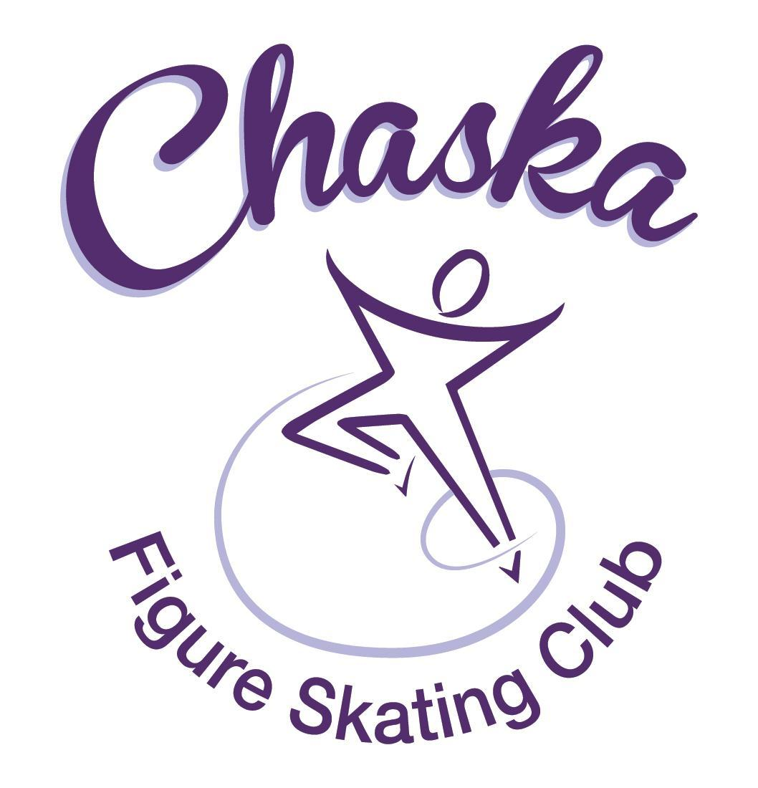 Chaska Figure Skating Club
Board Meeting Minutes
Tuesday, December 12, 2023

Meeting called to order by President Jenn Gizinski at 7:05p.m. Quorum was declared.
Board Members present: Jenn Gizinski, Elizabeth Matvick, Barb Houts-Swanson, Liz Nyhammer, Tracy Koepsell
Key Members present: Erin Swanson, Tiffany O’Boyle
Board Members and Key Members absent: Amy Nunn, Amanda Braun
Others present:
President’s Report: No report.
Vice President’s Report: No report.
Secretary’s Report:
- November Meeting Minutes – emailed
  - Motion made, seconded and carried unanimously to approve the November 2023 Board Meeting Minutes as submitted.

SkateSafe: No report.

Communication: No report.
Membership: Report emailed.

Associate Coach
Bethann Weick
Current Membership Totals for 2023-24
Home Club: 40
Subsequent: 4
Aspire Introductory: 9
Aspire: 7
Associate: 1
Collegiate Associate: 1
Reciprocal: 5
Collegiate: 10
Sustaining: 7
Home Club Coaches: 10
Associate Coaches: 4

- Discuss & Vote on Bethann Weick CFSC Associate Coach Application – Resume provided
  - Motion made, seconded and carried unanimously to approve Bethann Weick as an associate coach.

Social: CFSC Skating Spirit/Holiday Ice Sessions: 12/18 & 12/21

Junior Board: No report.

Fundraising:
- Holiday Boutique:
  - Boutique went well, bringing in net of $1252

Volunteer Coordinator: No report.

Aspire Liaison: No report.

TCFSA:
- Meeting 12/11 – verbal report.
  - Minnesota State competition will now be hosted by individual clubs; responsibilities are divided between TCFSA and host club. Profits are split 50/50. Clubs may submit an application to host. If clubs host, it’s requested they host 2 years in a row.

Marketing/PR: No report.
- Paar sports order is in the works; Elizabeth is coordinating with contact at Paar.

Treasurer’s Report: Reports emailed.
- Discuss/Vote on putting funds into a shorter CD – see report for details
  - Motion made, seconded and carried unanimously to invest in another CD at $25,000.

Ice Coordinator: Report emailed.

- Winter contracts are $24,672, plus $40 in late fees and $840 in RM buy-out fees, for a total of $25,552. We have 36 skaters doing AYCS. We have 16 skaters taking the Power Edge class. We have one new skater who purchased a 10-session promo pass.
- Winter Aspire contracts are $3222, with 2 skaters doing All-Aspire.
- We have open 8 RM slots, with 1 family still needing to sign up for 3 sessions, and I need to clarify with a couple others if they are going to buy-out or not. If they are not buying out, that will fill all slots.
- I would like to discuss the RM policy. As it currently states, a no-show fee is assessed if someone misses their session. If someone signs up for rink monitoring, but is not required to do so because their skater(s) is not contracting, but then misses a session, I would assume we would still charge them the no show fee. I just want clarification on this.
  - When communicating with the family that is making a change, a reminder will be sent regarding the Rink Monitor policy.
- The Christmas exhibition will be next Sunday. We have $297 in individual exhibition registrations, and $195 in Aspire group registrations.

Test Chair:
- Virtual test session in progress: December 15th, submissions between December 2nd – December 15th

Pro Liaison: No report.

Star of the North: Verbal update.
- Continue working on locking in resources

Ice Show: Verbal update.
- 2024 Dates: March 16th & 17th
- Theme: Enchanted
- Jenny is working on fundraiser/sponsor/advertising letter
- Will need someone to run lighting and install lighting this yr. Planning to look ahead of time to find a team.

Policy and Procedure Updates: No update.

Old Business:
- Rink Monitor/Skater Check in Process Improvement Plan: Using the show program for the rink monitors to identify the kids better. Positive feedback provided by rink monitors who have utilized the programs photos. Continue discussing in future meetings.
- Long Term Planning (LTP) – LTP Committee: Mary Ament-Johnson, Jenn Gionfriddo, Lauren Gizinski, Kristie Mitchell, Stan Houston. Long Range Plan has been updated. Long Range Plan Link
- Scholarship Fund Delegation: Idea: Delegate funds to go towards the Gold Medalists gifts or plaque/trophy case. Potentially price out display cases.
- USFS Checklist for Success: Any items to work on for the year?
- Calendar of Events: Would like to continue to get dates set for as many of our regular events for the 2023-24 yr as possible to be able to add them to our calendar for families to be able to plan; (exhibitions, club photo, banquet, etc.)

New Business:
- National Skating Month – will be held during open skate on 1/21. Jr. Board to host the event. Will post on our sites soon.
- All Gold Medalist tests passed by skaters while they were a CFSC Home Club & Associate Members have been added to the bulletin board in the rink lobby & to our website under “About Our Club”. Discuss plan for board moving forward.

Adjournment: Motion made, seconded and carried unanimously to adjourn at 8:15pm.

Respectfully submitted,

Liz Nyhammer, Secretary

