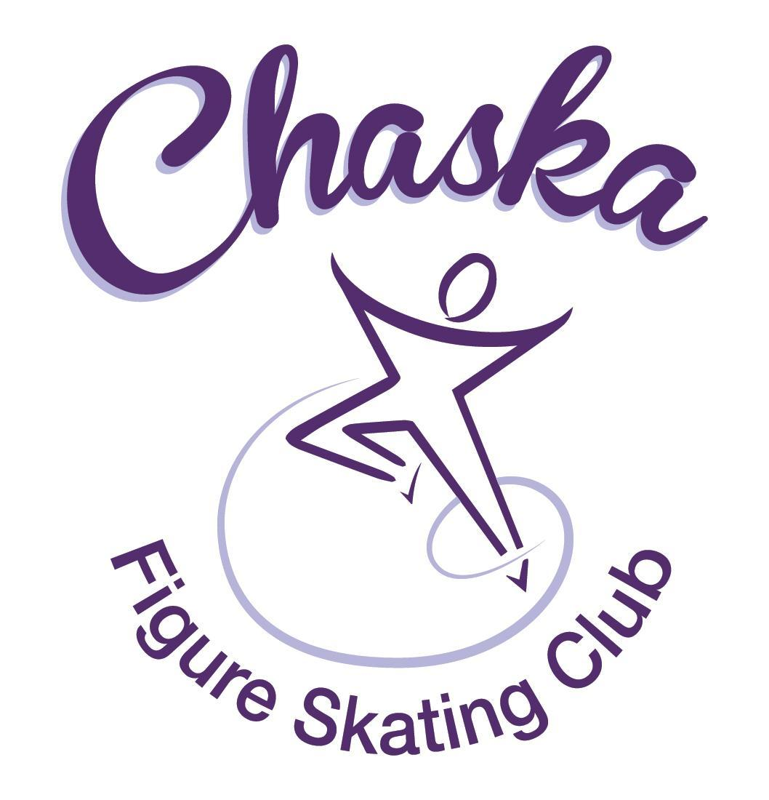 Chaska Figure Skating Club
Board Meeting Minutes
Tuesday, January 10, 2023

Meeting called to order by President Jenn Gizinski at 7:04p.m. Quorum was declared.
Board Members present: Jenn Gizinski, Barb Houts-Swanson, Elizabeth Matvick, Denelle Kamerud, Jenn Gionfriddo, and Liz Nyhammer
Board Members absent: Amanda Braun, Jess Kasprzak, Tracy Koepsell
Others present: Erin Swanson
President’s Report: Kristie Mitchell emailed her CFSC board resignation to Jenn Gizinski on 1/10/2023. Pro Liason position is vacated due to written resignation.
Vice President’s Report: No report.
Secretary’s Report:
- December Meeting Minutes – emailed
  - Motion made, seconded and carried unanimously to approve the December 2022 Board Meeting Minutes as submitted, with one verbiage update.

SkateSafe: No update.

Communication: No update.
Membership: Report emailed.
Aspire Introductory
Kyliee Plekkenpol

Reciprocal
Kayla Short
Current Membership Totals for 2022-23
Home Club: 37
Aspire Introductory: 6
Aspire: 10
Associate: 1
Reciprocal: 2
Collegiate: 3
Subsequent: 3
Sustaining: 10
Home Club Coaches: 12
Associate Coaches: 2

- Motion made, seconded and carried unanimously to approve the new members as submitted, with one word corrected.

Social: Potentially bringing the snack table back for the dress rehearsal day.

Junior Board: Successful big/lil event, good attendance. National skating month event coming up.

Fundraising: No update.

Volunteer Coordinator:
- Volunteer hours tracking document has been updated, through Holiday Boutique.

Aspire Liaison: Potentially planning something around Valentine’s Day.

TCFSA:
- No January meeting.

Marketing/PR: No report.

Treasurer’s Report: Reports emailed.

Ice Coordinator: Report emailed.
- Preliminary summer schedule is being reviewed.

Test Chair:
- Coaches voted for a virtual session in February, will be scheduled.
- Discuss if future fees due to late skater payment can be passed on to skater. Verbiage will be added to the testing form and website. Note will also be sent to the coaches.
  - Motion made, seconded and carried unanimously to pass late fees received rom USFSA for testing to the member(s) who were late paying for the test.
    - Verbiage will be added to the testing form and website. Note will also be sent to the coaches.
- In partnership with Eden Prairie Figure Skating Club (EPFSC), EPFSC has extended a member rate to CFSC members for testing.
  - Motion made, seconded and carried unanimously for CFSC to offer our home club test rate to EPFSC home club members in exchange for the same consideration from EPFSC to CFSC home club skaters.
    - CFSC President will reach out to EPFSC President

Pro Liaison:
- Discussed options to backfill this position; can be voting board member or non-voting key volunteer
  - Motion made, seconded and carried with one abstention to appoint Erin Swanson to fill the remaining term of the Pro Liaison non-voting key volunteer position.

Star of the North:
- Friday, 4/21 (test session) and Saturday, 4/22 (competition)
- Referee, accountant, music secured
- Perkins Media is confirmed for videography
- Sent dates to TCFSA for calendar
- Registration Open: Feb 27th
- Registration Closes: March 31st
- Barb will prep announcement and send for sanction
- Jenn Gio will work to align judges
- Suggested rates emailed:
  - Motion made, seconded and carried unanimously to approve the rate schedule as proposed.
- Dates to consider for 2024 competition: Fri, 4/26 – Sun, 4/28

Ice Show:
- Ice Show General Updates
  - SK8theUSA
  - SSG assignment sent out on Monday, 12/12/2022
  - Core Team working on planning
    - Practice schedule is out
    - Picture schedule will be coming out shortly
    - Jenn Gio working on cast party planning

Policy and Procedure Updates: None.

Old Business:

- Rink Monitor/Skater Check in Process Improvement Plan: Going to try to use the show program for the rink monitors to identify the kids better. Positive feedback provided by rink monitors who have utilized the programs photos. Continue discussing in future meetings.

- Long Term Planning (LTP) – LTP Committee: Mary Ament-Johnson, Jenn Gionfriddo, Lauren Gizinski, Kristie Mitchell, Stan Houston. Long Range Plan has been updated. Long Range Plan Link

- Scholarship Fund Delegation: Idea: Delegate funds to go towards the Gold Medalists gifts or plaque/trophy case. Potentially price out display cases.

- Ad Hoc Bylaws Review: Completed, uploaded to USFS, CFSC website, per new process will send to the IRS with next taxes.

- USFS Checklist for Success: Review preliminary results/compare to last year’s results; choose an item or 2 to work on.

- GoMotion Website Update: Prices/rates have been updated, changed over to CC/ACH payments only. Uplifter has switched over to the Uplifter Lite version.

- Skaters’ locker room lock update: Lock and key installed. Email sent out, providing code and instructions and expectations for use, especially the last member to use the room.

- Locker Room Cleaning: Sign-up sent out – a few have signed up.

New Business:

- Promo Table:
- Sent out volunteer sign-up for skate school dates: Feb 6, 9, 13, 16.
- February Meeting Date:
- Choose new date based on doodle poll results. New date is February 7th.
  - Jenn to include in next club communication
  - Liz to connect with community center on room availability

Adjournment: Motion made, seconded and carried unanimously to adjourn at 8:54 pm.

Respectfully submitted,

Liz Nyhammer, Secretary

