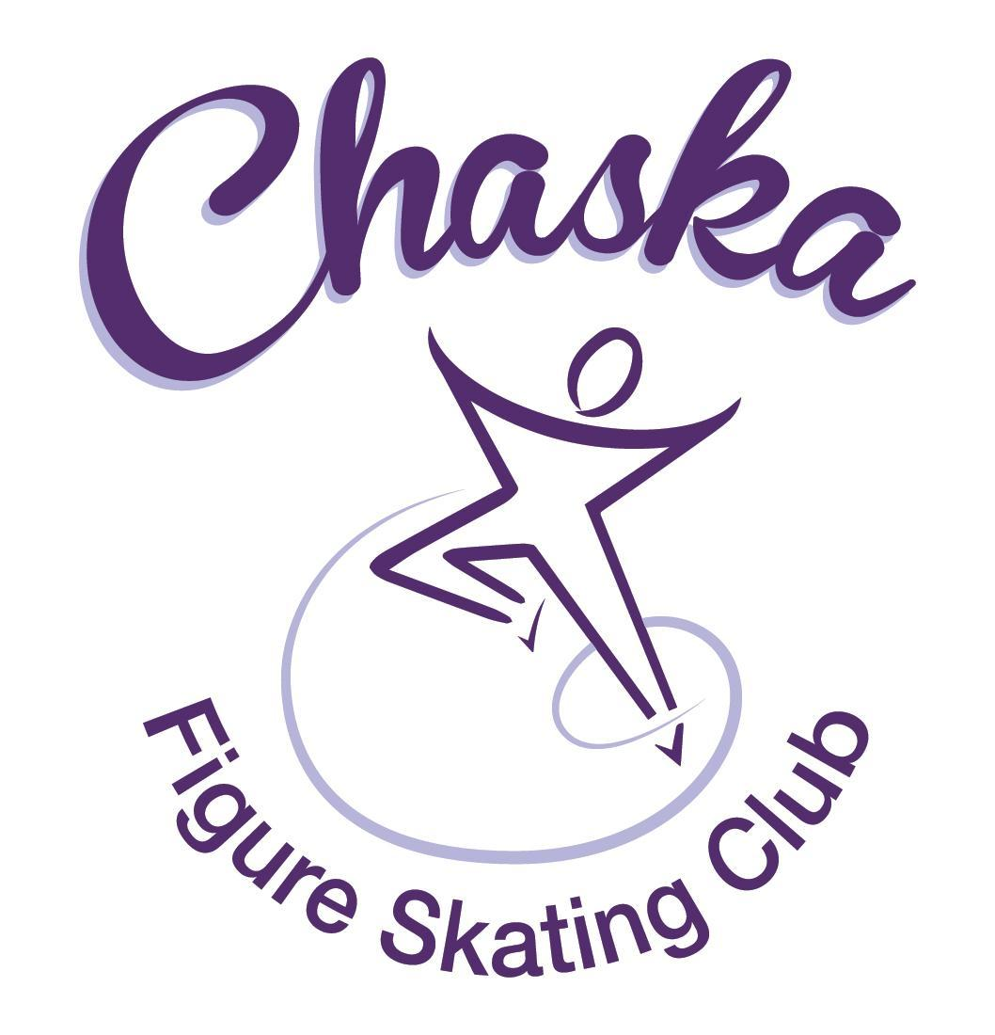 Chaska Figure Skating Club
Board Meeting Minutes
Tuesday, January 9, 2024

Meeting called to order by President Jenn Gizinski at 7:08p.m. Quorum was declared.
Board Members present: Jenn Gizinski, Elizabeth Matvick, Barb Houts-Swanson, Liz Nyhammer, Tracy Koepsell, Amy Nunn
Key Members present: Erin Swanson, Allison Buick
Board Members absent: Amanda Braun
Others present:
President’s Report: No report.
Vice President’s Report: No report.
Secretary’s Report:
- December Meeting Minutes – emailed
  - Motion made, seconded and carried unanimously to approve the December 2023 Board Meeting Minutes as submitted, with correction to board member and key position dispositions.

SkateSafe: No report.

Communication: No report.
Membership: Report emailed.

Home Club Membership
Finley Pinard

Associate Coach
Nadine Rutledge, pending paperwork

Reciprocal Membership
Kayla Short

Current Membership Totals for 2023-24
Home Club: 41
Subsequent: 4
Aspire Introductory: 9
Aspire: 7
Associate: 1
Collegiate Associate: 1
Reciprocal: 5 (2023) 0 (2024)
Collegiate: 10
Sustaining: 7
Home Club Coaches: 10
Associate Coaches: 6

- Motion made, seconded and carried unanimously to approve membership, pending paperwork.

Social: Discussed ideas regarding what has worked in the past.

Junior Board: FMSC event was low turnout, but enjoyable. Will look for promo items to use for National Skating Month event. Invite is extended to all coaches. February event for bigs and littles. Cast party planning is in the works. Jr. Board will do a project for the website highlighting specific moves/tricks.

Fundraising:
- River City Days
  - River City Days has announced they are returning to Lions Park for 2024; 7/26 – 7/28
- Gerten’s
  - Gerten’s fundraiser website for spring will be open as early as February 12th, our close date will be March 25th. We will open on March 1st.
  - Delivery will be between 8am - 12pm on May 4th; 2 hour window will be known on the 3rd.
- Ideas: Bagging groceries, partnering with CCC for future events
- Will look at how many skaters and coaches are planning for San Diego.

Volunteer Coordinator:
- Tracey to add a column to the volunteer tracker for the holiday spirit events.

Aspire Liaison: No report.

TCFSA:
- No meeting this month.

Marketing/PR: No report.

Treasurer’s Report: Reports emailed.
- Discuss/Vote on contract cancelation
  - Motion made, seconded and carried unanimously to approve the request for a full refund.
- CD is complete

Ice Coordinator: Report emailed.

- Winter contracts are $26,113, including late fees and $840 RM buy-out fees. We have 36 skaters doing AYCS. We have 16 skaters taking the Power Edge class. We have one new skater who purchased a 10-session promo pass, and one a 5-session pass.
- January buy-ins were $622, for quarter total so far of $26,735.
- Winter Aspire contracts are $2982, with 2 skaters doing All-Aspire.
- The Christmas exhibition was a success. We had $335.50 in individual exhibition registrations, and $195 in Aspire group registrations.

Test Chair:
- Next test session February 10th – 23rd
- Working on a plan for recording – Amy & Erin to have meeting with coaches as soon as plan is set. Meeting will be mandatory to have skaters test on club ice. Need to review the USFS rules.
- Parents and coaches have provided feedback on the last test session.

Summer Camp:
- Discuss/vote on rates proposed increase to $199 member/$210 returning non member/$225 non member for 2 days & $115 member/$130 non member (returning or new) for 1 day
- Capacity: 60 campers per day
- Brick City room booked
- Looking at morning ice for Thursday

Pro Liaison:
- See testing update under Test Chair

Star of the North: Report emailed.
- Judges are being obtained
- Technical controllers have been obtained
- Working on technical specialists; Amy to send a contact to Jenn (local)
- Looking for vendor for action photos
- Looking to open registration around the end of Feb; Becky will advise for registration close date.
- Drafted event menu
- Costs:
  - $100 for Compete USA 1st events
  - $140 for non-Compete USA 1st events
  - $30 for additional events
  - $25 for test credit fee

Ice Show: Verbal update.
- 2024 Dates: March 16th & 17th
- Theme: Enchanted
- Picture schedule will go out in the coming weeks

Policy and Procedure Updates: No update.

Old Business:
- Rink Monitor/Skater Check in Process Improvement Plan: Using the show program for the rink monitors to identify the kids better. Positive feedback provided by rink monitors who have utilized the programs photos. Continue discussing in future meetings.
- Long Term Planning (LTP) – LTP Committee: Mary Ament-Johnson, Jenn Gionfriddo, Lauren Gizinski, Kristie Mitchell, Stan Houston. Long Range Plan has been updated. Long Range Plan Link
- Scholarship Fund Delegation: Idea: Delegate funds to go towards the Gold Medalists gifts or plaque/trophy case. Potentially price out display cases.
- USFS Checklist for Success: Any items to work on for the year?
- Calendar of Events: Would like to continue to get dates set for as many of our regular events for the 2023-24 yr as possible to be able to add them to our calendar for families to be able to plan; (exhibitions, club photo, banquet, etc.)
- Display Cabinet: Gold medalists are in display cabinet – proposed plan

New Business:

Adjournment: Motion made, seconded and carried unanimously to adjourn at 9:05pm.

Respectfully submitted,

Liz Nyhammer, Secretary

