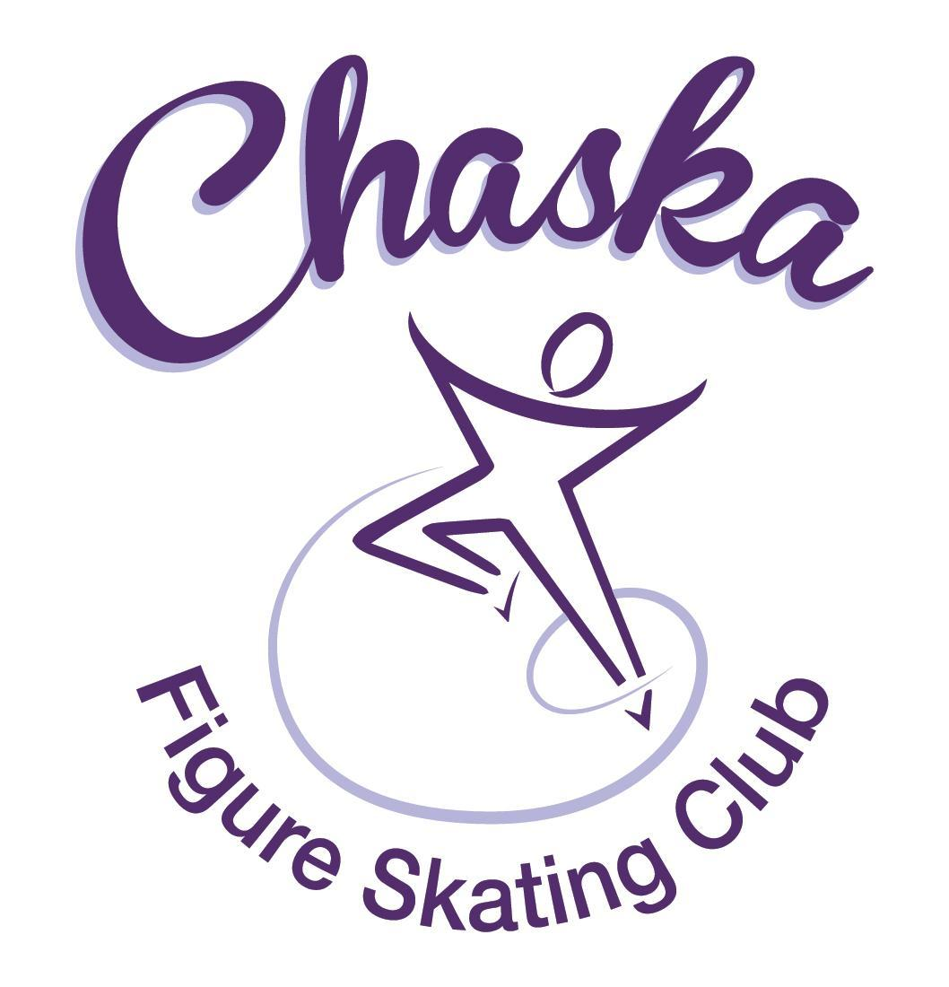 Chaska Figure Skating Club
Board Meeting Minutes
Tuesday, July 12, 2022

Meeting called to order by President Jenn Gizinski at 7:05 p.m. Quorum was declared.
Board Members present: Jenn Gizinski, Barb Houts-Swanson, Denelle Kamerud. Elizabeth Matvick, Amanda Braun, Jenn Gionfriddo, Kristie Mitchell, Tracy Koepsell and Liz Nyhammer.
Board Members absent:
Others present: Catie Cison-Flaten, Jess Kasprzak and Erin Swanson
Meet and Greet: None.
President’s Report: Barb, Kristie & Jenn G met with the CCC architect to discuss CCC renovations/upcoming projects. Good opportunity to share ideas from a CFSC perspective.
Vice President’s Report: No report.
Secretary’s Report: Motion made, seconded and carried unanimously to approve the June 2022 Board Meeting Minutes as submitted (with corrections noted).
SkateSafe:
- All compliance requirements must be completed by July 1, or by your current training’s expiration date, whichever comes first. Send certificate to group email upon receipt.
- One active SkateSafe/SafeSport report has been submitted and is currently under review.
Communication: No update.
Membership: Membership report emailed.

- Motion made, seconded and carried unanimously to approve the new members as submitted.

Aspire Introductory
Rylee Koepsell

Aspire Junior Club
Lydia Foutch
Holly Buick
Aliya Houston

Home Club
Abby O'Boyle
Annie Nyhammer
Ashlyn Meuwissen
Barbara HoutsSwanson
Brea Shamla
Carissa Kasprzak
Claire Stephens
Daeton Grove
Devorie Chuma
Harper Gunderson
Jillian Kamerud
Josie Meyer
Juhi Ghatti
Kaydlyn Harris
Kaylee Koepsell
Logan Nicholls
Quinn Koenig
Riya Juriasingani

Reciprocal
Kayla Short

Collegiate
Anita Eliason

Subsequent Home Club Family
Alison Weber

Sustaining
Amanda Braun
Barbara HoutsSwanson
Denelle Kamerud
Elizabeth Matvick
Elizabeth Nyhammer
Jennifer Gizinski
Shanna Chuma
Tracy Koepsell

Current Membership Totals for 2021-22
Home Club: 52
Aspire Introductory: 16
Aspire Junior: 9
Associate: 2
Reciprocal: 0
Collegiate: 4
Subsequent: 2
Sustaining: 8
Home Club Coaches: 12
Associate Coaches: 4

Current Membership Totals for 2020-21
Home Club: 50
Aspire Introductory: 12
Aspire Junior: 5
Associate: 0
Reciprocal: 8
Collegiate: 4
Sustaining: 8
Home Club Coaches: 13
Associate Coaches: 2

Ending Membership Totals for 2019-20
Home Club: 36
Introductory: 13
Junior Club: 9
Associate: 0
Reciprocal: 2
Collegiate: 3
Sustaining: 8
Home Club Coaches: 11
Associate Coaches: 3
Social: Initiated birthday card program for skaters. Birthday cards were provided at no cost to CFSC.

Junior Board: Big Sister / Little Sister number is coming along. Request made to be the first number performing at the exhibition.

Fundraising:
- River City Days: Volunteer email will be sent out.
- Gerten’s Fall Plant Sale: Discussion regarding this being one of the required fundraisers.
  - Motion made, seconded and carried unanimously to make the Gerten’s Fall Plant Sale a required fundraiser.

Volunteer Coordinator:
- Volunteer buy-outs have been billed. One family opted in to do extra rink monitor sessions this summer to complete hours.
- River City Days: River City Days conflicts with the State Games weekend. We will need someone who will be in town the last weekend in July to help make sure volunteers show up for our booths, as Catie will be attending State Games.
  - Requesting 3 volunteers per shift at Maui Waui
  - Requesting 2 volunteers per shift at Qdoba

ASPIRE Liaison: No report.

TCFSA: No report (no TCFSA meeting this month).

Marketing/PR: Club gear orders have been picked up from PAAR sports.

Treasurer’s Report: Reports emailed.
- 2022 – 2023 budget was reviewed and discussed.
  - Motion made, seconded and carried unanimously to approve the 2022-2023 budget.
- Camp was profitable; received positive feedback.
  - Motion made, seconded and carried unanimously to approve a budget of $50 for a gift card as a thank you for the camp coordinator.

Ice Coordinator: Report emailed.

Test Chair:
- Virtual Test Session in Progress; results due Wednesday

Pro Liaison: No report.

Star of the North: No report.

Ice Show: No report.

Policy and Procedure Updates: No updates.

Old Business:

- Rink Monitor/Skater Check in Process: Going to try to use the show program for the rink monitors to identify the kids better. Table for future meeting.

- Long Term Planning (LRP) Committee: Mary Ament-Johnson, Jenn Gionfriddo, Lauren Gizinski, Kristie Mitchell, Stan Houston. Long Range Plan has been updated. Table for future meeting.

- Ideas thus far: Delegate funds to go towards the Gold Medalists gifts or plaque/trophy case. Table for future meeting.

- Locker Room Lock: Sent/further discussion – need to reach out again. Table for future meeting.

- Ad Hoc Bylaws Review: Not done yet. Table for future meeting.

- USFS Checklist for Success: Table for future meeting.

- Summer Camp: Review survey data & discuss gift card for Amy.
- Feedback regarding Kim’s session: skaters were hoping to do more spinning.
- Favorable feedback with continuing camps in the future.

New Business:

- Lettering Committee: Discussed a request for exemption from the requirement of participating in the ice show to letter for the 2022-23 year.
- Motion made, seconded and carried unanimously to allow the individual skater to fulfill lettering performance requirements by doing two competitions in place of the ice show requirement.

- Chuck-A-Duck: Should this be conducted at the exhibition? Prize? Maybe a CFSC icestraveganza basket? 2 Ice show tickets? CFSC Car Decal? CFSC bag tag and an ice cream gift certificate to somewhere? Other thoughts? Will decide prior to exhibition.

- Club Jacket Logo: Discuss suggestion from Valley Sport (embroidery vs. heat transfer).
- Consideration: Could Shana provide a vector file and could we request a sample from Valley Sports (possibly use one of our sample jackets). Research and discussion to continue at a future meeting.

- Parent/Skater Meeting: Dates/times to consider: 8/15, 6-7pm & 9/1, 7-8pm
- Decision made to schedule two meetings, to accommodate end of summer schedules.

- Touch-A-Truck: Reached out to Jenn to gauge interest from CFSC to administer a game and provide prizes. Date is August 18th. Likely need 2-3 kids and 1-2 adults.

Adjournment: Motion made, seconded and carried unanimously to adjourn at 8:30 pm.

Respectfully submitted,

Liz Nyhammer, Secretary

