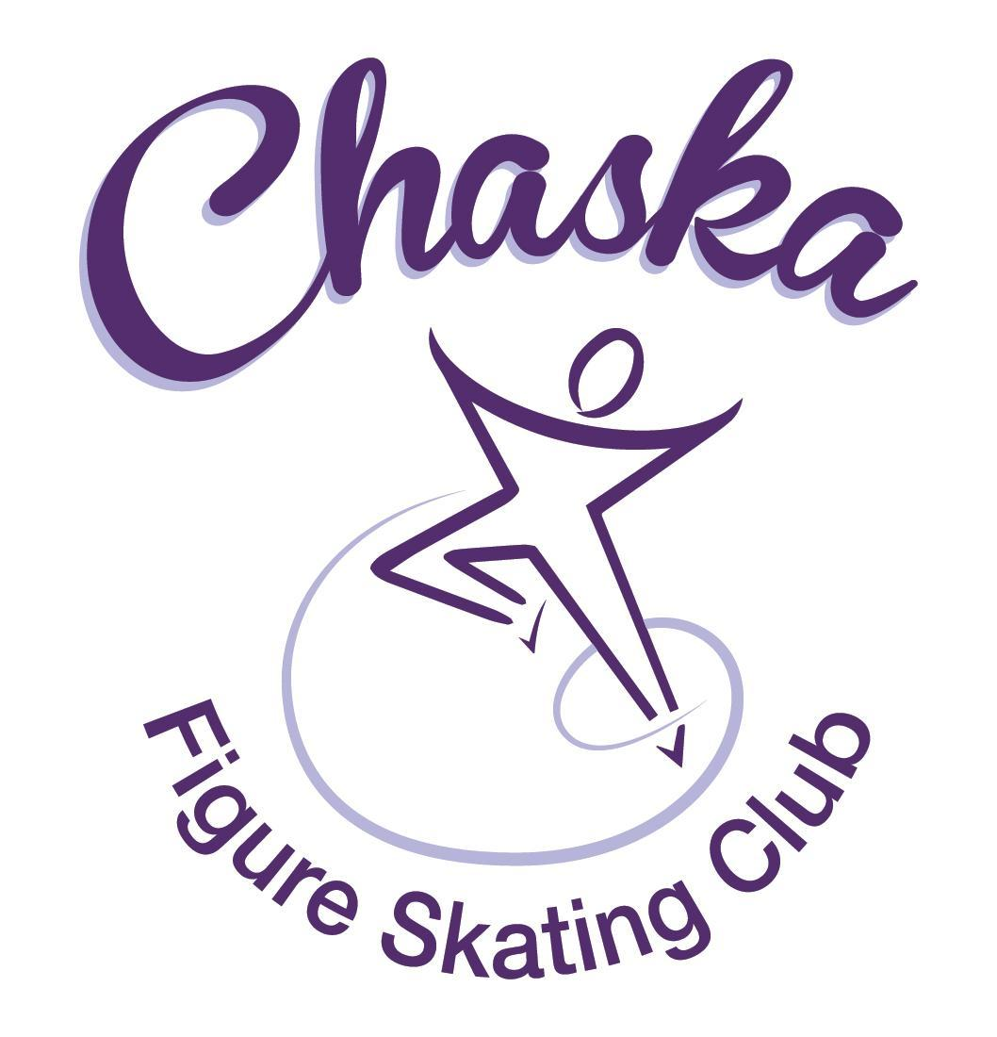 Chaska Figure Skating Club
Board Meeting Minutes
Tuesday, June 14, 2022

Meeting called to order by President Jenn Gizinski at 7:08 p.m. Quorum was declared.
Board Members present: Jenn Gizinski, Barb Houts-Swanson, Denelle Kamerud. Elizabeth Matvick, Amanda Braun, Tracy Koepsell, Jenn Gionfriddo, Kristie Mitchell and Liz Nyhammer.
Board Members absent: None.
Others present: Erin Swanson
Meet and Greet: None.
President’s Report: No report.
Vice President’s Report: No report.
Secretary’s Report: Motion made, seconded and carried unanimously to approve the May 2022 Board Meeting Minutes as submitted.
SkateSafe:
- All compliance requirements must be completed by July 1, or by your current training’s expiration date, whichever comes first. Send certificate to group email upon receipt.
- One active SkateSafe report has been submitted and is currently under review.
Communication: No update.
Membership: Membership report discussed. Motion made, seconded and carried unanimously to approve new members as submitted.

ASPIRE Introductory
Rylee Koepsell
Kara Gruidl
Leilani Ngetich

Aspire Junior Club
Lydia Foutch
Holly Buick
Aliya Houston

Associate
NA

Home Club
Abby O'Boyle
Annie Nyhammer
Ashlyn Meuwissen
Barbara HoutsSwanson
Brea Shamla
Carissa Kasprzak
Claire Stephens
Daeton Grove
Devorie Chuma
Harper Gunderson
Jillian Kamerud
Josie Meyer
Juhi Ghatti
Kaydlyn Harris
Kaylee Koepsell
Logan Nicholls
Quinn Koenig
Riya Juriasingani
Tenley Rutledge

Reciprocal
Kayla Short

Collegiate
Anita Eliason

Subsequent Home Club Family
Alison Weber

Sustaining
Amanda Braun
Barbara HoutsSwanson
Denelle Kamerud
Elizabeth Matvick
Elizabeth Nyhammer
Jennifer Gizinski
Shanna Chuma
Tracy Koepsell

Current Membership Totals for 2021-22
Home Club: 52
Aspire Introductory: 16
Aspire Junior: 9
Associate: 2
Reciprocal: 0
Collegiate: 4
Subsequent: 2
Sustaining: 8
Home Club Coaches: 12
Associate Coaches: 4

Current Membership Totals for 2020-21
Home Club: 50
Aspire Introductory: 12
Aspire Junior: 5
Associate: 0
Reciprocal 2020: 2
Reciprocal 2021: 6
Collegiate: 4
Sustaining: 8
Home Club Coaches: 13
Associate Coaches: 2

Ending Membership Totals for 2019-20
Home Club: 36
Introductory: 13
Junior Club: 9
Associate: 0
Reciprocal: 2
Collegiate: 3
Sustaining: 8
Home Club Coaches: 11
Associate Coaches: 3
Social: No Update.
Junior Board:
- Feed my Starving Children - June 18th
- Exhibition Planning has started for July 18th, looks like we will have a good turn out.
- Considering a budget of up to 250.00 for social event(s).
  - Motion made, seconded and carried unanimously to approve a budget of up to $250 for junior board social event(s).
Fundraising:
- Golf Outing: Tracy will follow up with Kelly to discuss next steps and feasibility of golf outing fundraiser. Concerns with obtaining enough volunteers to successfully cover the outing.
- Discussion to pursue glow run and raffle.
- River City Days: Registered for 2 booths Maui Wowi & Qdoba – Still need a volunteer for weekend of.
Report emailed. Gerten’s plant sale raised $1,684.64. Discussed potentially imposing buy-out fees for fundraising events to encourage greater participation. We anticipate two fundraisers during the year, as such are suggesting a $50 buy-out fee per fundraiser event per skating family for Home Club members. Motion made, seconded and carried unanimously to set a mandatory $50 buy-out fee per Home Club skating family per fundraising event if the family does not participate. This requirement will be noted in the membership materials for 2022/2023. Fundraising Committee is looking for four people to join a sub-committee for the Golf fundraising event. The goal is to get eighteen teams of four. We will do the Gerten’s plant sale again next year.
Volunteer Coordinator:
- Volunteer Buy-outs 2021-22
  - Motion made, seconded and carried unanimously to waive buyout fee for 1 family that transferred membership.
- River City Days: River City days conflicts with the State Games weekend. We will need someone who will be in town the last weekend in July to help make sure volunteers show up for our booths, as Catie will be attending State Games. Jenn Gizinski to send out an additional email soliciting a volunteer.
ASPIRE Liaison: Attempting to plan a Board and Brush event (DIY sign design studio in Chanhassen).
TCFSA: Barb provided a verbal update for the June meeting.
Marketing/PR: No report.
Treasurer’s Report: Discussion to solicit interest in preparing a budget for 2022-2023. Events currently tracked in more detail are Ice Show, SOTN and Camp. All other items for budget preparation shall be based on trend and knowledge of increased costs (e.g. ice costs). Aspire and Junior Board should have a separate line item for budget.
Ice Coordinator:
- Report emailed
- Discuss request to waive the late registration fee for a skater who was injured.
  - Motion made, seconded and carried unanimously to waive late registration fee for skater.
- Discuss allowing 2 siblings to share a promo pass pack.
  - Motion made, seconded and carried unanimously to allow 2 siblings to share a promo pass pack.
- Currently short rink monitors during summer contracts.
  - Motion made, seconded and carried unanimously to offer the limited opportunity for families who have not fulfilled their 2021-2022 volunteer hour requirement, to rink monitor 1 session for 1 hour of volunteer requirement, for this summer only.
- Fall Ice Contract
  - Goal to settle by July 1, 2022 regarding ice plan for Fall/Winter. In general, plan for 19 sessions per week for the fall.
  - Motion made, seconded and carried unanimously to allow up to $35,000 for fall ice cost budget.
- Upcoming Exhibition Dates
  - Mon, 7/18/2022
  - Sun, 10/30/2022
  - Sun, 12/18/2022
  - Sun, 4/16/2023
- 2023 SOTN Date:
  - Sat, 4/22/2023
- 2022-23 Ice Proposal
Test Chair:
- Virtual Test Session in Progress: June 11th - July 9th.
- Discussion regarding a possible summer, in person test session.
- Potential October test session.
Pro Liaison:
- 2 requests/asks from Amy Nunn
  - Requesting approval from the board to note within her online profiles that she is affiliated with the Chaska Figure Skating Club.
  - For a limited time period, requesting 1 parent/guardian in the far box to communicate virtually with Amy during lessons.
Ad Hoc Committee Reports:
Star of the North: No report.

Ice Show: No report.
Policy and Procedure Updates: Skater Code of Conduct – draft update attached – vote
Motion made, seconded and carried unanimously to approve the updated Skater Code of Conduct.

Old Business:

Rink Monitor/Skater Check in Process: Going to try to use the show program for the rink monitors to identify the kids better.

Long Term Planning (LRP) Committee: Long Range Plan has been updated.

Hardship Fund: As we are not aware of any specific instances where skaters/families are experiencing hardship, we will not take any further action at this time.

Ad Hoc Bylaws Review: Tabled for next meeting.
USFS Checklist for Success: Tabled for next meeting.

Summer Camp: Wed, 6/15 – Thur, 6/16.

New Business:

Spring Banquet: Discuss cost to attend fee – discuss – vote
41 adults, 33 students (74 total)
Motion made, seconded and carried unanimously to refund all paid individuals for the spring banquet.

Social Chairs: Jess Kasprzak and Julie Nichols

Aspire Liasion: Sheryl Reddig
Motion made, seconded and carried unanimously to appoint Jess Kasprzak and Julie Nichols as Social Chairs and Sheryl Reddig as Aspire Liasion for the 2022/2023 year.

Adjournment: Motion made, seconded and carried unanimously to adjourn at 9:07 pm.

Respectfully submitted,

Liz Nyhammer, Secretary

