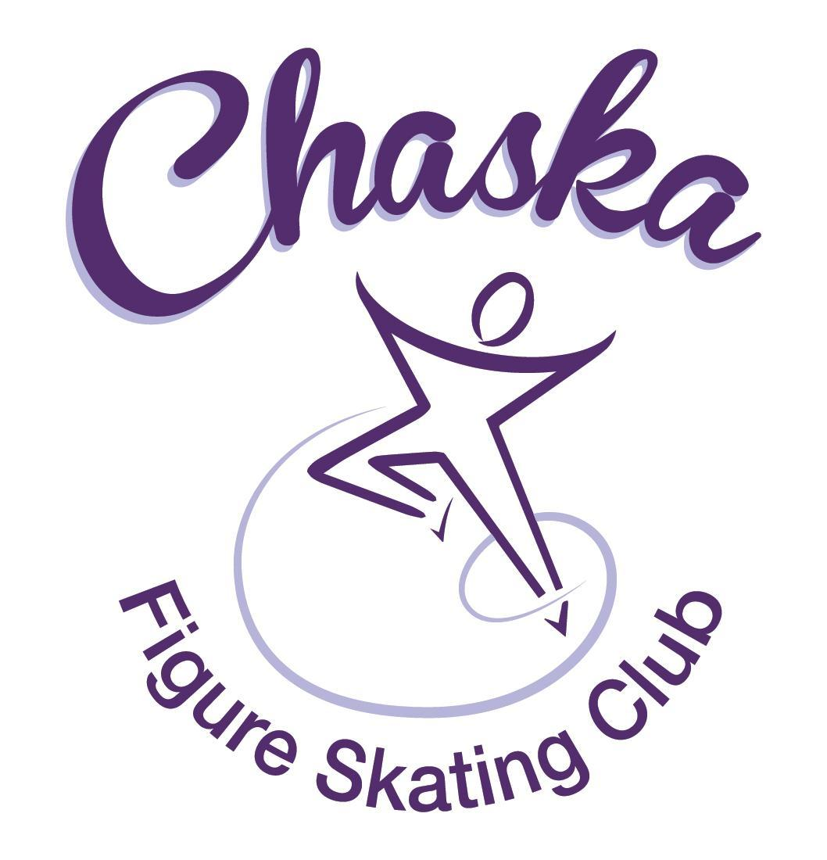 Chaska Figure Skating Club
Board Meeting Minutes
Tuesday, June 13, 2023

Meeting called to order by President Jenn Gizinski at 7:14p.m. Quorum was declared.
Board Members present: Jenn Gizinski, Barb Houts-Swanson, Tracy Koepsell, Erin Swanson, Liz Nyhammer
Board Members absent: Elizabeth Matvick, Amanda Braun, Amy Nunn
Others present: Tiffany O’Boyle
President’s Report: No report.
Vice President’s Report: No report.
Secretary’s Report:
- May Meeting Minutes – emailed
  - Motion made, seconded and carried unanimously to approve the May 2023 Board Meeting Minutes as submitted.

SkateSafe: All board members & key positions that have action items to complete, please watch due dates and take action.

Communication: No report.
Membership: Report emailed.
- Discuss LorRae requesting to be an associate coach instead of home club with us.

Aspire Introductory Membership
Gunderson, Freyja
Koepsell, Annalee
Seifert, Maisie

Aspire Membership
Koepsell, Rylee
Ngetich, Leilani
Provancha, Levi
Smith, Alivia

Home Club Membership
Braun, Cori
Brindmore, Noelle
Buick, Holly
Chuma, Devorie
Foutch, Lydia
Ghatti, Juhi
Goemer, Jillian
Grove, Daeton
Gunderson, Harper
Harris, Kaydlyn
Houston, Aliya
Juriasingani, Riya
Kasprzak, Carissa
Kearns, Elizabeth
Koenig, Quinn
Koepsell, Kaylee
Kultgen, Jocelyn
May, Azalea
Meuwissen, Ashlyn
Nyhammer, Annie
O'Boyle, Abigail
Pfouts, Audrey
Rice, Audriana
Shamla, Brea
Stephens, Claire
Swanberg, Angel
Weaver, Megan

Subsequent Home Club Membership
Braun, Amanda
Braun, Krysta
May, Naomi
May, Shelby

Sustaining Membership
Gizinski, Jennifer
Houts Swanson, Barbara
Koepsell, Tracy
May, Laura
Nyhammer, Liz

Collegiate Membership
Weber, Alison

Home Club Coach
Ament-Johnson, Mary
Becker, Michele
Gionfriddo, Jennifer
Johnson, Berrit
Houston, Stan
Mitchell, Kristie
Moran, Marie
Nunn, Amy
Schendel, Susan
Swanson, Erin

Associate Coach
Coe, Stephanie
Houston, Chris
Portner, LorRae

Current Membership Totals for 2023-24
Home Club: 26
Subsequent: 5
Aspire Introductory: 3
Aspire: 4
Associate: 0
Reciprocal: 5
Collegiate: 9
Sustaining: 4
Home Club Coaches: 10
Associate Coaches: 3

- Motion made, seconded and carried unanimously to approve the new members as submitted.
- Discuss question regarding a club membership with us for a collegiate member of another club.
  - Motion made, seconded and carried unanimously to approve the addition of a new membership category to the CFSC, that being an associate collegiate membership with the fee covering the four years coincident with the collegiate membership with USFS.

Social: Report emailed.
- Discuss Evereve Social/Fundraising idea
  - Social mixer while shopping
  - Evereve provides water and light snacks
  - Club can supply additional beverages/snacks
  - “Back to School or Fall Fashion” kick off shortly after school starts
  - 9/7 (evening) or 9/10 (late afternoon/early evening)
  - Event runs 2-3 hours
  - All sales during this time will earn us 15% of sales back to CFSC
  - Personalized styling experience
  - Connection opportunity for parents and skaters
- Tracy will connect with Alison to discuss further.

Junior Board: No report.

Fundraising:
- Recent Dining Events:
  - Noodles (Chanhassen Location) occurred on May 16, 4-8pm; low turnout/low return (~$40).
  - Concern regarding fundraising dining events - potentially burning bridges with local businesses.
- River City Days:
  - Reached out to Ross with Maui Wowi, they have confirmed they are in. Need form(s) filled out and submitted, along with deposit [last year was an online form].
  - Continue to have issues with Qdoba responding and/or confirming. At this time, not pursuing Qdoba any further due to scheduling concerns.
  - Jennie will reach out to see if Nautical Bowls is interested in partnering for River City Days.
- Upcoming Dining Events:
  - Panera (Chanhassen Location) set up for June 20, 4-8pm
  - No event for July due to River City Days
  - Consideration: Would quarterly dining events be a better option?

Volunteer Coordinator: No report.

Aspire Liaison: No report.

TCFSA:
- Meeting occurred 6/12, renewal forms coming out this month.
- CFSC will need to supply volunteers for the 2023 Minnesota L’etoile du Nord Challenge [August 17, 18, 19, 20]; competition will take place at Bloomington Ice Garden.
  - 4 hour shifts, # of shifts per club is dependent on club membership
    - Will likely be notified near the end of July
  - If we do not supply our required volunteers, we do not receive our stipend from TCFSA.

Marketing/PR: No report.

Treasurer’s Report: Reports emailed.

Ice Coordinator: Report emailed.
- Summer contracts are $ 23,786, including late fees and RM buy-outs. We have 34 skaters doing AYCS.
- Summer Aspire income is $ 4085. We have 5 skaters doing All-Aspire.
- Summer exhibition needs to be rescheduled due to Learn to Skate extending 1 week, into 8/21.
  - Need to pursue 8/24 7:15-8:30 for summer exhibition; ice coordinator will connect with rink manager to request availability.
- As of now, we have almost 40 open RM sessions, with some families still not signed up.
  - We may want to consider a slight change in schedule for next summer, with more 60-minute sessions, to avoid so many open rink monitor times.
- Discuss/Vote on charging camp participants member buy-in rates for those that are having lessons with the camp guest coaches on club ice.
  - Motion made, seconded and carried unanimously to charge camp participants member buy-in rates for club ice sessions on Tues (6/12), Wed (6/13), Thur (6/14).

Test Chair: No update.

Pro Liaison:
- REQUEST FROM COACHES: Several of the coaches would like the club to try offering a power/edge class. If the board approves, we'd like the ice coordinator to reach out to the arena manager to see when the club could get an additional 30 minutes of ice per week in the fall. If there are multiple options, then perhaps we could poll the club to see which time is preferred by the most people. We would rotate among whichever coaches are interested in teaching the class. We probably wouldn't be able to offer it during the hockey season, but if there was good turnout, then we could do it again next spring and summer.
  - Ice coordinator will request options from the rink manager.

Star of the North: No update.

Ice Show: No update.

Policy and Procedure Updates:
- Volunteer Policy – changes from last month were updated and posted online

Old Business:
- Rink Monitor/Skater Check in Process Improvement Plan: Using the show program for the rink monitors to identify the kids better. Positive feedback provided by rink monitors who have utilized the programs photos. Continue discussing in future meetings.
- Long Term Planning (LTP) – LTP Committee: Mary Ament-Johnson, Jenn Gionfriddo, Lauren Gizinski, Kristie Mitchell, Stan Houston. Long Range Plan has been updated. Long Range Plan Link
- Scholarship Fund Delegation: Idea: Delegate funds to go towards the Gold Medalists gifts or plaque/trophy case. Potentially price out display cases.
- USFS Checklist for Success: Would like to do this checklist again this summer to start off the new year.
- Aspire Promo Pass Packs & Promo Free Lesson Process Created: Google form added to registration process so that families know when lesson options are and we know when they will be coming. Mary & Erin updated on process.
- Summer Strength & Conditioning Camp:
- Registration in process
- Jennie & Kelly are running it. They are collecting funds directly. They will both complete SkateSafe Training & background checks prior to camp.

New Business:
- Calendar of Events: Would like to get dates set for as many of our regular events for the 2023-24 yr as possible to be able to add them to our calendar for families to be able to plan. (exhibitions, club photo, banquet, etc.)
- Budget: Next month review/approve budget for 2023-24 skating year.
- Touch-A-Truck: CCC has invited us to participate again this year. Event is 8/17. CFSC will help out and Jenn will confirm with CCC.

Adjournment: Motion made, seconded and carried unanimously to adjourn at 8:36pm.

Respectfully submitted,

Liz Nyhammer, Secretary

