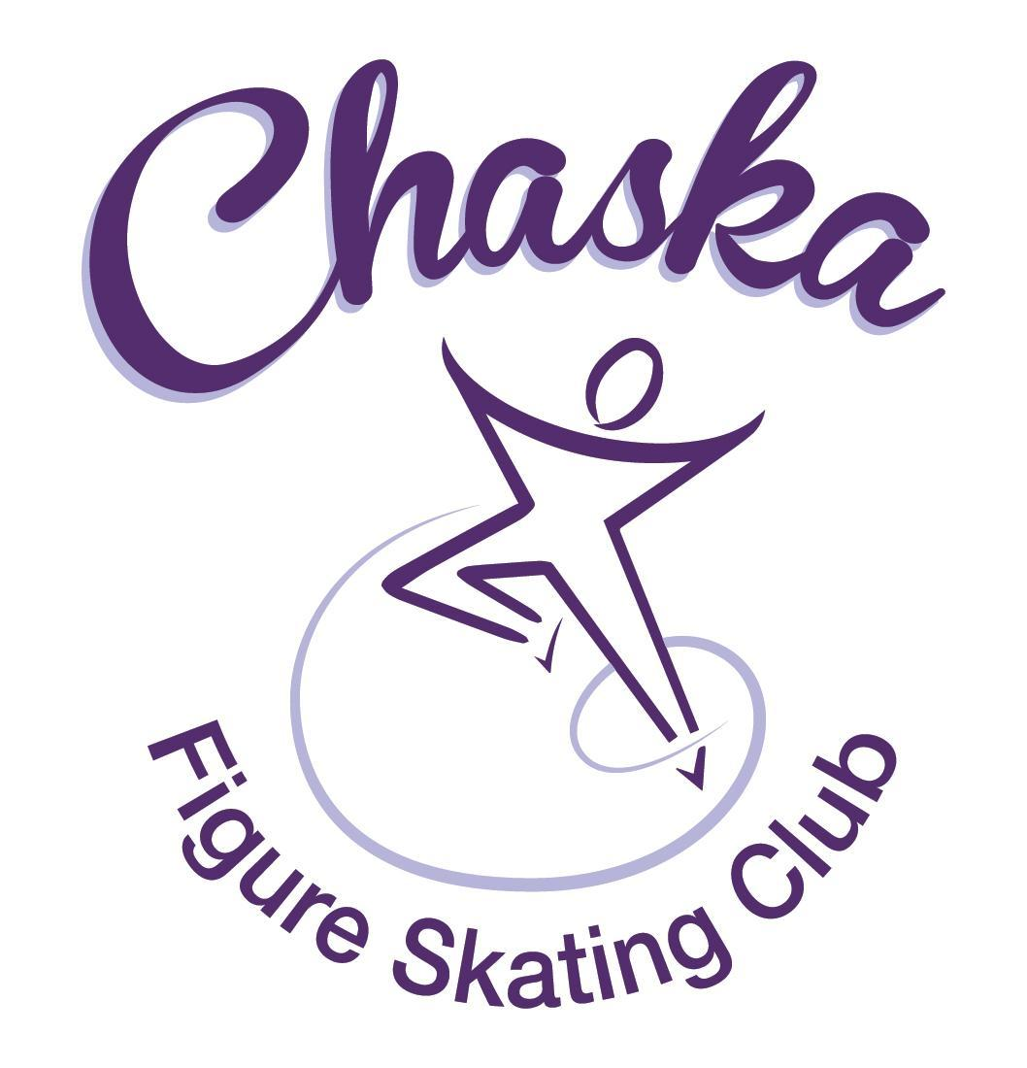 Chaska Figure Skating Club
Board Meeting Minutes
Tuesday, March 14, 2023

Meeting called to order by President Jenn Gizinski at 7:09p.m. Quorum was declared.
Board Members present: Jenn Gizinski, Barb Houts-Swanson, Elizabeth Matvick, Amanda Braun, Denelle Kamerud, Jenn Gionfriddo, Tracy Koepsell, Erin Swanson, and Liz Nyhammer
Board Members absent:
Others present:
President’s Report:
- Email was sent to EP President regarding testing fees – no response received. Follow-up email sent 3/12.
Vice President’s Report: No report.
Secretary’s Report:
- February Meeting Minutes – emailed
  - Motion made, seconded and carried unanimously to approve the February 2023 Board Meeting Minutes as submitted.

SkateSafe: No report.

Communication: No report.
Membership: Report emailed.
Aspire Introductory
Maisie Seifert

Aspire
Adeline Sullivan

Home Club
Shelby May - Upgrade from Aspire Membership

Reciprocal
Riana Forcier
Ava Forcier
Ashley Witte

Current Membership Totals for 2022-23
Home Club: 38
Aspire Introductory: 9
Aspire: 110
Associate: 1
Reciprocal: 5
Collegiate: 3
Subsequent: 3
Sustaining: 10
Home Club Coaches: 12
Associate Coaches: 2

- Motion made, seconded and carried unanimously to approve the new members as submitted.

Social: No report.

Junior Board:
- Planning for exhibition
- Discussing end-of-year event location

Fundraising:
- Silent auction is live
- Gerten’s sale will go-live soon, with a hard close date of April 6th
- Required sale amount for Gerten’s Spring Plant Sale mandatory fundraiser
  - $150.00 minimum sale requirement, otherwise charged $50.00 fee
- Results from Red Savoy fundraiser (2/28/23):
  - $193.70
- Setting up fundraiser for Jersey Mike’s on 4/18, 4pm-8pm (not allowed to donate more than 25% of sales)

Volunteer Coordinator:
- Volunteer hours tracking document has been updated, through February Promo Table.

Aspire Liaison: No report.

TCFSA:
- February meeting took place 2/13
- No official agenda, a chance for TCFSA Club Presidents to talk and exchange ideas & how clubs do things
- No reimbursement for National Skating Month Kits
- TCFSA 50th Anniversary Celebration end of April
- No meeting scheduled for March, next meeting will be in April

Marketing/PR: No report.

Treasurer’s Report: Reports emailed.
- Discuss dates for “charge created” vs. “pymt due” dates
  - Update to: created on the 10th, due on the 15th

Ice Coordinator: Report emailed.
- Spring contracts are $22,905, plus late fees of $65 and RM buy-outs of $ 900.
- We have 33 skaters doing AYCS.
- Spring Aspire contracts are $4572, with 6 skaters doing All-Aspire.
- We have 12 open RM slots, as of now; consider opening it up for volunteer hours after the SOTN competition.

Test Chair:
- Completed March test session; results and payments are being processed.
- Judge panel is finalized for SOTN test session.

Pro Liaison:
- 1 item included in the Contracting for Ice Policy Update discussed in Policy and Procedure Updates.

Star of the North:
NEW INFO:
- Dance judges were confirmed
- Registration opened: 21 skaters with 52 starts as of 3/14
- Inquiry regarding a critique during SOTN. Consider offering it during the SOTN test session and charge the test fee rate.

RECURRING INFO:
- Friday, 4/21 (test session) and Saturday, 4/22 (competition)
- Referee, accountant, music, and judges secured
- Perkins Media is confirmed for videography
- Registration Open: Feb 27th
- Registration Closes: March 31st
- Dates to consider for 2024 competition: Fri, 4/26 – Sun, 4/28

Ice Show:
- Ice Show General Updates
  - SK8theUSA
  - More volunteers needed, otherwise on course
  - Program advertisement sales were successful
  - Discuss the cost ($150) for Kristi and Heather to attend light training
    - Motion made, seconded and carried unanimously to approve $150 cost for Kristi and Heather to attend show lighting training.

Policy and Procedure Updates:
- Discuss/Vote on changes to Contracting for Ice Policy Document – attached with updates in red.
  - Motion made, seconded and carried unanimously to approve updates to the Contracting for Ice Document
- Discuss/Vote on changes to Promo Pass Policy – attached.
  - Motion made, seconded and carried unanimously to approve updates to the Promo Pass Policy.
  - Motion made, seconded and carried unanimously to approve amended Promo Pass Policy.

Old Business:

- Rink Monitor/Skater Check in Process Improvement Plan: Going to try to use the show program for the rink monitors to identify the kids better. Positive feedback provided by rink monitors who have utilized the programs photos. Continue discussing in future meetings.

- Long Term Planning (LTP) – LTP Committee: Mary Ament-Johnson, Jenn Gionfriddo, Lauren Gizinski, Kristie Mitchell, Stan Houston. Long Range Plan has been updated. Long Range Plan Link

- Scholarship Fund Delegation: Idea: Delegate funds to go towards the Gold Medalists gifts or plaque/trophy case. Potentially price out display cases.

- USFS Checklist for Success: Review preliminary results/compare to last year’s results; choose an item or 2 to work on.

- Follow-up on request for funds for a skater – request for up to 1 session/week

- Motion made, seconded and carried unanimously to allow the skater currently experiencing a hardship situation be allowed to purchase the promo ticket for this quarter, with no expiration date on the passes; with payment allowed as able.

New Business:
- Appoint 2 USFS Governing Council Delegates:
  - Barb Swanson
  - Erin Swanson
- Appoint 3 people for 2023 nominating committee:
- Jenn Gionfriddo
- Amanda Braun
- Jenn Gizinski
- Spring Banquet Date
  - Tentatively scheduled for Sunday, May 21st
  - Mid-morning
  - Venues will be vetted

Tabled Topics:
- Discuss aspire lesson cost adjustment and discuss promo pass option to include aspire lesson.

Adjournment: Motion made, seconded and carried unanimously to adjourn at 9:29pm.

Respectfully submitted,

Liz Nyhammer, Secretary

