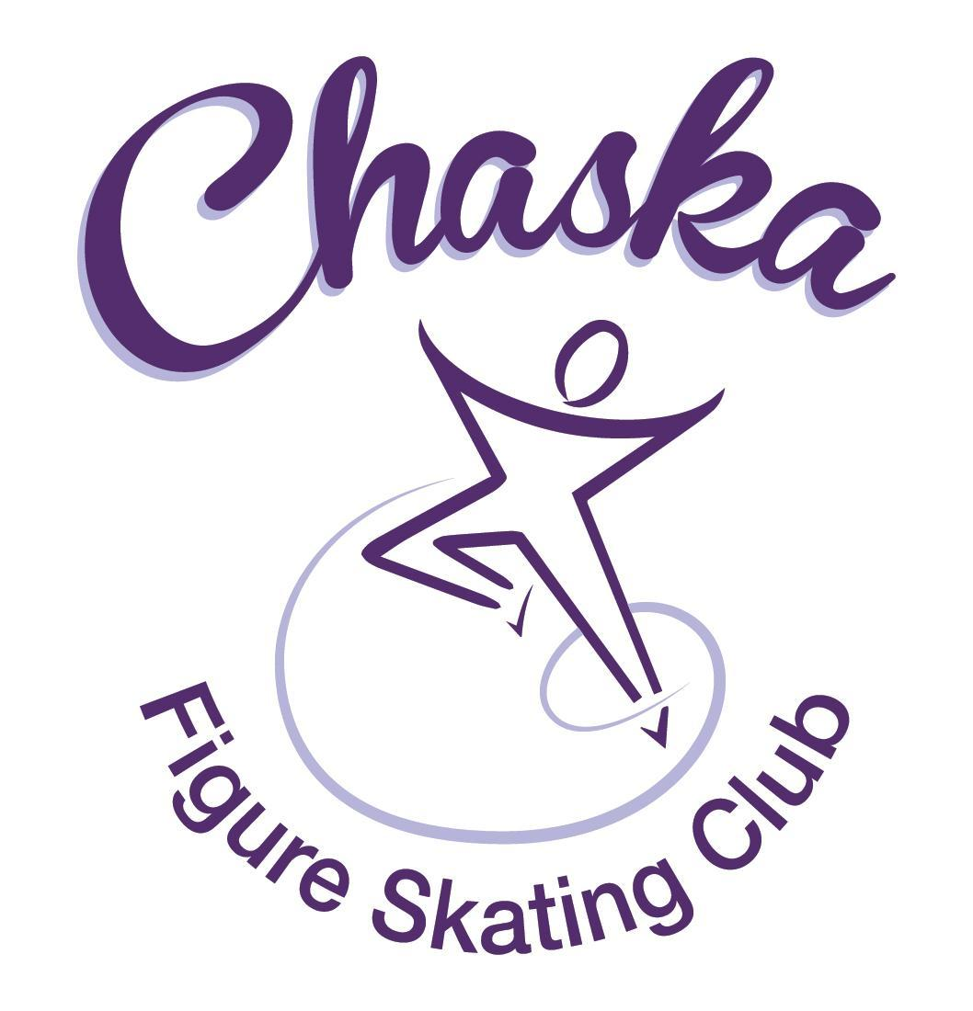 Chaska Figure Skating Club
Board Meeting Minutes
Tuesday, May 10, 2022

Meeting called to order by President Jenn Gizinski at 7:07 p.m. Quorum was declared.
Board Members present: Jenn Gizinski, Barb Houts-Swanson, Denelle Kamerud. Elizabeth Matvick, Amanda Braun, Tracy Koepsell, Jenn Gionfriddo, Erica Gisel and Kristie Mitchell.
Board Members absent: None.
Others present: Liz Nyhammer and Erin Swanson
Meet and Greet: None.
Voting: President for the upcoming term is Jennifer Gizinski, Vice president Elizabeth Matvick and Treasurer Amanda Braun.
President’s Report: No report.
Vice President’s Report: No report.
Secretary’s Report: Motion made, seconded and carried unanimously to approve the April 2022 Board Meeting Minutes as submitted.
SkateSafe: No report.
Communication: No update.
Membership: Membership report discussed. Motion made, seconded and carried unanimously to approve the new Aspire Introductory members. USFSA set their prices for 2022/2023 with no changes. Motion made, seconded and carried unanimously to keep our membership prices consistent for 2022/2023.

Aspire Introductory
Adeline Sullivan
Rylee Koepsell

Current Membership Totals for 2021-22
Home Club: 52
Aspire Introductory: 16
Aspire Junior: 9
Associate: 2
Reciprocal: 0
Collegiate: 4
Subsequent: 2
Sustaining: 8
Home Club Coaches: 12
Associate Coaches: 4

Current Membership Totals for 2020-21
Home Club: 50
Aspire Introductory: 12
Aspire Junior: 5
Associate: 0
Reciprocal: 8
Collegiate: 4
Sustaining: 8
Home Club Coaches: 13
Associate Coaches: 2

Ending Membership Totals for 2019-20
Home Club: 36
Introductory: 13
Junior Club: 9
Associate: 0
Reciprocal: 2
Collegiate: 3
Sustaining: 8
Home Club Coaches: 11
Associate Coaches: 3
Social: No Update. Stars on Ice show is this Sunday, May 15th.
Junior Board: No update.
Fundraising: Report emailed. Gerten’s plant sale raised $1,684.64. Discussed potentially imposing buy-out fees for fundraising events to encourage greater participation. We anticipate two fundraisers during the year, as such are suggesting a $50 buy-out fee per fundraiser event per skating family for Home Club members. Motion made, seconded and carried unanimously to set a mandatory $50 buy-out fee per Home Club skating family per fundraising event if the family does not participate. This requirement will be noted in the membership materials for 2022/2023. Fundraising Committee is looking for four people to join a sub-committee for the Golf fundraising event. The goal is to get eighteen teams of four. We will do the Gerten’s plant sale again next year.
Volunteer Coordinator: River City days conflicts with the State Games weekend. We will need someone who will be in town the last weekend in July to help make sure volunteers show up for our booths as Catie will be attending State Games. Jenn Gizinski to send out an email asking for a volunteer. Families who were delinquent on hours were notified prior to the Star of the North Event.
ASPIRE Liaison: Trying to plan a Board and Brush event.
TCFSA: No May meeting.
Marketing/PR: Spring gear order will be ready to go live by the end of this week and will be open for around two weeks.
Treasurer’s Report: Report in process. Preliminary financials for the Star of the North show income of around $8,000.
Ice Coordinator: Report emailed. Ice rates are likely going up $10/hour in 2023.
Test Chair: Next virtual test session will be late June/early July and will be a three judge panel.
Pro Liaison: No Updates.
Ad Hoc Committee Reports:
Star of the North: Received positive feedback from judges and skaters for the Star of the North competition. For next year’s competition we should discuss where we can find additional spaces for coaches to communicate with their skaters during warm up periods.

Ice Show: Survey responses received.
Policy and Procedure Updates: No report.

Old Business:

Rink Monitor/Skater Check in Process: Going to try to use the show program for the rink monitors to identify the kids better.

Long Term Planning (LRP) Committee: Long Range Plan has been updated.

Hardship Fund: As we are not aware of any specific instances where skaters/families are experiencing hardship, we will not take any further action at this time.

Ad Hoc Bylaws Review: Tabled for next meeting.
USFS Checklist for Success: Tabled for next meeting.

Summer Camp Registration: We have enough registrants to cover the cost of the camp. We are full for the lower two levels of the camp.

Spring Banquet: Fourteen adults and ten students have signed up for the banquet as of today.

New Business:

Secretary: Amanda Braun resigned her position as Secretary of the CFSC Board for the 2022/2023 year. Motion made, seconded and carried unanimously to appoint Liz Nyhammer to the position once Amanda Braun’s resignation becomes effective.

Social Committee: Amanda Braun resigned her position as Social Chair for the CFSC for the 2022/2023 year.

Adjournment: Motion made, seconded and carried unanimously to adjourn at 9:00 pm.

Respectfully submitted,

Amanda Braun, Secretary

