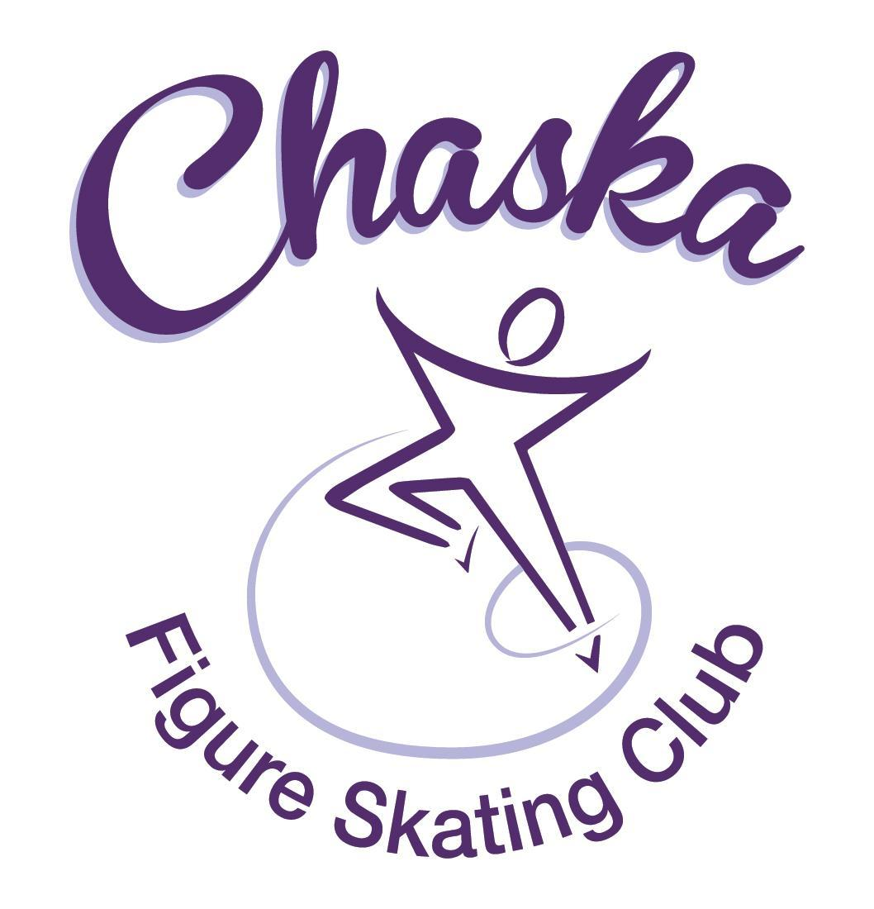 Chaska Figure Skating Club
Board Meeting Minutes
Tuesday, May 9, 2023

Meeting called to order by President Jenn Gizinski at 7:07p.m. Quorum was declared.
Board Members present: Jenn Gizinski, Elizabeth Matvick, Barb Houts-Swanson, Jenn Gionfriddo, Tracy Koepsell, Erin Swanson, and Liz Nyhammer
Board Members absent: Amanda Braun, Denelle Kamerud
Others present:
President’s Report: No report.
- Voting for 2023-24 Board/Key Positions
  - Motion made, seconded and carried unanimously to approve the white ballot.
- Motion made, seconded and carried unanimously to appoint Elizabeth Matvick as second TCFSA Representative.
- 7:30pm LorRae Portner – interested in being a CFSC Coach – resume attached
  - Motion made, seconded and carried unanimously to grant provisional approval, pending references.
Vice President’s Report: No report.
Secretary’s Report:
- April Meeting Minutes – emailed
  - Motion made, seconded and carried unanimously to approve the April 2023 Board Meeting Minutes as submitted.

SkateSafe: No report.

Communication: No report.
Membership: Report emailed.

Aspire Introductory
Emily Moran

Current Membership Totals for 2022-23
Home Club: 38
Aspire Introductory: 11
Aspire: 12
Associate: 1
Reciprocal: 5
Collegiate: 9
Subsequent: 3
Sustaining: 10
Home Club Coaches: 12
Associate Coaches: 2

- Motion made, seconded and carried unanimously to approve the new members as submitted.

Social: No report.

Junior Board:
- End-of-year event on Friday: Grand Slam
- Plan to use balance of budgeted funds for gift for banquet

Fundraising:
- Jersey Mike’s: Proceeds ended at $105.26
- Gerten’s Plant Sale:
  - Pickup went super smooth! Truck was on time, the volunteers were awesome, no missing or damaged plants! SUCCESS!
- River City Days:
  - Reached out to Ross with Maui Wowi on 4/28 and 5/7, no response.
  - Email from Qdoba bounced back, found out they have new owners. I have reached out on 5/8 and have not heard a response.
- Upcoming Dining Events:
  - Noodles (Chanhassen Location) set up for May 16, 4-8pm
  - Panera (Chanhassen Location) set up for June 20, 4-8pm
  - No event for July due to River City Days

Volunteer Coordinator:
- Volunteer hours tracking document has been updated, through Star of the North.

Aspire Liaison: No report.

TCFSA:
- No meeting

Marketing/PR:
- Arena banner with updated sponsors ordered
- Contacted PAAR Sports for getting Spring/Summer gear store opened; awaiting response from PAAR Sports.

Treasurer’s Report: Reports emailed.

Ice Coordinator: Report emailed.
- We will be able to get 1.5 hours of ice on Wednesdays at Waconia this next year. This will add $2025 to our ice costs, if the board approves purchasing it.
- Discuss/vote increasing Waconia ice times for fall/winter/spring
  - Motion made, seconded and carried unanimously to approve purchasing 1.5 hours of ice on Wednesdays at Waconia for fall/winter/spring.
- Discussed date for summer exhibition; ice coordinator will connect with rink manager
  - Tentative primary date: August 21, 2023
  - Tentative secondary date: August 24, 2023

Test Chair:
- Virtual test session is live
- Consideration for SOTN 2024, may not offer a test session

Pro Liaison:
- Coaches requesting that we ask Aspire Promo Pack skaters to indicate what session they plan to attend and/or list if sessions are full.
  - Jenn Gizinski to look into options on potentially identifying a way to understand anticipated participation day/time for Aspire Promo Pack skaters.

Star of the North: No update.

Ice Show: No update.

Policy and Procedure Updates:
- Volunteer Policy – update emailed. Updates to payment/billing if hours are not met are marked in red.
  - Motion made, seconded and carried unanimously to approve the updated Volunteer Policy.

Old Business:

- Rink Monitor/Skater Check in Process Improvement Plan: Using the show program for the rink monitors to identify the kids better. Positive feedback provided by rink monitors who have utilized the programs photos. Continue discussing in future meetings.

- Long Term Planning (LTP) – LTP Committee: Mary Ament-Johnson, Jenn Gionfriddo, Lauren Gizinski, Kristie Mitchell, Stan Houston. Long Range Plan has been updated. Long Range Plan Link

- Scholarship Fund Delegation: Idea: Delegate funds to go towards the Gold Medalists gifts or plaque/trophy case. Potentially price out display cases.

- USFS Checklist for Success: Review preliminary results/compare to last year’s results; choose an item or 2 to work on.

- Spring Banquet:
- Date: May 21st
- Time: 10:30am – 1:00pm
- Location: Hazeltine

- Membership Rates
- USFS has published an increase in rates
- Last changed CFSC rates in January 2023; will leave rates as is

- Off-Ice Classes:
- Consideration: strength and conditioning classes
- Support from the board, to pursue the following details provided by instructor(s):
  - days/times
  - location
  - enrollment/cost options
  - how enrollment will be handled and promoted
  - requirements related to insurance/safe sport/waiver; will require of instructor(s)
- Agreement of final details to be agreed upon between instructors, board, and coaches

Adjournment: Motion made, seconded and carried unanimously to adjourn at 9:10pm.

Respectfully submitted,

Liz Nyhammer, Secretary

