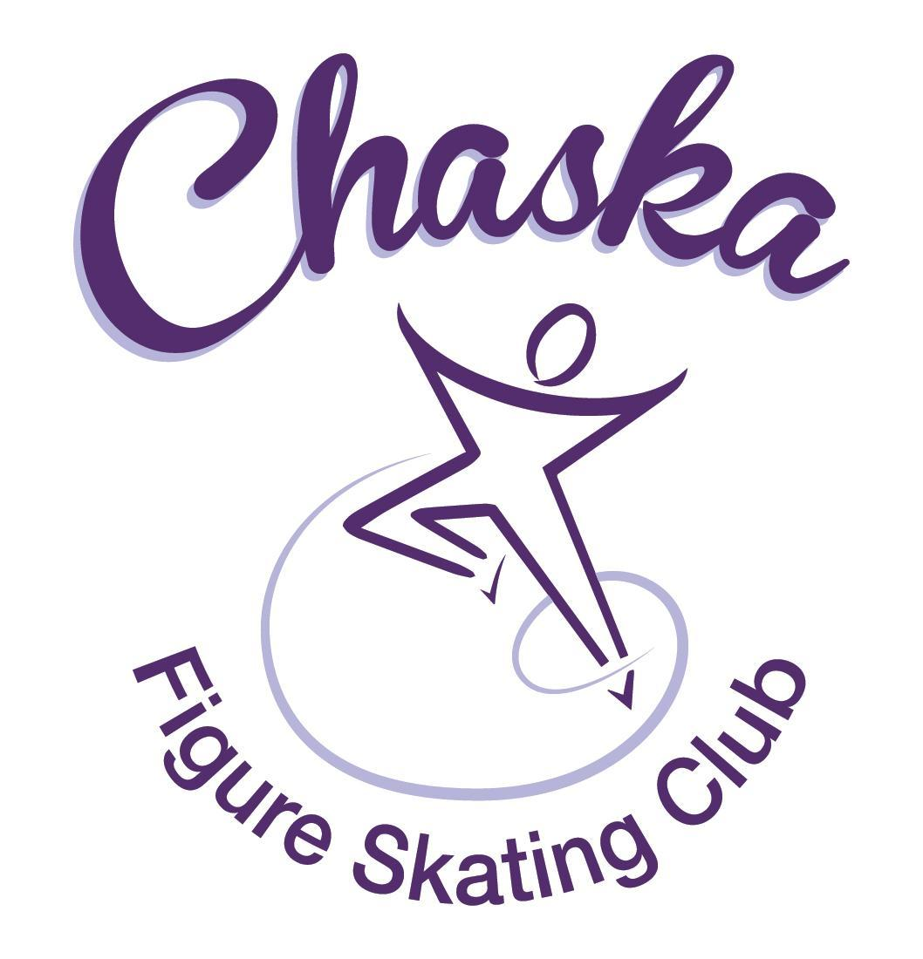 Chaska Figure Skating Club
Board Meeting Minutes
Tuesday, November 8, 2022

Meeting called to order by President Jenn Gizinski at 7:05p.m. Quorum was declared.
Board Members present: Jenn Gizinski, Barb Houts-Swanson, Elizabeth Matvick, Amanda Braun, Jess Kasprzak, Tracy Koepsell, and Liz Nyhammer
Board Members absent: Jenn Gionfriddo, Kristie Mitchell, Denelle Kamerud
Others present: Erin Swanson
Meet and Greet: Stephanie Coe
President’s Report:
- Coach – Stephanie Coe Meet & Great – interested in coaching private & group lessons with our club - Resume emailed
  - Motion made, seconded and carried unanimously to approve Stephanie Coe as a new home club coach with CFSC, pending confirmation from her references.

Vice President’s Report: No report.
Secretary’s Report:
- October Meeting Minutes – email
  - Motion made, seconded and carried unanimously to approve the September 2022 Board Meeting Minutes as submitted.
- October Meeting Minutes – email
  - Motion made, seconded and carried unanimously to approve the closed Board Meeting Minutes from September 13, 2022 as submitted.

SkateSafe: No update.

Communication: No update.
Membership: Report emailed.
Home Club
Reagan Smythurst
Current Membership Totals for 2022-23
Home Club: 38
Aspire Introductory: 5
Aspire: 8
Associate: 1
Reciprocal: 1
Collegiate: 3
Subsequent: 1
Sustaining: 8
Home Club Coaches: 11
Associate Coaches: 1

- Motion made, seconded and carried unanimously to approve the new members as submitted.

Social: No update.

Junior Board: Update emailed.
- We had a great meeting and a successful event at both the Glow Walk and Halloween Live. Pictures have been sent to get them posted on social media. November news will be coming out shortly so please encourage people to reference them when they have questions.

Fundraising:
- CFSC 4th Annual Holiday Boutique: Event date is 11/19/22, 9-3pm @ CCC
  - Currently have 26 vendors--the goal is 30 again!
  - Sign up genius link has been sent for volunteers

Volunteer Coordinator:
- Updated volunteer hours tracking document has been updated, through Glow Run.

ASPIRE Liaison: No report.

TCFSA:
- November meeting is 11/14/22.

Marketing/PR:
- Banner: Has been ordered and delivered the week of 11/13; banner will then be given to the Rink Manager to be installed.
- Club photo: Ordering available now
- Winter Gear Order: Ordering available now

Treasurer’s Report: Reports emailed.
- Reports emailed
- New website is now live. Credits/balances cannot be carried over until an account is created.

Ice Coordinator: Report emailed.
- The winter exhibition is scheduled for 12/18/22, 4:15 – 6:00. Sanction has been received.
- Motion made, seconded and carried unanimously to approve a reduced registration fee for a skater who was unable to attend last group practice and the exhibition due to exposure to contagious illness.
- CCC Rink Manager has reached out to Ice Coordinator to begin discussions around summer ice time, rink maintenance, etc.

Test Chair:
- Virtual test session was completed. No current test session on the schedule.

Pro Liaison: Coaches will continue discussing a policy regarding ear bud usage while skating.

Star of the North:
- Friday, 4/21 and Saturday, 4/22
- Discussed the preference of focusing on growing our competition as is; marketing with surrounding clubs.
- Focus on potentially adding additional events like showcase, showcase duets, and ice dance

Ice Show:
- Ice Show General Updates
  - SK8theUSA
  - As of 11/6, 46 club & 16 skate school
- Discussion regarding a proposal for coaches to be paid for their time on ice at the dress rehearsal and ice shows
  - Due to the extended cost that has not been budgeted or fundraised for, an idea was brought up to create a volunteer sign-up for on-ice support. This would provide coaches the opportunity to sign-up if they would like to volunteer their time during the rehearsal and show sessions. If sessions remained open, sign-up would be opened to parents to sign-up.

Policy and Procedure Updates:
- Rink Monitor Policy Update Proposal:
  - Motion made, seconded and carried unanimously to add an intermediate level for rink monitor buyout, and increase buyout fees as follows: $120 for 5 or more required sessions, $60 3-4 required sessions, $40 for 1-2 required sessions; starting with the Winter 2022 contract.

Old Business:

- Rink Monitor/Skater Check in Process: Going to try to use the show program for the rink monitors to identify the kids better. Positive feedback provided by rink monitors who have utilized the programs photos. Continue discussing in future meetings.

- Long Term Planning (LTP) – LTP Committee: Mary Ament-Johnson, Jenn Gionfriddo, Lauren Gizinski, Kristie Mitchell, Stan Houston. Long Range Plan has been updated. Long Range Plan Link

- Scholarship Fund Delegation: Delegate funds to go towards the Gold Medalists gifts or plaque/trophy case. Potentially price out display cases.

- Ad Hoc Bylaws Review: Not done yet.

- USFS Checklist for Success: Review preliminary results/compare to last year’s results. Continue to discuss in future meetings.

- National Skating Month: Event date is 1/22/23; partnering with CCC to celebrate National Skating Month during open skate. Kit has been ordered from USFS.

- GoMotion Website: Overall, positive feedback. Calendar view appears to be more challenging; sessions are shown, but not specific times. Working through a best practice in viewing the calendar.

- Coaches’ room lock update: Key box has been installed.

New Business:

- Club Jacket price – suggest increasing price to $100 to cover our cost here.
- Motion made, seconded and carried unanimously to set the jacket fee to cover the cost of the jacket, shipping cost, and embroidery cost, to the next $5
- Skater Locker Room: Recommendation to purchase an additional key box for the locker room.
- Motion made, seconded and carried unanimously to purchase an additional key lock box for the skaters locker room and have skaters agree to not sharing the code outside of CFSC members.
- CFSC Holiday Gathering: December 17th, 2:00 – 3:30 @ Swanson’s home.

Adjournment: Motion made, seconded and carried unanimously to adjourn at 9:18 pm.

Respectfully submitted,

Liz Nyhammer, Secretary

