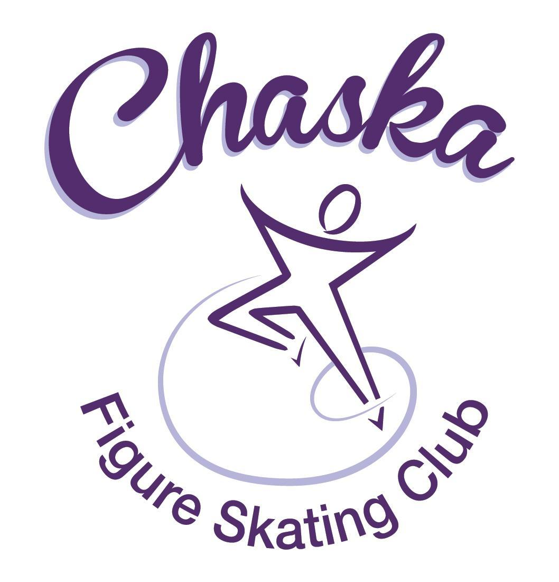 Chaska Figure Skating Club
Board Meeting Minutes
Tuesday, November 14, 2023

Meeting called to order by President Jenn Gizinski at 7:09p.m. Quorum was declared.
Board Members present: Jenn Gizinski, Elizabeth Matvick, Barb Houts-Swanson, Liz Nyhammer, Tracy Koepsell, Erin Swanson, Amy Nunn
Board Members absent: Amanda Braun
Others present:
President’s Report:
- 1 Conflict Resolution Incident reported & resolved by officers following conflict resolution process
Vice President’s Report: No report.
Secretary’s Report:
- October Meeting Minutes – emailed
  - Motion made, seconded and carried unanimously to approve the October 2023 Board Meeting Minutes as submitted.
- Will reserve the board room for 2024 CFSC Board Meetings

SkateSafe: No report.

Communication: No report.
Membership: There are no new memberships or upgrades this month.

Current Membership Totals for 2023-24
Home Club: 40
Subsequent: 4
Aspire Introductory: 9
Aspire: 7
Associate: 1
Collegiate Associate: 1
Reciprocal: 5
Collegiate: 10
Sustaining: 7
Home Club Coaches: 10
Associate Coaches: 4

Social: No report.

Junior Board: No report.
- October and November newsletters are posted online
- Events have been added to the Junior Board calendar

Fundraising:
- Holiday Boutique:
  - CCC room reserved for 11/18/23, 9am-3pm
  - Currently have 31 vendors registered
  - Will need volunteers to help vendors during setup, and then help tearing down at the end
  - Facebook ads are running – what other advertising efforts would be beneficial?
    - Share printed flyers at community establishments (on community bulletin boards)
    - Share event on local online groups (e.g. Facebook sale sites/chatter sites)
- Show Donation/Sponsorship
  - Consider sending the show donation/sponsor letters our before the end of the year.

Volunteer Coordinator: No report.

Aspire Liaison: No report.

TCFSA:
- Presidents meeting was 10/23 – verbal report
- November meeting moved to 12/11

Marketing/PR: No report.
- Spirit Award Trophy: Consider reviving the spirit award trophy
  - Ideas: Solicit ownership, shift nomination criteria/groups, have forms available at the coaches room door, add info to website, and add form to website
  - Tiffany O’Boyle has offered to lead the initiative; Elizabeth Matvick will connect with Tiffany to share knowledge and process details

Treasurer’s Report: Reports emailed.
- Refund request from families:
  - Partial refund for 1/3 of fall quarter – skater unable to skate due to injury from 10/23 through the rest of the quarter. Dr.’s note received.
    - Motion made, seconded and carried unanimously to approve the refund for the remainder of the quarter.
  - Winter Quarter – request to waive late registration fee for skater who is out with an injury and unsure when she will be able to return.
    - Motion made, seconded and carried unanimously to remove the late fee for the skater involved.

Ice Coordinator: Report emailed.

- Fall contracts are $26,499, including late fees and RM buy-out. We have 34 skaters doing
AYCS. We have 18 skaters taking the Power Edge class. September buy-ins were $337.
October buy-ins were $ 451, for total so far of $27,287.
- Fall Aspire contracts are $3474 after adjustments. We have 2 skaters doing All-Aspire.
- Fall exhibition income was $764 ($374 individual, $390 Aspire group), before expenses.

- Tentative summer ice schedule is as follows (basically the same as last summer):
  - Mondays 3:45 – 5:45 PM
  - Tuesdays 8:00 – 9:30 AM, 3:45 – 5:45 PM and 6:00 – 7:30 PM
  - Wednesdays 3:45 – 5:15 PM and 5:30 – 7:00 PM
  - Thursdays 4:15 – 5:45 PM and 7:00 – 8:00 PM
  - Fridays 9:00 – 10:30 AM

Questions for consideration:
1. Should we cancel or decrease ice Saturday June 1? This last Saturday of spring has
traditionally had very low attendance of only 6-7. Consider 9:00-11:00 (2-1hr sessions)
2. Should we cancel ice Friday, July 5? Yes, cancel.
3. Do we want to keep Wednesdays as four 45-minute sessions, or have three 60-minute
sessions? Send survey options to families around the end of March: Monday - 5:15-5:45, Tuesday – 5:15-5:45, Wednesday - 5:15 – 5:45 or 7:00-7:30, Thursday – 5:15-5:45; could the responders indicate all sessions they could/would attend [leverage the dance survey framework]
4. Do we want to increase ice time? If so, should we extend Thursdays by starting at 4:00
or 3:45 (this would allow us to have one 60-minute session plus one 45-minute session, or
two 60-minute sessions, respectively)? Keep as is.
5. Should we continue power edge class over the summer? When should we have it? We
can get an additional 30 minutes on Wednesday evening, or Thursday afternoon starting at
3:45. Yes, continue power edge class.
6. Should we consider cutting some sessions the week of SGOA (July 17-21)? If so, which
ones? Consider removing 4 sessions for that week; decision to be made after coach discussions.
7. Do we want our summer exhibition before SGOA, or in August as usual? Leave for August due to more flexibility in August.
- Consideration for winter contract: Rink monitor requirements: Board members (2 sessions) and key positions (4 sessions)

Test Chair:
- Upcoming virtual test session: December 15th, submissions between December 2nd – December 15th

Pro Liaison: No report.
- Upcoming dance session: January 7th – February 18th

Star of the North: Verbal update.
- Competition added to the TCFSA Compete USA Series
- Competition & test session added to the TCFSA Calendar
- Bloomington competition has their competition listed for the same dates on their website. They will look into it after mids are over. Jenn Gizinski to follow-up with Bloomington on Monday, 11/20. Barb to inquire with David to see if there are any alternative weekends available for ice.
Ice Show: Verbal update.
- 2024 Dates: March 16th & 17th
- Theme: Enchanted
- Approximately 75 skaters registered
- Pictures will take place at St. John’s in Chaska
- Jenn Gizinski will begin drafting the sponsorship/donation letter
- Will need someone to run lighting and install lighting this yr. Planning to look ahead of time to find a team.
- Brick City room is reserved for the cast party and paid for.

Policy and Procedure Updates: No update.

Old Business:
- Rink Monitor/Skater Check in Process Improvement Plan: Using the show program for the rink monitors to identify the kids better. Positive feedback provided by rink monitors who have utilized the programs photos. Continue discussing in future meetings.
- Long Term Planning (LTP) – LTP Committee: Mary Ament-Johnson, Jenn Gionfriddo, Lauren Gizinski, Kristie Mitchell, Stan Houston. Long Range Plan has been updated. Long Range Plan Link
- Scholarship Fund Delegation: Idea: Delegate funds to go towards the Gold Medalists gifts or plaque/trophy case. Potentially price out display cases.
- USFS Checklist for Success: Any items to work on for the year?
- Calendar of Events: Would like to continue to get dates set for as many of our regular events for the 2023-24 yr as possible to be able to add them to our calendar for families to be able to plan; (exhibitions, club photo, banquet, etc.)
- Food Drive: Met goal of 275 items. Recommend decreasing goal next year and extending the drive to include 2 weekends, perhaps starting with the weekend of the fall exhibition.

New Business:
- Received a request from a family to see if they are able to use our logo on a jacket/clothing.
  - Logo is proprietary and not for personal use.
- National Skating Month – no physical kit this year. We are signed up through USFS stating that we will be holding an event. Will need to come up with our own items/plan.
- Rooms are reserved at Mankato AmericInn for the Mankato competition. Coaches will communicate details with their skating families.

Adjournment: Motion made, seconded and carried unanimously to adjourn at 9:49pm.

Respectfully submitted,

Liz Nyhammer, Secretary

