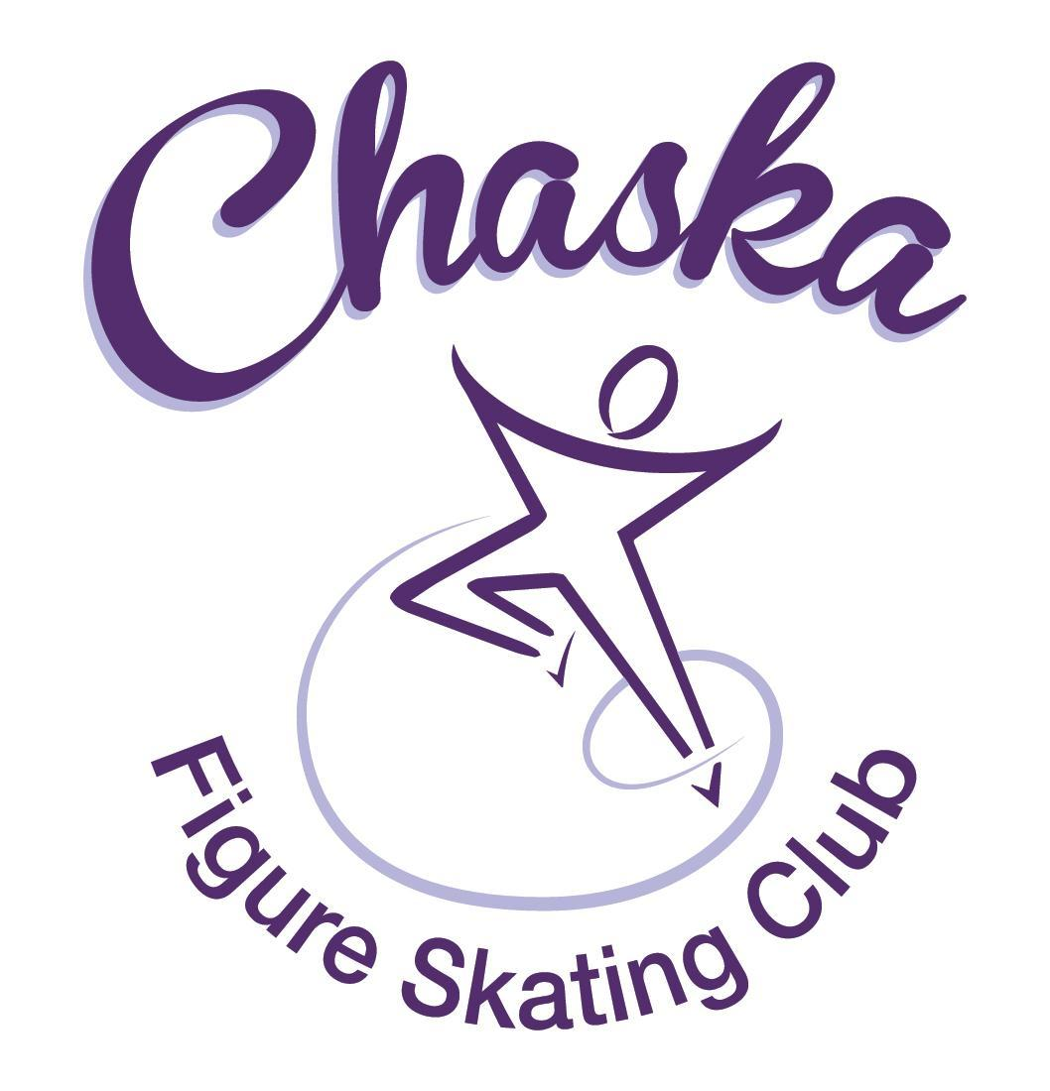 Chaska Figure Skating Club
Board Meeting Minutes
Tuesday, October 11, 2022

Meeting called to order by President Jenn Gizinski at 7:37p.m. Quorum was declared.
Board Members present: Jenn Gizinski, Barb Houts-Swanson, Elizabeth Matvick, Kristie Mitchell, Jess Kazprzack, and Liz Nyhammer
Board Members absent: Amanda Braun, Jenn Gionfriddo, Tracy Koepsell
Others present: Erin Swanson
Meet and Greet: None.
President’s Report: No report.
Vice President’s Report: No report.
Secretary’s Report: September Meeting Minutes – email
Motion made, seconded and carried unanimously to approve the September 2022 Board Meeting Minutes as submitted.

SkateSafe: No update.

Communication: No update.
Membership: Report emailed.

Aspire Introductory
Levi Provancha

Aspire
NA

Associate
Jaelyn Sather

Home Club
Cori Braun – approval backdated to June 2022
Krysta Braun- approval backdated to June 2022

Reciprocal
NA

Collegiate
NA

Subsequent Home Club Family
NA

Sustaining
NA

Home Club Coach
Jennifer Gionfriddo

Associate Coach
NA

Transfer Out
NA

Current Membership Totals for 2022-23
Home Club: 37
Aspire Introductory: 5
Aspire: 8
Associate: 1
Reciprocal: 1
Collegiate: 3
Subsequent: 1
Sustaining: 8
Home Club Coaches: 11
Associate Coaches: 1

Ending Membership Totals for 2021-22
Home Club: 52
Aspire Introductory: 16
Aspire Junior: 9
Associate: 2
Reciprocal: 0
Collegiate: 4
Subsequent: 2
Sustaining: 8
Home Club Coaches: 12
Associate Coaches: 4

Ending Membership Totals for 2020-21
Home Club: 50
Aspire Introductory: 12
Aspire Junior: 5
Associate: 0
Reciprocal 2020: 2
Reciprocal 2021: 6
Collegiate: 4
Sustaining: 8
Home Club Coaches: 13
Associate Coaches: 2

Ending Membership Totals for 2019-20
Home Club: 36
Introductory: 13
Junior Club: 9
Associate: 0
Reciprocal: 2
Collegiate: 3
Sustaining: 8
Home Club Coaches: 11
Associate Coaches: 3

- Motion made, seconded and carried unanimously to approve the new members as submitted.

Social: Verbal update.
- Discussing date/time for holiday gathering and future ideas.

Junior Board: Update emailed.
- Great meet and greet event!
- This month we will be hosting Halloween Live
- Assisting during the Glow Run!

Fundraising:
- Glow Run: Event date is 10/15/22
  - Registration is now closed (37 participants, goal was 40)
- CFSC 4th Annual Holiday Boutique: Event date is 11/19/22, 9-3pm @ CCC
  - Currently have 18 vendors--the goal is 30 again!
- Gerten’s Fall Fundraiser was successful!
  - Received a check for $1820.10
- Banner currently being updated
- New annual process for Sponsors/Logos and banner ordering (Jenn G)
  - Outreach and engagement with sponsors primarily takes place between Nov – May, update banner in June for July 1st

Volunteer Coordinator:
- Updated volunteer hours tracking document has been updated, through Gerten’s & Garage Sale.
- Jess K will set up a Sign-up Genius form for exhibition snacks.

ASPIRE Liaison: No report.

TCFSA:
- No October meeting.

Marketing/PR:
- Banner updated & overlay ordered. Potentially ordering full banner, based on recommendation from print vendor.
- Club photo date: 10/30, following the fall exhibition (on ice). Exhibition is 4:00-5:30.
  - Suggestion for future years: Would families be interested in individual photos (for a cost) to be used for a montage. Allows all members the opportunity to be included.
- Winter Gear Order: Looking to offer online ordering in early November (potentially 11/4-11/14)

Treasurer’s Report: Reports emailed.
- Reports emailed
- Request to write off & payout old account balances – report attached
  - Motion made, seconded and carried unanimously to write off old account balances.
  - Motion made, seconded and carried unanimously to hold credits for families that chose not to use credits; if families request funds, pay as requested; do not move them forward to the new system.
- Request to prorate summer contract to waive August & prorate fall contract to not include Sept. for a skater who was suspended
  - Motion made, seconded and carried unanimously to credit summer contract specific to dates that are applicable and not credit fall contract.

Ice Coordinator: Report emailed.
- The fall exhibition is scheduled for 10/30/22. Sanction has been received.
  - We have 9 skaters registered for the Aspire group number, and a total of 28 numbers total (as of 10-11-22).

Test Chair:
- No in person test session scheduled due to low attendance. The October test session has been changed to virtual with submission on the 26th of October.
  - Suggestion for future updates: Ensure all coaches (home and associate) are notified via email for updates/changes.

Pro Liaison: No update.

Star of the North:
- Do we want to apply to be part of the Excel Series? Details attached. Also would need to secure a technical accountant and rent the IJS Mini-system from TCFSA cost=$600 for the rental.
- Considerations:
  - Do we focus on growing our competition as is, by connecting with surrounding clubs?
  - Do we proceed with IJS (not Excel Series)? This may attract higher-level skaters seeking IJS judging.
  - Do we solicit feedback from other club who have recently converted to IJS (pros/cons, cost, etc)?
  - Look at costs associated with offering IJS.

Ice Show:
- Ice Show General Updates
  - SK8theUSA (will highlight the seniors)
- Request for exception for solo/small group eligibility discuss/vote – letter from family attached
  - Motion made, seconded and carried unanimously to not deviate from the CFSC Board’s initial decision of rejection to override our CFSC policy related to SSG.
- Request for consideration of account in arrears – document attached
  - Motion made, seconded and carried unanimously to require the skater account in arrears to be current by 12/1/22. Minimum payment of $500 must be received by 11/1/22, remainder of balance must be received by 12/1; there must also be an attestation by the coach that payment or payment plan to coach is adequate and followed in order to be considered for SSG in the 2023 Ice Show.

Policy and Procedure Updates: No updates.

Old Business:

- Rink Monitor/Skater Check in Process: Going to try to use the show program for the rink monitors to identify the kids better. Positive feedback provided by rink monitors who have utilized the programs photos. Continue discussing in future meetings.

- Long Term Planning (LTP) – LTP Committee: Mary Ament-Johnson, Jenn Gionfriddo, Lauren Gizinski, Kristie Mitchell, Stan Houston. Long Range Plan has been updated. Long Range Plan Link

- Scholarship Fund Delegation: Delegate funds to go towards the Gold Medalists gifts or plaque/trophy case. Potentially price out display cases.

- Ad Hoc Bylaws Review: Not done yet.

- USFS Checklist for Success: Review preliminary results/compare to last years results.

- National Skating Month: Event date is 1/22/23; partnering with CCC to celebrate National Skating Month during open skate. Kit has been ordered from USFS.

- GoMotion Website: Document attached; implementation going smoothly.

- Coaches room lock update:

New Business:

- Club Jacket price – suggest increasing price to $100 to cover our cost here.
- Motion made, seconded and carried unanimously to increase club jacket price to $100.

Adjournment: Motion made, seconded and carried unanimously to adjourn at 9:16 pm.

Respectfully submitted,

Liz Nyhammer, Secretary

