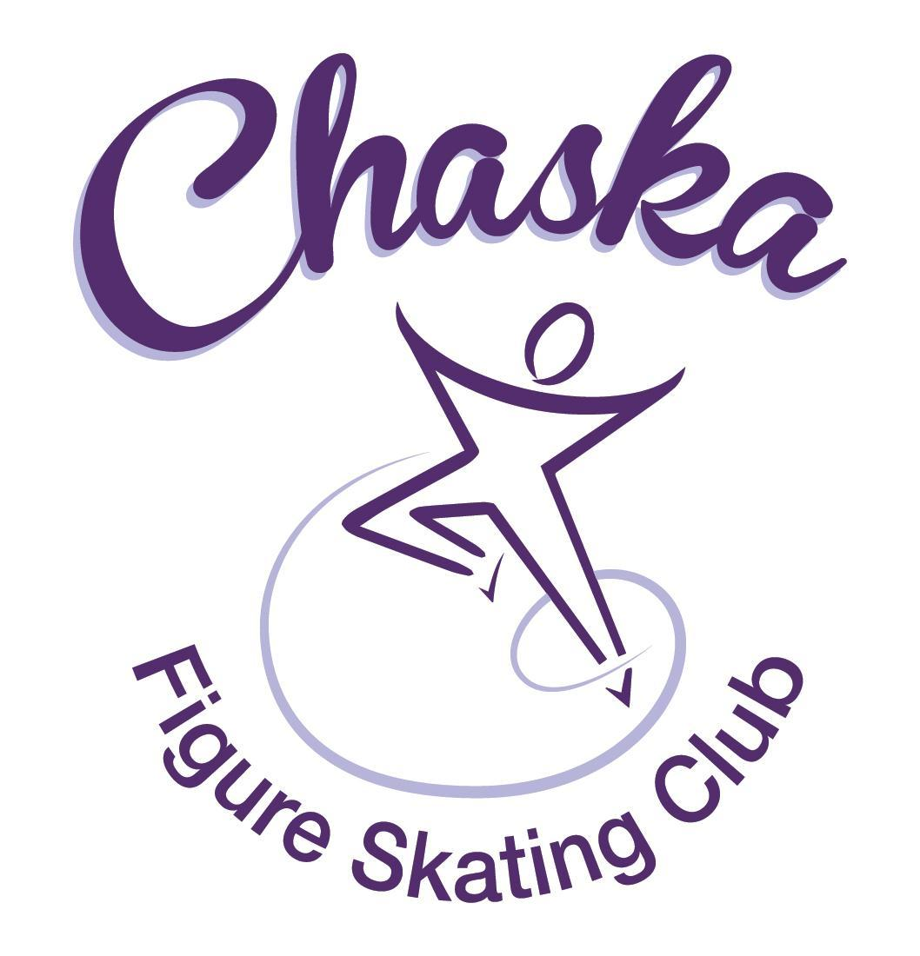 Chaska Figure Skating Club
Board Meeting Minutes
Tuesday, October 10, 2023

Meeting called to order by President Jenn Gizinski at 7:05p.m. Quorum was declared.
Board Members present: Jenn Gizinski, Elizabeth Matvick, Barb Houts-Swanson, Liz Nyhammer, Tracy Koepsell, Erin Swanson, Amy Nunn, Tiffany O’Boyle
Board Members absent: Amanda Braun, Jenn Gionfriddo, Julie Nicholls
Others present:
President’s Report: No report.
Vice President’s Report: No report.
Secretary’s Report:
- September Meeting Minutes – emailed
  - Motion made, seconded and carried unanimously to approve the September 2023 Board Meeting Minutes as submitted.

SkateSafe: No report.

Communication: No report.
Membership: Report emailed.
- Upgrade from Aspire Introductory to Aspire
  - Annalee Koepsell
  - Maisie Seifert
- Motion made, seconded and carried unanimously to approve the membership as submitted.

Social: No report.
- Evereve Event was 10/8, 3-5:30pm; low participation, feedback provided from organizer to CFSC Board.

Junior Board: No report.

Fundraising:
- Gerten’s Plant Sale
  - Fall sale went well, even though there were delivery truck issues. Fundraising efforts should total approx. $1500 from Gerten’s.
  - Spring sale delivery date has been set for May 4, in the morning.
- Holiday Boutique:
  - CCC room reserved for 11/18/23, 9am-3pm
  - Currently have approx. 20 vendors, aiming for 30
  - Will need volunteers to help vendors during setup, and then help tearing down at the end
  - Facebook ads are running – what other advertising efforts would be beneficial?
    - Share printed flyers at community establishments (on community bulletin boards)
    - Share event on local online groups (e.g. Facebook sale sites/chatter sites)

Volunteer Coordinator: Hours are updated on spreadsheet.

Aspire Liaison: No report.

TCFSA:
- No October Meeting
- Presidents meeting set for 10/23

Marketing/PR:
- Fall/Winter Club Gear order - contacted PAAR Sports to begin building online store assortment, in hopes of opening/closing sooner so not running so tight to Christmas time as year’s past. Hoping to open 10/15 and close 10/30…giving families ample time to shop!

Treasurer’s Report: Reports emailed.
- Refund request from families:
  - A new Aspire skater joined beginning of September and determined it isn't working out right now. Requesting a refund for the Saturday morning session that runs through November starting Sept 24th on.
    - Motion made, seconded and carried unanimously to provide a 2/3rds refund of contract cost for fall quarter.
  - A family is quitting skating but had already signed up for AYCS for the quarter. Requesting a refund from Sep 24th on.
    - Motion made, seconded and carried unanimously to follow established CFSC policy in handling the refund request for the established skater.

Ice Coordinator: Report emailed.
- Summer ice income was $25,546. We had 34 skaters doing AYCS
- Summer Aspire income was $ 4358, with one promo pass. 5 skaters did All-Aspire.
- Summer exhibition income was $472.50 ($214.50 individual, $260 Aspire group).

- Fall contracts are $26,499, including late fees and RM buy-out. We have 34 skaters doing AYCS. We have 18 skaters taking the Power Edge class. September buy-ins were $337.
- Fall Aspire contracts are $34744. We have 2 skaters doing All-Aspire.
- The fall exhibition is scheduled for 10-29-23. Sanction has been received.

- We will not be able to have our after school ice on Thursday, November 2, due to David having missed a girl’s hockey game scheduled for that day.

- Sanction has been received for the ice show.

Test Chair:
- Working with coaches to provide transparency of testing plans with each other on club sessions. Seems to be making an improvement.

Pro Liaison:
- The coaches would like a safety reminder sent out in the next communication, to include:
  - wearing yellow belt when skating their program to music
  - reminder of earbud policy
  - reminder of cell phone use policy
- The coaches would like to continue to offer power edge class during the winter quarter.
Star of the North:
- Competition added to the TCFSA Compete USA Series
- Competition & test session added to the TCFSA Calendar
- Discuss 6.0 vs. IJS for this years competition
  - IJS/CJS Needs: Can use paper to eliminate need for renting the IJS system
    - 1 technical accountant
    - 2 accountants on site day of (there's a lot more data entry for IJS on paper.)
    - 2-3 technical specialists
    - 1-2 technical controllers (TCs can also judge, but there aren't that many TCs in the universe so getting them is important.)
  - Total cost for judges/officials last yr: $1472.44 - PY $1784.25
  - National Showcase 2024 Requires qualifying at a competition that uses CJS (Component Judging System). If we want to continue to be a qualifying competition we would need to move to using the CJS system.
- Consideration: Rink 1 = all day, Rink 2 – 10am-2pm, pending registrations
- Awaiting response from Bloomington President as their website lists their competition as being the same weekend as ours
Ice Show:
- 2024 Dates: March 16th & 17th
- Theme: Enchanted
- Skater/Parent Number Fees – discuss vote current: 1 parent/1 skater $20, 1 parent/2 skaters $30, 1 parent/3 skaters/?
  - Motion made, seconded and carried unanimously to set the fees for this year at $21, $31, $41, respectfully.
- Registration details will go out by end of week
- SSG qualifier emails will be sent out by end of week [to skater families and coaches]
- Will need someone to run lighting and install lighting this yr. Planning to look ahead of time to find a team.
- Request for coach stipend for show weekend – see attachment
  - Motion made, seconded and carried, with two board members abstaining, to approve coach stipend for show weekend at $50/coach per event (including 2 shows and 1 dress rehearsal), up to 6 coaches for dress rehearsal and 4-5 coaches per show.
- Kristie will let us know the dates for promo table during skate school soon.

Policy and Procedure Updates: No update.

Old Business:
- Rink Monitor/Skater Check in Process Improvement Plan: Using the show program for the rink monitors to identify the kids better. Positive feedback provided by rink monitors who have utilized the programs photos. Continue discussing in future meetings.
- Long Term Planning (LTP) – LTP Committee: Mary Ament-Johnson, Jenn Gionfriddo, Lauren Gizinski, Kristie Mitchell, Stan Houston. Long Range Plan has been updated. Long Range Plan Link
- Scholarship Fund Delegation: Idea: Delegate funds to go towards the Gold Medalists gifts or plaque/trophy case. Potentially price out display cases.
- USFS Checklist for Success: Any items to work on for the year?
- Calendar of Events: Would like to continue to get dates set for as many of our regular events for the 2023-24 yr as possible to be able to add them to our calendar for families to be able to plan. (exhibitions, club photo, banquet, etc.)

New Business: None.
- November food drive 11/6 – 11/12: check with coaches on doing the Dec Exhibition if meet goal of 275 items.
- Fall Exhibition: Tiffany to run chuck-a-duck and snack table.

Adjournment: Motion made, seconded and carried unanimously to adjourn at 8:57pm.

Respectfully submitted,

Liz Nyhammer, Secretary

