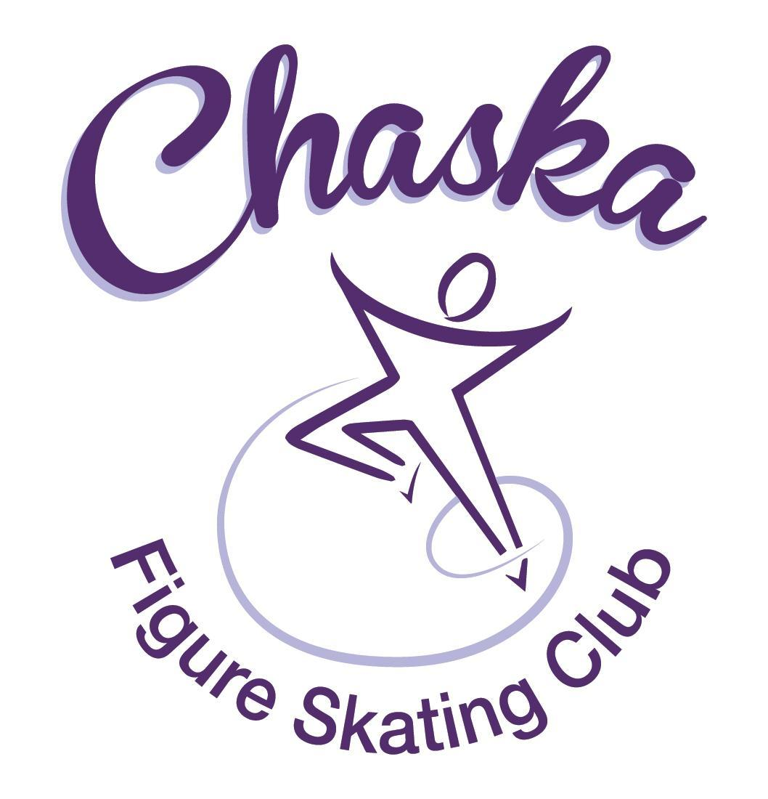 Chaska Figure Skating Club
Board Meeting Minutes
Tuesday, September 13, 2022

Meeting called to order by President Jenn Gizinski at 7:05 p.m. Quorum was declared.
Board Members present: Jenn Gizinski, Barb Houts-Swanson, Elizabeth Matvick, Amanda Braun, Jenn Gionfriddo, Kristie Mitchell, Tracy Koepsell and Liz Nyhammer.
Board Members absent:
Others present: Erin Swanson
Meet and Greet: None.
President’s Report: No report.
Vice President’s Report: No report.
Secretary’s Report: Motion made, seconded and carried unanimously to approve the August 2022 Board Meeting Minutes as submitted. Motion made, seconded and carried unanimously to approve the closed Board Meeting Minutes from August 8, 2022 as submitted.
SkateSafe:

- Two current reports under review with USCSS.
Communication: No update.
Membership: Report emailed.

- Motion made, seconded and carried unanimously to approve the new members as submitted.

Aspire Introductory
Carolyn Cooper

Home Club
Saloni Siddavatam

Current Membership Totals for 2022-23
Home Club: 35
Aspire Introductory: 4
Aspire: 8
Associate: 0
Reciprocal: 1
Collegiate: 3
Subsequent: 1
Sustaining: 8
Home Club Coaches: 10
Associate Coaches: 1

Social: Discussed potentially reserving a block of tickets for Disney On Ice.
- Barb will reserve tickets for 7pm performance on Friday, 12/9
- Jenn will include information in the next email communication, to ‘save the date’ for interested families

Junior Board: Schedule of Events & Newsletter going out in next communication.

Fundraising:
- Glow Run: Event date is 10/15/22; registration is open.
- Holiday Boutique: Event date is 11/19/22, 9-3pm
  - Discussed options for signage to advertise the holiday boutique
- Motion made, seconded and carried unanimously to charge families, that did not meet the minimum requirement of $50 in sales, the difference between $50 and sales totaling less than $50; accompanied by a supporting explanatory email.

Volunteer Coordinator:
- Updated volunteer hours tracking document has been updated, through Touch a Truck event.

ASPIRE Liaison: No report.

TCFSA:
- Proxy sent (will get credit for attending)

Marketing/PR:
- Looking into banner sponsor updating; options with vendor.
  - Lakeside printing can do a vinyl overlay on the sponsor side of the banner
  - Will need to finalize sponsor list prior to production of overlay
- Discuss possible date options for annual club photo – still waiting to hear from photographer.
  - Potential date: 10/30, following the fall exhibition (on ice).

Treasurer’s Report: Reports emailed.

Ice Coordinator: Report emailed.
- Received a request to waive the late fee for a newer skater who was not on the e-mail list, so did not receive contracting information in time to contract before the deadline.
  - Motion made, seconded and carried unanimously to waive the late fee for a newer skater who was not on the e-mail list, so did not receive contracting information in time to contract before the deadline.
- Received a request to waive the late fee for a skater who was not in the country during membership and contract registration windows.
  - Motion made, seconded and carried unanimously to waive the late fee for a skater who was not in the country during membership and contract registration windows.
- The fall exhibition is scheduled for 10/30/22. Sanction has been received.

Test Chair:
- Virtual session in progress.

Pro Liaison:
- Discussed if it’s possible to research combo lock options for the coaches door.
- Jenn G to discuss with rink manager.

Star of the North: No report.

Ice Show:
- Received a request to approve an exception for solo/small group eligibility.
  - Motion made, seconded and carried unanimously to reject an exception for solo/small group eligibility.

Policy and Procedure Updates: No updates.

Old Business:

- Rink Monitor/Skater Check in Process: Going to try to use the show program for the rink monitors to identify the kids better. Positive feedback provided by rink monitors who have utilized the programs photos. Continue discussing in future meetings.

- Long Term Planning (LRP) Committee: Mary Ament-Johnson, Jenn Gionfriddo, Lauren Gizinski, Kristie Mitchell, Stan Houston. Long Range Plan has been updated. Table for future meeting.

- Idea: Delegate funds to go towards the Gold Medalists gifts or plaque/trophy case. Potential price out display cases. Table for future meeting.

- Ad Hoc Bylaws Review: Not done yet. Table for future meeting.

- USFS Checklist for Success: Table for future meeting.

- Parent Skater Meeting:
- 21 families attended on Monday, 8/15/22
- 14 families attended on Thursday, 9/1/22
- Meeting follow-up details emailed.

- National Skating Month: Event date is 1/22/23; partnering with CCC to celebrate National Skating Month during open skate. Kit will be ordered from USFS.

- GoMotion Website Option: Jenn has met with GoMotion multiple times. Will continue working on build. Goal is to have it live by November contract registration.

New Business:

- Fall Exhibition:
- Will need to confirm time (4:00-5:30 OR 4:15-5:45)
- Chuck-A-Duck: Is anyone available to run it at the event. Tracy volunteered to coordinate
- Snacks: Anyone to coordinate them?
- Aspire Group Practices: Sunday’s (16th, 23rd, 30th) at 3:00-3:45

Adjournment: Motion made, seconded and carried unanimously to adjourn at 8:31 pm.

Respectfully submitted,

Liz Nyhammer, Secretary

