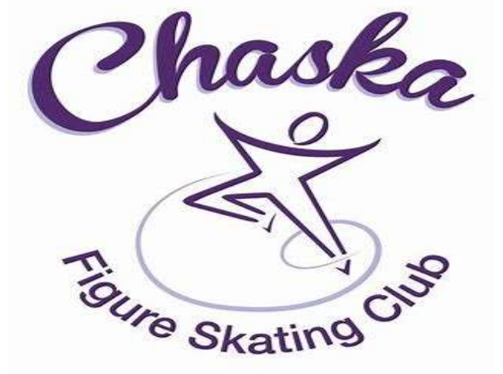
CFSC Junior Board News
November 2023
 | 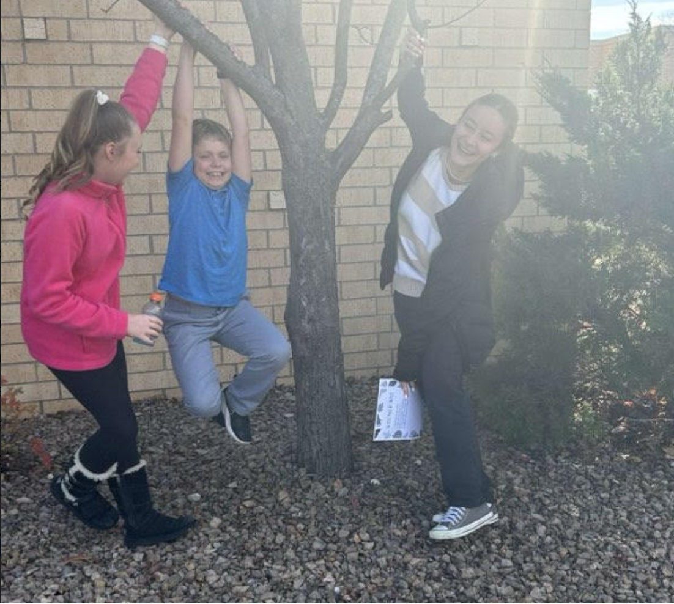
CFSC Junior Board
Adult Leader
Jennifer Gionfriddo
jhill8269@gmail.com

CFSC Junior Board Leaders
Juhi Ghatti
Megan Weaver
Upcoming Events  Feed My Starving Children  12.08|7:00-8:45  18732 Lake Dr E  Chanhassen MN |  | November brought another great month for Junior Board and a fun event to kick off the Bigs/Little program. At the Fall Fun Fest bigs and little alike got together to meet new friends and old.  During the event, skaters ate yummy snacks while they played ‘would you rather’. After a quick bite to eat it was outside for the scavenger hunt! One of the items they search for were ‘skaters having fun!’ You can see a snapshot of some of those skaters having fun on the newsletters featured image!  After the scavenger hunt skaters played skater bingo where instead of the word being called, it was described, and the tables had to determine which word to cross out on the board. See how you would do….1) This skating skill is both a jump and a turn? 2) This skating jump has a forward take off and includes 1.5 revolutions in the air?  Our next big event is our yearly food packing race at Feed My Starving Children in December. Make sure to continue to check the CFSC site for updated information and event dates.

