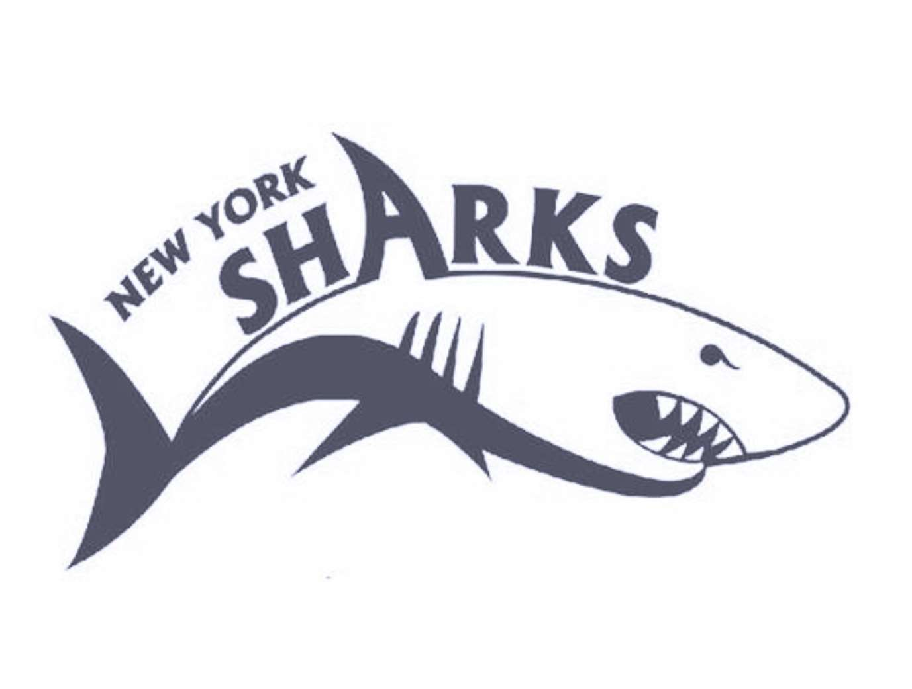

NYSA 2020 WINTER INVITE Valley Central High School

January 18-19, 2020

Metro Sanction # 200119

Invited Teams: AG, WSSC, MWSC, NBS,RFAC, HVD, TRS, BAD, YMID, BGNW, EAST, HAWKS, VAC, GAEL, LIE, DA, COND, AGUA, MVA, YBAR, NCAC, SPAR, SSC, SMC, SSL, WAC, APEX, FAST, IA, LGAC, MAKO, MPNY, GATORS-NJ, BBNJ,WAV-NJ, LSA, FREE, SWAG, CAT-NJ, HCY-NJ, YFD, LIAC, HS, DESC-NJ, PATS, SS, WSA, JCC, TS, HAA, QNS, SWIM70-CT, Ridgefield Aquatic Club CT, SCY, DVWM, FOBY, SCAR, EXCEL-NJ, IA-MR,PAC
NYSA 2020 Winter INVITE
Saturday & Sunday January 18, 19 2020

SANCTION:

LOCATION:

FACILITY:

SESSIONS:

FORMAT:

ELIGIBILITY:

DISABILITY SWIMMERS:

ENTRIES:

Held under the sanction of USA Swimming/Metropolitan Swimming, Inc., #

Valley Central High School Natatorium, 1175 Rt 17k Montgomery NY 12549

Valley Central is an indoor 8 lane 25-yard pool. The meet will be run in the deep end of the pool and the shallow end will be used for continuous warm up and warm downs. Colorado electronic timing system and an 8-line scoreboard.
The pool has not been certified in accordance with Article 104.2.2C (4)

REVISED 1/16/2020

Session 1: Saturday AM: 7:30 AM Warm Up, 8:30 AM Start
*** Saturday 1000 yd Free – 13-14 ONLY will Swim directly after Session 1
Session 3: Saturday PM: 11:45 AM Warm Up, 12:45 PM Start
*** Saturday 1000 yd Free – 11-12 and 15 and over ONLY will Swim directly after Session 3

Session 4: Sunday AM: 8:30 AM Warm Up, 9:30 AM Start Session 5: Sunday PM: 12:30PM Warm Up, 1:15PM Start
Session 6: Sunday PM: 2:30 PM Warm Up, 3:30 PM Start

This is a timed final meet.
The meet will be deck seeded.

Open to all Invited USA Swimming/Metropolitan Swimming Inc. registered swimmers. All swimmers participating in this meet must be registered by the first day of the meet. No “Deck Registrations” will be accepted
Age on January 18, 2020 will determine age for the entire meet.

Swimmers with disabilities are encouraged to attend. Contact the meet director if you need special consideration. The athlete (or the athlete’s coach) is also responsible for notifying the meet referee of any disability prior to the competition.

Swimmers may compete in 5 individual events per day for Saturday and Sunday. NT’s will not be accepted. The host club reserves the right to enter their swimmers with NT’s. All entries will be accepted on a first come, first serve basis. Teams will be considered accepted when the host club accepts the entries The host club must stay within the four hour per session rule.

If necessary, the 400 IM, 500 Free, 1000 free and 1650 free (women) will each be limited to the fastest 5 heats; the 400 IM and 500 Free,1000 free, and 1650 free (men) will be limited to the fastest 6 heats. Host team retains the right to keep its swimmers entered in these events.

All received entries will be confirmed within 48 hours. Emailed Hy-Tek entry file is preferred. If sending by mail, entries should be sent on disk. A master sheet must accompany all entries.

PLEASE SEND PAYMENTS TO ADDRESS BELOW.
U.S. Mail Entries/Payment to: NYS Aquatics, Inc, c/o Edgar Perez
10 Julia Court
Tappan NY 10983

Email Entries/Confirm Entry Receipt: NYSAentries@gmail.com
Sign Express Mail Waiver allowing delivery without signature.

DEADLINE: 1: All invited teams will be given priority on a first come/first serve basis. All other teams please send email to BG26608@hotmail.com. All entries must be received by January 10, 2020.
2: The final entry deadline for this meet is January 10, 2020.

An email confirming receipt of entries if you provide an email contact. Please contact Meet Director if you do not receive such a report within 2 days of your original email.

ENTRY FEE:

WARM-UP:

SCRATCHES:

COACHES:

AWARDS:

OFFICIALS:

MEET DIRECTOR:

ADMIN
OFFICIAL:

RULES:

SAFETY:

An entry fee of $8.00 per individual event and a $3.00 per swimmer facility fee must accompany the entries. Make check payable to: NY Sharks Aquatics, Inc. Payment must be received by January 10, 2020 for email entries. Payment must be included with all mail entries. Failure to pay entry fees by this deadline could result in teams being barred from the meet.

The host club reserves the right to assign lanes for warm up based on the size of the meet. If lanes are not assigned the first 40 minutes will be general warm up. The last 20 minutes will have lanes 2 and 7 open for one-way sprints. Lanes 1 and 8 for pace and all other lanes may be assigned by the meet director’s discretion. No diving will be allowed accept in designated sprint lanes. All swimmers must be supervised by a coach.

Coaches will be given scratch sheets upon check-in for each session. All scratches are due no later than 30 minutes prior to the start of the session. Coaches are asked to indicate clearly individual events scratches and which swimmers will not be participating in the session.

In accordance with Metropolitan Swimming Inc. Policy, only those coaches who display current, valid USA Swimming credentials will be permitted to act in a coaching capacity at this meet. Coaches who do not possess these credentials will be required to leave the deck area.

Ribbons will be award for 1st through 8th Place for age groups 9/10 and 11/12.

Meet Referee: Mark Amodio, Amodio@vassar.edu
Officials wishing to volunteer should contact Meet Referee by January 10, 2020.

Edgar Perez, nysaentries@gmail.com

Regina O’Brien, nysaentries@gmail.com

The current USA Swimming Rules and Regulations will apply.
The USA Swimming Code of Conduct is in effect for the duration of the meet. The overhead start procedure may be used at the discretion of the meet Referee.

All swimmers must wear footwear upon leaving the pool area.
Metropolitan Safety and Warm-up procedures will be in effect. Marshals will be present throughout warm-ups and competition, and have the authority to remove, with the concurrence of the meet Referee, any swimmer, coach, club, or spectator for failure to follow the safety rules.

“Any swimmer entered in the meet must be certified by a USA Swimming member coach as being proficient in performing a racing start or must start each race from within the water. When unaccompanied by a member-coach, it is the responsibility of

the swimmer, or the swimmer’s legal guardian, to ensure compliance with this requirement”

MAPP:

WATER DEPTH:

DISCLAIMER:

AUDIO/VISUAL STATEMENT:

Current USA Swimming Rules, including the Minor Athlete Abuse Prevention Policy (“MAAPP”), will govern this meet.

USA 2011 - 202.3.7 "The meet announcement shall include information about water depth measured for a distance of 3 feet 3½ inches (1.0 meter) to 16 feet 5 inches (5.0 meters) from both end walls."
1.0 meter = 4 feet 6 inches, 5 meters = 13 feet

Upon acceptance of his/her entries, the participant waives all claims against Valley Central School District, New York Sharks Aquatics, Inc., Metropolitan Swimming Inc., USA Swimming Inc., their agents or representatives for any injury occurring as a result of the meet. "It is understood that USA Swimming, Inc. and Metropolitan Swimming, Inc. shall be free from liabilities or claims for damages arising by reason of injuries to anyone during the conduct of the event."

Use of Audio or visual recording devices, including a cell phone, is not permitted in changing areas, rest rooms, locker rooms or behind the starting blocks.

DECK CHANGING: Deck changes are prohibited.

DRONES:

ADMISSION:

MERCHANTS:

PARKING:

Operation of a drone, or any other flying apparatus, is prohibited over the venue (pools, athlete/coach areas, spectator areas and open ceiling locker rooms) any time athletes, coaches, officials and/or spectators are present.

$7.00 Adults/Session $3.00 Program/Session

A Swim Shop Vendor will be on site, as well as, a food concession.

There is free unlimited parking at Valley Central High School. All cars must be parked in designated parking spaces.
NO parking allowed in the fire zone in front of the buildings OR on Route 17K. If you are parked illegally…you will be ticketed and/or towed at your own expense.

FACILITY RULES:
• NO SMOKING within 100 feet of any entrance to the school or inside the school.
• NO FOOD is allowed on deck. Liquid refreshments in plastic bottles are allowed.
NO GLASS BOTTLES or JUICE BOXES allowed on deck.

Session #1: Saturday, January 18, 2020 7:30 AM Warm up, 8:30 AM Start

Girls Event # | Age Group Event | Boys Event #
1 | 9 -10 200 yd. Free | 2
3 | 13-14 200 yd. Freestyle | 4
5 | 9-10 100 yd. Backstroke | 6
7 | 13-14 100 yd. Backstroke | 8
9 | 9-10 100 yd. Breaststroke | 10
11 | 13-14 200 yd. Breaststroke | 12
13 | 9-10 50 yd. Butterfly | 14
15 | 13-14 100 yd. Butterfly | 16
17 | 9-10 50 yd. Freestyle | 18
19 | 13-14 50 yd. Freestyle | 20
21 | 9-10 200 yd. IM | 22
23 | 13-14 400 yd. IM | 24

Session #2: Saturday, January 18, 2020
13-14 to swim directly after Session 1
11-12 and 15 and over to swim directly after Session 3

Girls Event # | Age Group Event | Boys Event #
97 | 11 and over 1000 yd. Free | 98
**Swimmer MUST provide own TIMERS AND COUNTERS**
Session #3: Saturday, January 18, 2020
11:45 AM Warm up, 12:45 PM Start

Girls Event # | Age Group Event | Boys Event #
25 | 11-12 200 yd. Free | 26
27 | 15 and Over 200 yd. Freestyle | 28
29 | 11-12 50 yd. Backstroke | 30
31 | 15 and Over 100 yd. Backstroke | 32
33 | 11-12 100 yd. Breaststroke | 34
35 | 15 and Over 200 Breaststroke | 36
37 | 11-12 50 yd. Butterfly | 38
39 | 15 and Over 100 yd. Butterfly | 40
41 | 11-12 50 yd. Freestyle | 42
43 | 15 and Over 50 yd. Freestyle | 44
45 | 11-12 200 yd. Backstroke | 46
47 | 15 and Over 400 IM | 48

Session #4: Sunday, January 19, 2020 8:30 AM Warm up, 9:30 AM Start

Girls Event # | Age Group Event | Boys Event #
49 | 13-14 200 yd. Ind. Medley | 50
51 | 9-10 100 yd. Ind. Medley | 52
53 | 13-14 100 yd. Breaststroke | 54
55 | 9-10 50 yd. Breaststroke | 56
57 | 13-14 200 yd. Backstroke | 58
59 | 9-10 50 yd. Backstroke | 60
61 | 13-14 200 yd. Butterfly | 62
63 | 9-10 100 yd. Butterfly | 64
65 | 13-14 100 yd. Freestyle | 66
67 | 9-10 100 yd. Freestyle | 68
69 | 13-14 500 yd. Freestyle | 70
71 | 9-10 500 yd. Freestyle | 72

Session #5: Sunday, January 19, 2020 12:30 AM Warm up, 1:15 AM Start

Girls Event # | Age Group Event | Boys Event #
99 | 11and over 1650 yd Freestyle | 100
**Swimmer MUST provide own TIMERS AND COUNTERS**

Session #5: Sunday, January 19, 2020
2:30 PM Warm up, 3:30 PM Start

Girls Event # | Age Group Event | Boys Event #
73 | 11-12 200 yd. Breaststroke | 74
75 | 15 and Over 200 yd. Ind. Medley | 76
77 | 11-12 100 yd. Ind. Medley | 78
79 | 15 and Over 100 yd. Breaststroke | 80
81 | 11-12 50 yd. Breaststroke | 82
83 | 15 and Over 200 Backstroke | 84
85 | 11-12 100 Backstroke | 86
87 | 11 and Over 200 yd. Butterfly | 88
89 | 11-12 100 yd. Butterfly | 90
91 | 15 and Over 100 yd. Freestyle | 92
93 | 11-12 100 yd. Freestyle | 94
95 | 11 and over 500 yd Freestyle | 96




Metropolitan Swimming Photographer Registration Form

As of 05/18/16 - All Metropolitan Teams need to include this in the meet information packet as well as file this form with Safety in Sport Coordinator, prior to the start of the meet.

This form must be completed by any photographer (video or still) who intends to take pictures at an Metropolitan Swimming sanctioned meet, and is taking those pictures of anyone other than his or her own child, from any location on deck. Submit the form to the Meet Director prior to commencing activity.

THERE WILL BE NO FLASH PHOTOGRAPHY PERMITTED AT THE START.

Name___________________________________________________________________

Phone Number___________________________________________________________

Government ID (driver’s license preferred) or USA Swimming Registration Card:

Type of ID_____________________ #________________________

Taking photos of________________________________________________________________

On behalf of____________________________________________________________________

Purpose _______________________________________________________________________

Professional photographers/videographers will be allowed on deck at the discretion of the Meet Director and Meet Referee, and must adhere to the following guidelines:

Do not stand on the starting end of the pool, or in the starter’s box; use of the bulkhead is at the discretion of the Meet Director and Meet Referee.

Do not stand on the edge of the pool (leave approximately two feet for officials and coaches).

Leave the deck when not actively photographing.

Respond immediately to direction from the Meet Referee.

Signature ______________________________________________ Today’s Date____________

Meet_____________________________________________ Location_____________________

Date(s) of meet________________________________

