Lake Monsters LapsforCash 2024 Pledge Sheet
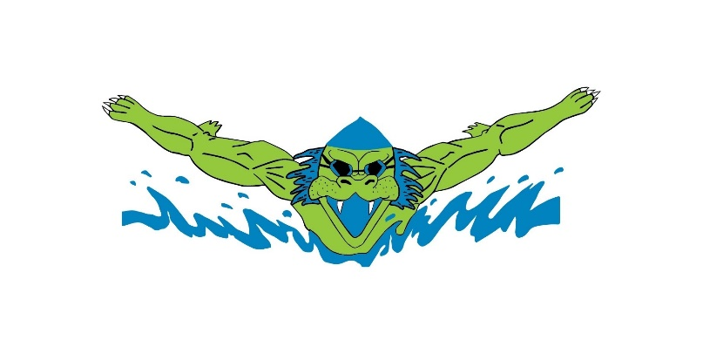
Dear Donor,
My name is _______________________ and I am seeking donations for our annual LapsforCash to raise money for my swim team. Funds donated will go toward the purchase of dryland and pool equipment, instructional aids, and season awards. My goal is to complete 200 lengths of our 25y pool on 11/15/24.
Contributions will be gratefully accepted as either a per-lap (25 yards) pledge for each pool length I complete or a set amount. Regardless of which method you select, both I and the Lake Monsters Swim Team (https://www.gomotionapp.com/team/mtlm/page/home) will be deeply grateful for your generosity.
Donor’s Name | Email Address | Per-lap Amount | Set Amount | Amount Collected | Cash or Check
Thank you for your generous support. Please make checks payable to “Mission Valley Aquatics” and include on the “For” line, “Restricted donation—Lake Monsters Swim Team.” Donations are tax-deductible.

