MONTANA SWIMMMING

July 5, 2018

Dear Members of Montana Swimming:

Attached are the minutes of the Montana Swimming spring House of Delegates (HOD) meeting that was held May 18, 2018, in Bozeman. Please review the attached minutes to ensure they accurately reflect the meeting and let me know by August 15th if they do not. If I don’t receive any replies by August 15, I’ll assume they are satisfactory.

Congratulations to Ethan Harder, from the Billings Aquatic Club, and Katharine Berkoff of the Missoula Aquatic Team, who were selected the Male and Female Swimmers of the Year by Montana Swimming.

Congratulations to Matthew Fritz and Mari Aoki, both from the Missoula Aquatic Club, who were selected as the Montana Swimming Male and Female Sportspersons of the Year.

Congratulations to Mrs. Toni Popp from Kalispell Aquatic Team for being select as the outstanding volunteer to receive the Phillips 66 award.

The Montana Swimming Holiday Classic (formerly the senior championships) will be hosted by LAKE Monsters in Polson December 14-16. The Montana Swimming Short Course State Championships will be host by MAC in Missoula March 1-3. The Montana Swimming Junior BC Championships will be hosted by BOZ in Bozeman March 9-10.

Respectfully submitted,

Susan Huckeby
Secretary, Montana Swimming
shuckeby@msn.com

Montana Swimming Spring House of Delegates Meeting Minutes

May 18th, 2018

Hilton Garden Inn Conference Room, Bozeman, Montana

The spring 2018 Meeting of the Montana Swimming House of Delegates was called to order at 8:00 p.m. on Friday, May 18th by General Chair Tony Popp.

The meeting notice, which was duly and properly given, was posted on the LSC website. The meeting agenda is found in the appendix. Roll call was taken and those in attendance signed in on the attendance sheet found in the appendix. A quorum was present and the meeting proceeded.

General Announcements:
General Chair Tony Popp made the following announcements and the handouts presented are in the appendix:
- Tony passed out guidelines for submitting proposals for the fall HOD meeting.
- Tony passed out information on how to apply for a Presidential-At-Large (PAL) appointment to attend the US Aquatic Sports convention in September.
- Everyone was encouraged to submit ideas for the USA Swimming Bright Ideas contest. The LSC with the wining idea will receive a cash award from USA Swimming. Tony presented an idea submitted by Mrs. Toni Popp (bridge program).
- Several board of director officer position will be open for election at the fall meeting including General Chair (Tony is term limited out), Admin Vice Chair, Treasurer, Senior Vice Chair, Officials Chair (Merle is term limited out), and the Records Chair. People are encouraged to run for a board position.

Introductions:
Board members, new athlete representatives, club voting members, and all those present at the meeting were introduced.

Meeting Minutes:

The meeting minutes from the May 2017 House of Delegates meeting were approved as presented.

Two corrections were made to the October 2017 House of Delegates meeting minutes as follows (highlighted correction added). The minutes were then approved as corrected.

  - First Correction: Change wording as noted:
- Budget – Craig:
  - See attached budget report. Craig Smith plans to put proposals together for next year on how to plan and work with the LSC reserve funds.
  - Matt Yovich would like to put together a task force (3-5 bodies) to assist with evaluating and recommending priorities for future budget development efforts work with Craig upcoming options for reserve funds.

  - Next Correction: Change the word 'meets' to 'events' in three places as follows in MR 101 - Zones proposal:

Recommendation:
Increase the number of required meets throughout the year from four meets to six meets events, include provision of attending at least one (1) long course meet that is held in Montana prior to the Western Zone Championship. This will be effective immediately.

6. Increasing the number of meets events to attend throughout the year would encourage more participation in Montana Swimming that is consistent throughout the year, rather than focusing on one event.

Recommendation:
Increase the number of required meets throughout the year from four meets to six meets events, include provision of attending at least one (1) long course meet that is held in Montana prior to Zones.

Reports of Officers

Written reports by the officers are posted on the website and included in the appendix.

Officials Update: Officials Chair Merle Gunderson reported there are 80 or so officials in the LSC. Phil Dolan, HLST, attended the fall officials meeting and Jim Cherewatenko attended the April Western Zone workshop. The MT Swimming fall officials meeting will be in Butte at the YMCA on October 6 followed by an all YMCA swim meet in the afternoon. Kirby Beierle will set up the meet.

Jim Cherewatenko reported on the officials meeting he attended at the Western Zone workshop in Denver. The LSC rented radios for meets beginning on October and they have been well received. Jim asked that teams encourage parents to train to become officials as well as pursue further training to become a starter or referee.

Diversity and Inclusion News: D&I Chair Susan Huckeby introduced the three athletes and their parents and the coach along with herself who will attend the 2018 Western Zone Diversity and Inclusion Camp and Summit at San Diego State University in San Diego in June. The athletes attending the camp and their parents as well as the coach delegate are:
- Sara Guillen, BOZ, and her parents Fernando and Paola Guillen;
- Bennett Apostol, BY, and his parents Joe and Christina Apostol;
- O'Shay Birdinground, BY, and his parents Gary and Jolene Birdinground;
- Kristen Wyatt, BY head coach will represent Montana as a coach member at the summit.

Susan also presented a check for $2495 to the Bozeman Brookies head coach Caty Flikkema for the team's successful application for the spring Montana Swimming Reach Out grant program. The club will use the funds to hold learn to swim camps this summer for minorities and low income children as well as provide training funds for several low income/outreach athletes on their team. The next round of grant applications will be due in the fall and the application is posted on the website. Susan thanked finance vice chair Matt Yovich and athlete representative Mari Aoki for serving on the grant committee.

Coach Retreat: Montana Swimming Coach Representative Kirby Beierle reported the LSC coach retreat will be September 8-9 at a location to be announced. All Montana Swimming coaches are invited to attend. There are 4-5 coaches on the planning committee and the group will ask coaches attending the clinic to lead workshops at the retreat. Kirby is continuing to seek funding for the event.

Athlete Announcements: Tony Popp thanked all the athlete representatives for their efforts on behalf of Montana Swimming. Tony thanked outgoing athlete representatives Mari Aoki and Olivia Bauman. The new senior athlete representatives are AJ Popp (KATS) and Claire Becker (MYST). The new junior athlete representatives are Hannah Jourdonnais (MYST) and Isabella Seagrave (MAC).

AJ, Claire and MAC coach Jay Friend attended the first USAS Leadership Summit at the University of Houston this spring. The athletes reported it was a great leadership opportunity and they also did community service work. The athletes had practice and dryland training at the summit. AJ reported on discussion about USAS banning tech suits for 14&U athletes. She will submit a proposal banning tech suits for younger athletes in Montana. Claire proposed Montana add the 100 IM and 50's of the strokes for older athletes in Montana Swimming as these events are now offered by the NCAA.

Clinic, Mixer Meet and Camp Updates: Technical Planning chair Sean Marshal reported HLST is hosting the mixer meet in late July. Further updates are posted on the website in his report.

Treasurer's Report: Treasurer Craig Smith discussed the budget and the unaudited reports are posted on the website. The statement of financial position or balance sheet shows a cash balance as of December 31, 2017 in the amount of $260,502.46 -- an increase of approximately $15,000 from the previous year. The budget vs. actual report showed the LSC finished 2017 approximately $2000 under the proposed budget. The budget compared to previous years report shows the LSC financial picture to be very similar to the 2016 budget numbers.

Old Business
There was no old business to discuss.

New Business

Awards:
Nominations were accepted for the Phillips 66 volunteer of the year, male and female athlete of the year, and the male and female sportsperson of the year. The male and female athlete of the year awards are based on power points.

Phillips 66 Volunteer of the Year: Mrs. Toni Popp, KATS.

Montana Swimming Male Athlete of the Year: Ethan Harder, Billings Aquatic Club

Montana Swimming Female Athlete of the Year: Katharine Berkoff, Missoula Aquatic Club

Montana Swimming Male Sportsperson of the Year: Matthew Fritz, Missoula Aquatic Club

Montana Swimming Male Sportsperson of the Year: Mari Aoki, Missoula Aquatic Club
Nominees: Mari Aoki, MAC; AJ Popp, KATS; Claire Becker, MYST; Caroline McCormick, MYST; and Olivia Bauman, PWST.

2018-2019 Short Course Meet Schedule:

Dates were selected and bids were accepted for the short course season championship meets.

Montana Swimming Holiday Classic (formerly the senior championships): December 14-16 hosted by LAKE Monsters in Polson.

Short Course State Championships: March 1-3 hosted by MAC in Missoula, Bid of $4500.

Junior BC Championships: March 9-10 hosted by BOZ in Bozeman, Bid of $4500.
Other bids to host the Junior BC Championships were submitted from the Butte YMCA, $4500. LAKE Monsters withdrew their bid to host the meet.

The short course meet schedule was approved and is in the appendix.

Other Business:
Championship Meet Host Fee Committee: Chaired by Matt Yovich. The committee will review the current meet host bid fees provided to host championship meets in Montana Swimming. Contact Matt if you would like to serve on the committee.

Ad hoc Budgeting Committee: Chaired by Matt Yovich. The committee will assist with evaluating and recommending priorities for future budget development efforts. Contact Matt if you would like to serve on this committee.

Governing Documents Update Task Force: Chaired by Tami Peters. The taskforce will review and update the LSC policy and procedure manual and rules and regulations manual. Contact Tami if you would like to serve on this task force. Tami would like to have an athlete, official, parent, and coach on the task force.

Scholastic All America, College Bound, website updates:
- Susan Huckeby reminded everyone that applications for the USAS Scholastic All America program will accept applications form June 1 - August 15. Athletes must have completed the 9, 10, 11, or 12 grade; have a 3.5 or higher gpa; and have a qualifying time (2017 Winter Juniors cut, compete at Open Water Nationals, or a qualifying disability meet). Home school students may apply. The application with complete information is online on the USAS website at www.usaswimming.org/SAAApp.
- There is a new college bound page on the website under the athlete tab that lists all our graduating seniors. Send information on graduating seniors to Susan to be posted.
- There is also a new past results meet page. Send meet results files to Susan to post.
- If you have ideas for topics to be posted on the website, send them to Susan.

California Concussion Training: All coaches must complete the California required concussion training before coaching at a meet in California. The information is posted on the website.

Resolutions and Orders

It was moved, seconded and passed to destroy the ballots from the meeting.

Adjournment

With no further business, General Chairperson Tony Popp adjourned the meeting at 9:40 pm

Respectfully submitted,

Susan Huckeby
Montana Swimming Secretary

Appendix

- Agenda
- 2018-2019 MT Swimming Short Course Meet Schedule
- Treasurer's Reports
- General Chair Report
- Finance Vice Chair Report
- Secretary's Report
- IT/Webmaster report
- Diversity & Inclusion Chair Report
- Technical Planning Vice Chair Report
- Official's Chair Report
- Scholastic All America Report
- Safe Sport Chair Report
- Meeting handouts:
  - USAS Convention Presidential-At-Large Appointments
  - USAS Bright Idea Contest: My Bright Idea - The Bridge Club
  - MT Swimming Proposal Guidelines
- Meeting Attendance Sign In Sheets

Montana Swimming Spring H.O.D. Meeting Agenda
Bozeman, MT – May 18th, 2018
Hilton Garden Inn, 2023 Commerce Way
Big Sky, Big Dreams, Big Success!
Sign in – voting members from each team are one adult and one A.G. athlete
General announcements
Introduction of MT Swim board members and new athlete reps – Dr Tony Popp, General Chair, et al
Review and approve minutes from Fall HOD meeting – Susan Huckeby
Official’s Update – Merle /Jim
D/I news – Susan Huckeby
Coach’s Retreat – Coach Kirby Beierle
Athlete announcements – A.J. Popp/Claire Becker
Update on clinics, Mixer Meet, camps, etc. – Coach Sean Marshall, Technical Planning Chair
Montana Swimming Financial Report – Craig Smith, Treasurer
Final Nominations and election of Phillips 66 outstanding volunteer award – Dr Tony (past recipients are posted on the website).
- This annual award is presented to a Montana Swimming non-coach volunteer, elected by the HOD at the spring meeting. The award may be received once by a recipient.
- Nominees received to date: Mrs. (Jamaican) Toni Popp
Announcement of male and female athletes of the year – based on power point scores – Lanni/Major/Kyle
- This annual award is presented to the outstanding Montana Swimming male and female athlete of the year. The award is currently based on a formula using Hy-Tek power points.
- Nominees:

Election of M/F sportsmen of the year – Athlete reps
- Athletes must be a junior or senior in high school to receive the award. Award considerations include leadership, community service, scholarship, work experience, swimming, sportsmanship and other considerations.
- Nominees:

Set dates for State SC Championship, Junior BC Championship, and Senior Championship meets
Review bids for championship meets and vote on awarding to those venues and host teams
Approve SC meet schedule
Open floor to comments/announcements
Adjournment

2018-2019 Montana Swimming Short Course Meet Schedule

Date Meet Location Host Team___
September 21-23 BAC IMX Challenge Billings BAC
September 28-30 KATS Invite Kalispell KATS
October 6 MT Swim Officials Meeting Butte YMCA MT Swim
October 7 MT Swim Fall HOD Meeting Butte YMCA MT Swim
October 13 BAC & MAC Dual Meet Missoula MAC
October 13-14 HLST Jamie Turner Memorial Butte HLST
October 20-21 WRSC Fall Frenzy Whitefish WRSC
October 27-28 FAST Fall Frost Great Falls FAST
November 2-4 MAC Fall Invite Missoula MAC
November 10-11 HOT Sugar Beet Classic Hardin HOT
November 16-18 Butte Mining City Classic Butte BYSC
Nov. 28-Dec 1 USA Swimming Winter Nationals Greensboro, North Carolina
December 2 KATS Pentathlon Kalispell KATS
December 5-8 USA Swimming Winter Junior Nationals West Austin, Texas
December 8-9 BOZ Teddy Bear Classic Bozeman BOZ
December 14-16 MT Swim Holiday Classic Polson MT Swim/LAKE
January 5-6 FAST Snowflake Open Great Falls FAST
January 13 WRSC One Day Winter Classic Whitefish WRSC
January 19-20 HOT Tropical Meet Hardin HOT
January 25-27 Butte Snowball Classic Butte BYSC
February 1-3 BAC Last Chance Qualifier Billings BAC
February 1-3 MAC Winterfest Missoula MAC
February 8-9 MHSA High School State Bozeman MHSA
Feb. 23-24 Pacific NW YMCA Regional Champs Federal Way, WA YMCA
March 1-3 MT Swim SC State Champs Missoula MT Swim/MAC
March 9-10 MT Swim Junior BC Champs Bozeman MT Swim/BOZ
March 14-17 Speedo Senior Sectional Champs Federal Way, WA King Aquatic Club
March 21-24 NW Age Group Regional Champs Federal Way, WA Valley Aquatics

2018 Spring Treasurer's Report

Statement of Financial Position or Balance Sheet:

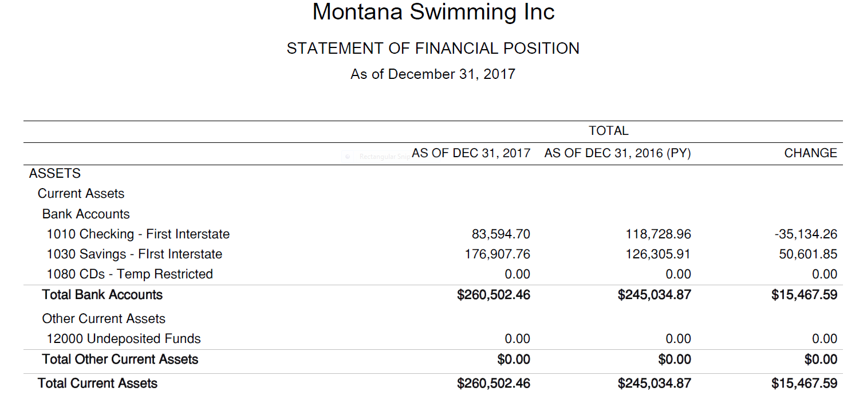

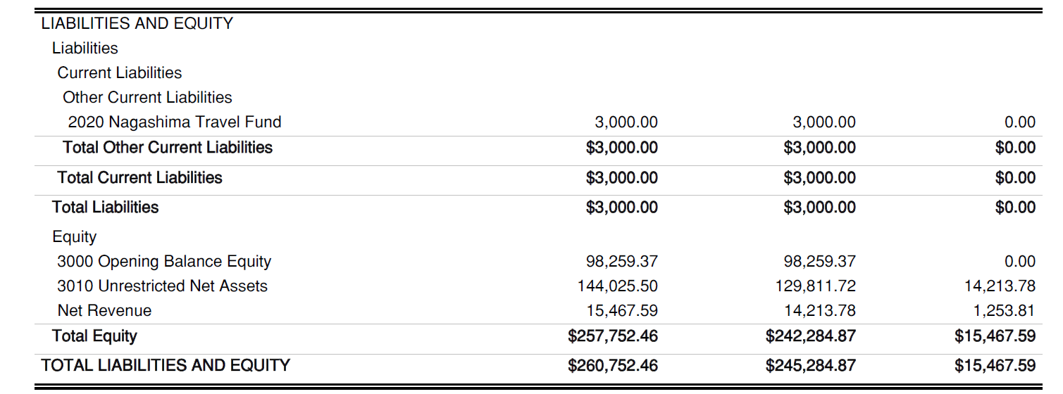

FY 2017 Profit & Loss -- Budget vs Actual Report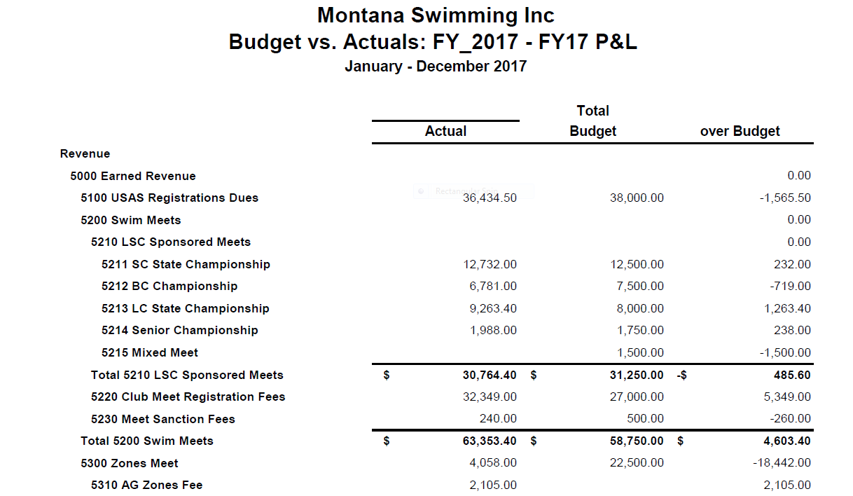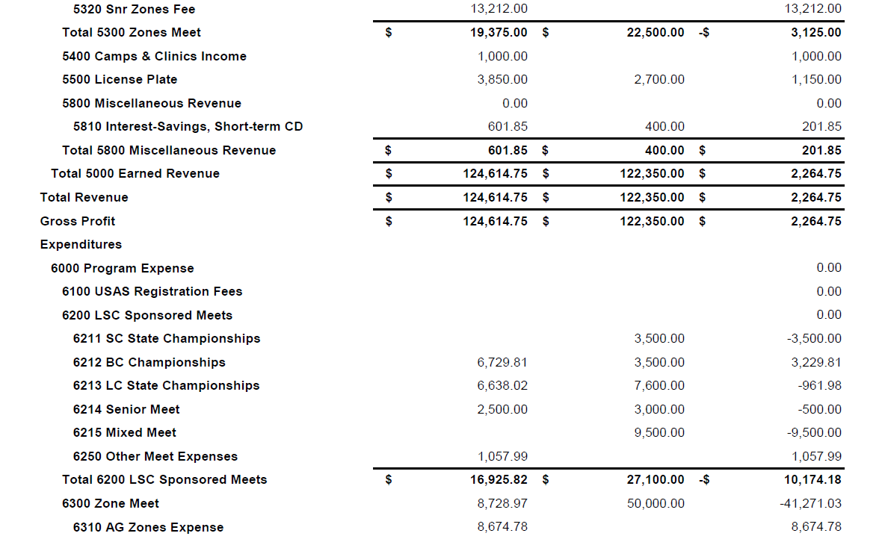
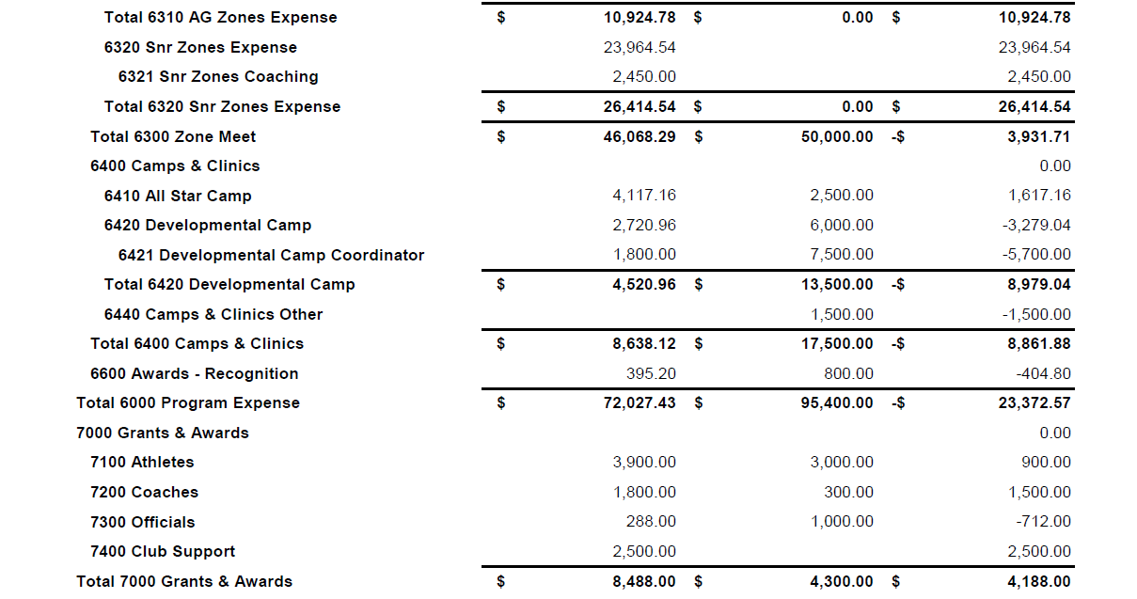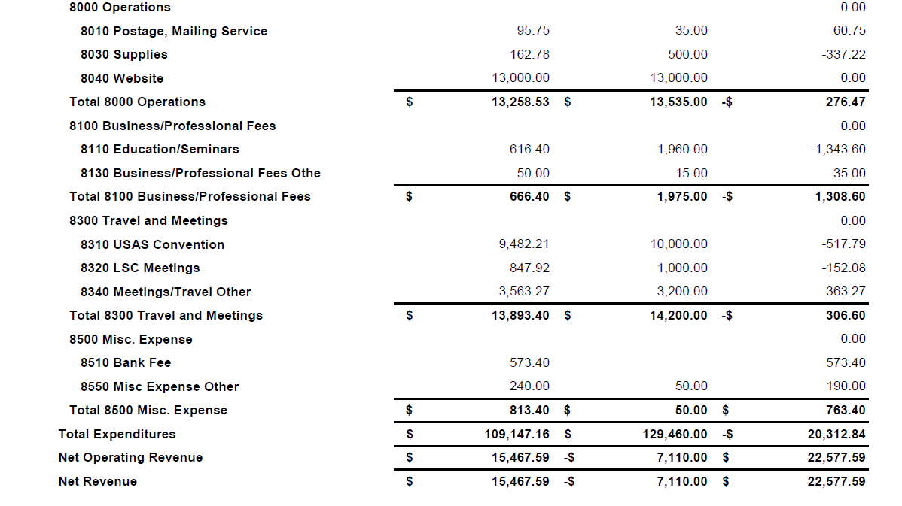

FY 2017 Profit & Loss vs Previous Year
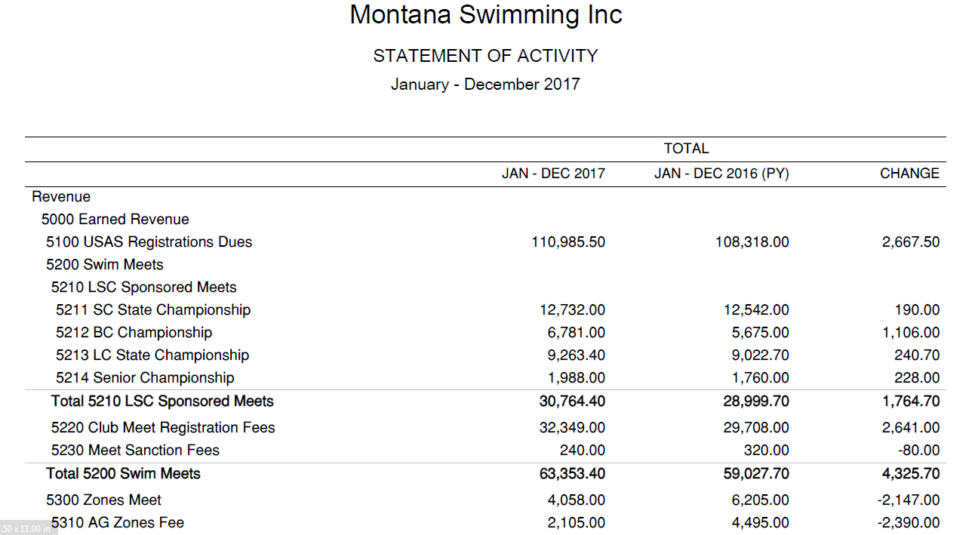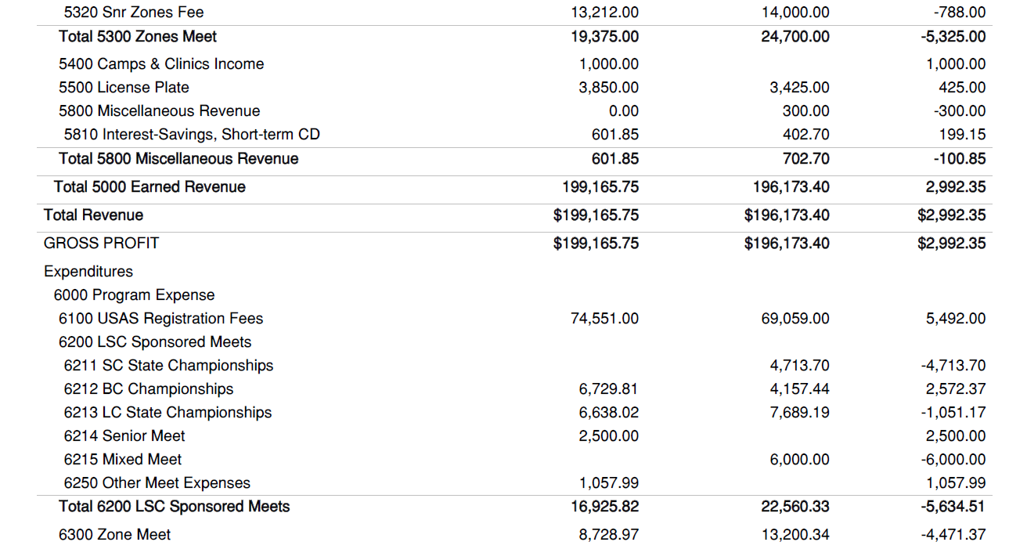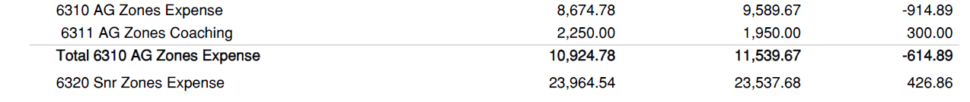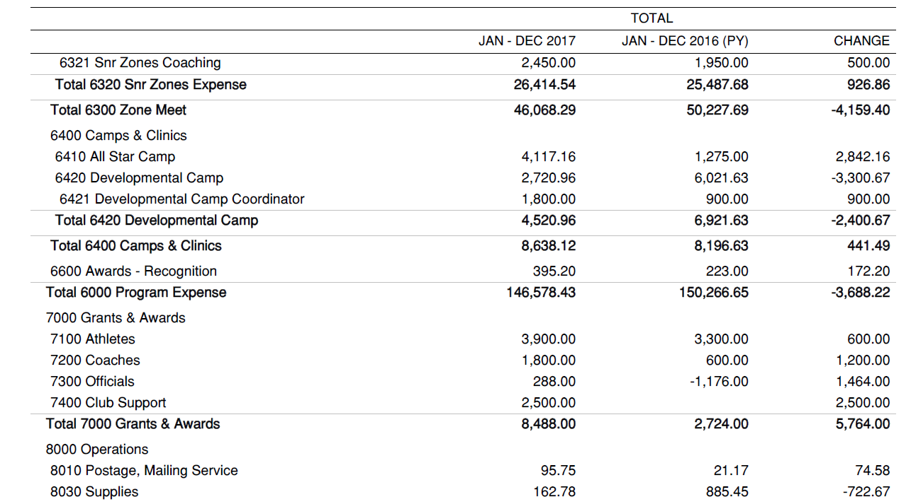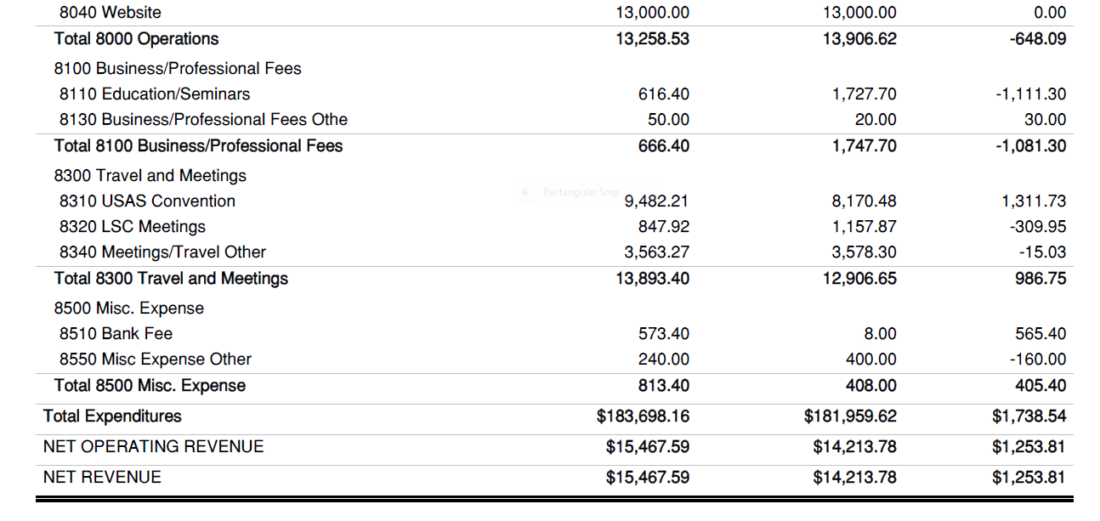

Spring 2018 Montana Swimming General Chair’s Report

The Winter and Spring have been eventful in that MTS has sent representatives to many workshops, meetings, etc. with USA Swimming. These events significantly help our athletes and volunteers become even more valuable to our LSC and shows USAS we are in it for real. I am surprised each year at convention to learn of the LSCs that do not take part in the education and guidance which is continually offered by USAS. I hope in the years to come MTS continues to see the value in participating in these events.
As General Chair I receive emails, at least weekly, that require some knowledge of swimming and some common sense. Some of them are problematic, but many are simply silly. This is the case with the master swimmer who wrote wanting me to overturn his/her DQ in the master’s state championship because he/she had trained for six full weeks and had no idea why the disqualification was called. Sometimes ya just gotta laugh.
I am not sure why, but I also get many emails concerning the Summer Federation League although MTS and USAS have no affiliation with them. Obviously, to many people, swimming is just swimming no matter the governing body.
My biggest rash/bombardment of communications since October, 2017 was the outcry of parents, coaches, and athletes about the “surprise rules” during the State High School meet in Great Falls. Again, this is not my jurisdiction, but I got the calls, texts, emails, and face to face complaints. This concerned me enough that I have asked Merle to try to get H.S. swimming in line with USAS rules and policies in order to make a more uniform system throughout the state.
Our MTS State Championship was held at the Butte Y and this was a meet where our MTS community really pulled together and shined. The Butte Y meet management had a family emergency and many parts of the meet tried to “fall through the cracks”, but volunteers from almost every team stepped up and filled in the blanks, making it a successful meet. The officiating crew did an outstanding job and I must give kudos to Merle, Jim and their CJ crew.
I was reappointed to the USAS Sports Medicine and Science Committee and am working on an age group level sports medicine protocol for meets. This is a longer process than I first thought, but we have some really smart people from across the country working on this and I think it will happen. The idea is to keep our age groupers from injury, so all our teams have a better retention rate and less athletes quitting due to injury.
This will be my last few months as General Chair, so I am actively grooming the likely next candidates. But if anyone is interested in this position please contact me and I’ll tell you the good, the bad, and the ugly of the position.

Dr Tony Popp

2018 Spring Finance Vice Chair Report
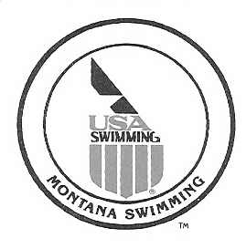

May 18, 2018

Montana Swimming House of Delegates,

I am pleased to present the following summary of Financial Division standing for Fiscal Year 2017 and activities and plans for FY 2018. The financial position of MT Swimming continues to be strong. Please see the following paragraphs for additional details

Finance/Treasury: Financial results for the 2017 calendar year show that revenues exceeded expenses by approximately $15,000. Revenue exceeded the budget estimate by approximately $2,000. As in recent previous years, actual expenses underran compared to budget. Actual expenditures were approximately $20,000 less than budget (~15 percent). A significant portion of the underrun was the lack of spend on approved program(s) – e.g., Mixed Meets. The spending underrun resulted in an increase in MT Swimming’s reserves. We now have approximately $260,000 in cash-equivalent assets. This is approximately 140 percent of our current annual expenditures.

Note that there were significant increases in programmatic spending that resulted from proposals approved at the October 2017 MT Swimming HOD meeting. We need to watch and evaluate the impact of those programmatic costs during 2018 and beyond.

License Plates: Proceeds from sales of the MT Swimming Specialty License Plates continue to increase. Income from license plates for 2017 were $3,850, a 12 percent year-over-year increase.

Budget Planning: The Treasurer and Budget Committee will prepare a draft budget for FY 2019 for presentation and approval at the Fall HOD meeting. I have received interest from several volunteers including both coaches and officials to sit on an ad-hoc committee to evaluate future budget priorities and inform the budgeting process. I’m very interested in adding an athlete to that committee.

Please feel free to contact me if you have questions or require additional information.
Respectfully Submitted,

Matt Yovich
Finance Vice-Chair
Montana Swimming
myovich@woodardcurran.com

2018 Spring Secretary Report

The minutes from the 2017 Spring and Fall HOD meetings were e-mailed out to board members and teams this week for review. Both have been posted on the website and need to be approved at the 2018 Spring HOD meeting. Please let me know if there are any changes or corrections to be made.

Teams, please send me your team contact and team president's e-mail information so I may e-mail minutes and other LSC information to your team.

I am pleased to serve you and assist whenever possible.

Respectfully submitted,

Susan Huckeby
Montana Swimming Secretary
May 11, 2018

2018 Spring IT Webmaster Report

New on the Montana Swimming website now is the College Bound page which can be found under the athletes tab. Please send me the name of your graduating senior, club, high school, and where the athlete will attend college or other plans after graduation to post. If your college plans are currently undecided let me know about any changes and I'll update the page.

Also new is a past meet results page that's still being constructed as I have many years of data to add. It is located under the meets tab and will have a list of the meets, host, location, the meet information, event file and results files. Past meet results can also be found under the meets tab by searching under the past & archived tab.

Also under the athletes tab is information about sports medicine and doping control. The Reach Out grant program is posted under the diversity & disability tab. Other new information is posted in different places on the website as reports and articles are sent to me.

Information about Zones is posted both under the zones tab on the home page and under each specific zone meet under the meets tab.

Over the past year many reports have been posted on the website. I have tried to add news articles of interest to the members of the LSC and keep things up to date. Thank you to everyone for sending me reports, times, and news articles!

As your team contacts change, please e-mail me your updated information so I can update the team listing.

Teams, please send your meet information to me to post once it is sanctioned. Many times teams don't send their warm-up schedules and psych sheets prior to the meet for posting. Also, please send me an unlocked Meet Manager back-up after the meet so I can produce the various results reports to post on the website. If you attend an out of state meet, do send those results to me as well including any Team Manager or Meet Manager files you receive. For teams hosting time trials or dual meets send that information to me also for posting.

Please keep the information, times, suggestions, and stories coming. My e-mail address is shuckeby@msn.com. I love posting stories about the accomplishments of our Montana Swimming members! Thank you.

Respectfully submitted,
Susan Huckeby
Montana Swimming Webmaster/IT Chair
May 10, 2018

Diversity and Inclusion Chair Report 2018 Spring HOD Meeting

I am very pleased to announce that Montana Swimming will be represented by athletes Bennett Apostol (Billings YMCA Seahawks), O'Shay Birdinground (Billings YMCA Seahawks) and Sara Guillen (Bozeman Barracudas) along with Billings YMCA Seahawks Head coach Kristen Wyatt and I at the 2018 Western Zone Diversity and Inclusion Camp at San Diego State University June 14-17. The camp features several national level coaches and a national team athlete who will coach the athletes during the camp. Kristen and I will participate in the WZ Diversity Summit. The athletes will participate in a community outreach event as well as classroom activities, dry land training, and practice.

Montana Swimming awarded the first Reach Out grants in February. The Hardin Otters Swim Team was awarded $1250 for training equipment, scholarships and training fees for outreach and minority swimmers. The Bozeman Multisport Aquatics (Bozeman Brookies) were awarded $1250 for scholarships for low income and minority swimmers. The second round of the Reach Out grants will award $2495 to the Bozeman Multisport Aquatics (Bozeman Brookies) to provide learn to swim camps this summer to area minority and low income swimmers as well as scholarships for low income minority swimmers. BMA held three successful learn to swim camps last summer in Bozeman and hope to reach more children this summer. The grant program awards funding to Montana Swimming teams to provide opportunities for low income/outreach, minority, LGBTQ, and disabled athletes to participate in swimming through such activities as learn to swim camps, scholarships, providing training equipment or swim suits and more. The grant program requirements and applications are posted on the Montana Swimming website under the diversity/disability tab. My thanks to Montana Swimming Finance Vice Chair Matt Yovich (BOZ) and Montana Swimming Senior Athlete Representative Mari Aoki (MAC) for serving on the grant committee. Their input was very valuable! The next round of grant applications will be due in October. The grant application forms will be posted in June.

I attended the 2018 Western Zone workshop in Denver in April and participated in the diversity and inclusion chair track. As a part of that workshop I was asked to present a short talk on what Montana Swimming has accomplished in diversity and inclusion. The presentation was very well received.

USA Swimming asked me to serve as a diversity and inclusion chair mentor this spring. I am paired with another LSC diversity chair in the Western Zone and hope to provide her with support, a listening ear, and encouragement as she provides more diversity and inclusion programming in her LSC.

I also serve on the USA Swimming outreach membership task force. The group is currently looking at ways to include more women and minorities as officials and coaches along with a possible outreach membership for officials and other non-athlete members.

The Montana Swimming website features a tab for diversity and inclusion as well as disability swimming. Numerous resources can be found there.

Information about the Montana Swimming athlete outreach membership policy and more information about outreach membership can be found on the website.

As a member of the Western Zone Diversity and Inclusion committee and the Western Zone Diversity and Inclusion camp committee I have been busy working with the committee members to develop the camp and other diversity and inclusion activities and resources. Information is posted on the Western Zone website. The camp will be excellent with a staff of great coaches and speakers, the location at San Diego State University is beautiful, and the athletes will have the opportunity to participate in a community beach cleanup effort.

If you have question about diversity and inclusion please feel free to contact me.

Respectfully submitted,

Susan Huckeby
Montana Swimming Diversity and Inclusion Chair
May 10, 2018

2018 Spring Technical Planning Report - AAA Camp & Mixer Meet

Update on clinics, Mixer Meet, camps, etc. – Coach Sean Marshall, Technical Planning Chair

HLST Mixer Meet July 27-29th, 2018
Organized and Planned by Coach Kyle Kallin, Head Coach of HLST.
“I was planning on splitting the kids who sign up for the meet into two teams. It would be a dual meet between the two with normal race events. Relays would be made up at the meet by coaches so they could be fun. We have a waterpark night planned for Saturday evening after the meet where the families and swimmers can use the waterpark and we will have food trucks from town in the parking lot. So far that is all I have for the meet.”

Below is the report from the last Mixer meet held by Bozeman along with format, comments, and most importantly a budget breakdown to help Coach Kyle with planning for this year’s event.

April/May 2016 Mixer Meet Report
(From Coach Sobek)
On April 30th and May 1st Montana Swimming held the Third “Mixer Meet” from a recommendation for LSC’s that have a population of less than 2500 to get more interest in the sport.
Basic Format of the Event
We had 103 Register and 94 participating swimmers for the weekend.
7 swimmers represented BTST/BY/PWST/and KATS, all others were BOZ.
There were 59 (63%) girls and 35 boys (37%).
There were 50 swimmers 10 and under (53%) and 44 swimmers 11 and over (47%).
Cost was $30 to participate.
Swimmers 11 & over engaged in 1.5 hours of water time in Saturday morning that was training and social
interactive focused. Swimmers chose a stroke or sprint/middle distance/distance freestyle and got to work with a coach for their lane. Mid-day we did some team building/get to know you activities and relay races and age separated dodgeball games. Just before lunch, swimmers had a 5-10 minute Safe Sport Session with Coach Shelly (LSC Safe Sport Chiar) to review what Safe boundaries are and why we should be aware of them. An afternoon 3 hour swim session was planned for all participants with rotation of skill development and working with multiple coaches, they worked through starts, turns and strokes and had a chance to work with each coach at the event. There was also 45 minutes of game time in which 10 and unders played kickboard tag, and 11 and overs played water polo. There were also snacks, 2 lunches and dinner provided to athletes. Upon Arrival, Swimmers received a Cooler, MT Swimming Logo bumper sticker, and USA Swimming sticker, pencil and Tattoos to promote our sport. Additional lifesaver award and other prizes were also given throughout the event.

Attending Coaches Comments
We had 6 BOZ coaches attend, with no other interest from other MT Coaches-3 emails were sent out to coaches to try to get support for the meet. Each group was about 16-17 swimmers. We also incorporated ways that the kids got to meet each coach during dryland team building sessions. Coaches had a great time interacting with all kids. Saturday’s event ran from 7:15am for 11 and overs and 9:30am for 10 and unders (check-in) to 6:00pm pick-up. Sunday’s meet ran from about 8:00am (warm-ups) to about noon and included pizza lunch at the end. We took the advise from coaches at the first mixer event and let 11 and overs start early, and had 10 and unders start later and that seemed to work much better. Coaches appreciated the older swimmers and their desire to fill leadership roles. Many opportunities were given for older swimmers to fill leadership roles and that was an exciting thing for coaches to see kids develop these skills.
Budget Breakdown:
Income from Meet Fees for event: $8850
MT Swimming paid host $6,000
Meet Fees Collected $2850
Expenses: Total-$6521.47
Participation awards: $2,025.85
Gift Card Awards/prizes: $275
Food (2 lunches, 1 dinner and snacks): $3,149.03
Water Coolers/Dodge balls/items to serve food: $81.59
Payment to Coaches: $990
Remaining Expenses not yet paid and Estimates:
Pool $400
Gym $40
Cafeteria $140
Anticipated Profit to Host Team: $1,748.53
Recommendations: Continue to provide this event for Montana Swimmers in increase the mix of teams
participating. Thank you to Montana Swimming for creating this event, we hope to see it increase in
attendance and more coach participation from other teams.

AAA Camp Info for 2018 Camp
Organized and Planned by Program Development Co-Chairs.

Due to multiple scheduling conflicts in the last couple months with the National Junior Team Camp, Zone Select Camp, Open Water Nationals, Mel Zajac, and the Mesa Grand Prix events Program Development Co-Chair Major Robinson decided to push the AAA camp back to a later date.
Montana Swimming held a successful AAA camp last year (2017) in Bozeman late in the month of May. Last year we paid for the assistant college coach from Wyoming to come up and run the camp assisted by Major Robinson, Mike Turner, and Sean Marshall. The camp consisted of a Friday night thru Sunday Setup with 3 long course practices and various talks and team building activities.

Since last year’s camp was well received and a great way for our Montana Swimmers to bond and train together we do need to plan a camp for 2018. In planning for this year’s camp coach Jay Friend (MAC) & myself have discussed and are willing, with help from the Program Development Co-Chairs, to run a camp in late August or early September (potentially September 1st thru 3rd since the 3rd there is no school due to Labor Day). Either MAC or BAC can host the camp to jump start the short course season for Montana Swimming.
The qualifications for the camp could be multiple (2+) AA cuts or (1) AAA cut swim and the ages for the camp will be 13 & Over to include a larger group. Costs for the camp could hopefully if the Montana Swimming budget allows be limited or even quite possibly covered completely so that the swimmers attending don’t have any extra expenses for their families to incur. More detailed information if this option is agreed upon by the majority of Montana Swimming Teams will be sent out and posted to the Montana Swimming website in early July prior to Long Course State Championships.

2018 Spring Officials Chair Report

April 29, 2018

Montana Swimming House of Delegates,

I would like to report that as of April 29th Montana Swimming had 82 registered officials with only a few currently working on their stroke and turn certification.

We had a very successful short course season that concluded with the 2018 Montana Swimming SC State Championship Meet in Butte February 23-25, 2018 and 2018 Montana Swimming BC Championship Meet in Polson March 10-11, 2018. We had 39 officials that worked the short course meet over the three days. With this many officials working, the meet was run extremely well and the majority of the comments which were made during and after the meet were all positive and, with around 396 swimmers, the meet was completed ahead of the projected time line each day. The meet started on a down side as the finals didn’t have the finalist announced or paraded out to music. We worked with several other teams to get enough volunteers to help make the remainder of the meet run great.
The officials that were given the responsibility to be the leads for the officials at the meet did a great job with the assignment of the deck officials and hopefully will volunteer for those positions in the future not only at Montana Swimming Meets but will work upper level meets.
The 2018 Montana Swimming BC Championship Meet had enough officials to run the meet but there was not much relief for the officials. On both days we only had enough officials to cover the deck without relief but we added in several breaks to slow down the meet and get the officials off the deck for a break. The meet had 136 swimmers and was completed early both days and all comments were positive.

Montana Swimming had several officials who traveled and worked the upper level and should have numerous officials working the upper level meets this summer.

As the 2018 long course season starts, I would like to reinforce the need for all teams to step up and work to recruit new officials as we will continue to lose officials each year and the need for trained officials will grow each year. I would like to ask that we continue to add two officials from each team every year.

In conclusion, I would like to thank all the officials that have worked meets throughout the last year, the officials that have helped me this year and for all their efforts in training and mentoring our new officials. I would encourage all our officials to continue with the training and mentoring of all the officials. We have a great group of officials in our LSC and I know we all learn something at the meets we work.

If anyone has questions or need anything please feel free to contact me.

Respectfully Submitted,

Merle L Gunderson
Montana Swimming Officials Chairman
mtgunders@outlook.com

2018 Spring Scholastic All America Report

As a member of the USA Swimming Scholastic All America subcommittee, I serve as the Western Zone women's tabulator. The committee is busy from late May until early September as we verify the applications submitted. The subcommittee meets every September at the USA Swimming convention to review the previous year's program and make changes to the upcoming year's program.

New this year athletes who have competed their freshman year of high school and meet the other program requirements will be allowed to apply for the USA Swimming Scholastic All America team! In the past the honor was only available for swimmers having completed their sophomore, junior or senior year of high school.

The application process opens on June 1 and close August 15. Swimmers access the application through their USA Swimming Deck Pass account and must upload a complete transcript in either PDF or Jpeg formats. No word documents will be accepted and no report cards will be accepted. Home school students, disabled athletes, and open water swimmers may apply for the program if qualified. The only grades that are accepted are those for academic programs. Athletes with AP, IB, or dual college credit courses will receive an extra 0.5 point in the gpa calculation. Athletes must have a 3.5 gpa or higher in academic subjects (grades lower than a C result in an automatic rejection of the application) and have achieved a 2017 Winter Junior qualifying time with in the qualifying time period or completed in specific open water or disability meets.

Parents, if you will be applying for your child you must log into Deck Pass using your child's log in information to apply for the program.

Over the years more Montana swimmers have qualified for the team and I'm hoping again this year Montana Swimming will have a strong showing. My thanks to the athletes, their coaches, and parents for all your hard work in qualifying for the USA Swimming Scholastic All America program!

If you have any questions, please free to contact me. The program requirements are listed below.
Sincerely,

Susan Huckeby
Western Zone Tabulator
USA Swimming Scholastic All America Subcommittee
May 10, 2018

2017-2018 SCHOLASTIC ALL AMERICA PROGRAM REQUIREMENTS
Application Process open June 1- August 15, 2018
New this year! Athletes who have completed their freshman year of high school may apply for the program!!

2017-2018 ACADEMIC QUALIFICATIONS
- Grade completion requirement – applicant must have completed 9th, 10th 11th or 12th grade
- GPA Requirement – minimum 3.5 GPA for the current academic year
  - A=4, B=3, C=2. If numerical grades are used, the following scale will be used unless the school’s letter grade conversion is given on the transcript: A=90-100; B=80-89; C=70-79. In calculating the GPA no rounding will be used – one decimal place only.
  - Honors, Advanced Placement, International Baccalaureate, and dual credit college level academic courses will earn one half (.5) extra Grade Point. Grades for academic subjects only are calculated – history/social studies, English, mathematics, sciences, foreign languages, computer sciences, visual and performing arts if indicated as academic. A grade lower than a C in an academic subject will mean automatic rejection of the applicant. Grades for non-academic courses will NOT be calculated – art, band, choir, orchestra, health, driver education, physical education, and any other class marked non-academic on a transcript.
  - There will be no special status designation for a 4.0 GPA other than for a national champion who also has a 4.0 GPA.
- Pool Requirements
  - Applicants must have swum an individual pool time equal to a 2017 Winter Junior qualifying time in any individual event during the SAA qualifying period (August 16, 2017 – August 15, 2018) with qualifying times in SWIMS – list of times are posted on the USA Swimming website. A qualifying time will be available for selection from the SWIMS database during the application process. Only ONE time is necessary and only ONE application is necessary.
  - 2017-2018 Qualifying Time Standards
- Disability or Open Water Requirements (for athletes without pool requirements)
  - Applicants must have competed in one of the following meets:
2017 Can-Am Open – December 15-17, 2017, Charlotte, NC
2018 World Para – April 19-21, 2018, Indianapolis, IN
2018 Open Water National Championships – May 11-13, 2018, Tempe, AZ

TO APPLY FOR THE SAA TEAM FOR 2017 2018
Note: You will not be able to access the SAA application without being logged in and linked to the athlete’s Membership account.

To apply:
- Go to the USA Swimming Home Page or any page on the site.
- In the upper right corner, click on “Sign In”.
  - If you do not have an account, click on the link to “create account” and follow the instructions.
- If you have an account, simply type your log in name and your password in the appropriate place.
  - Make sure the account you have signed in with is linked to your (the athlete’s) USA Membership account. (If you are unsure of the link, go to My Account, Membership Information, where you can either link with ‘Click Here’ or Unlink to check the linked membership record and re-link.) You will not be able to access the SAA application without being logged in and linked to the athlete’s Membership account.
- Once you are sure you are correctly linked to your athlete registration, navigate to the SAA Application page (Resources, Browse More, Times, SAA, SAA Requirements, click on link to SAA Application and complete the application. Make sure you SUBMIT the application. If you cannot complete the application, SAVE your work so you can go back again to finish.
  - Once you submit your application, you will receive a confirmation email sent to your Deck Pass log-in email. If you do not receive that confirmation immediately upon submission, PLEASE contact Betty Kooy – blkooy@gmail.com so that we can check the status of your application.
- Your complete high school transcript will need to be uploaded for your application to be complete. All grades for the current year (both semesters 2017-2018) must be on the transcript. You must have completed the 9th, 10th, 11th or 12th grade in order to apply.
  - Note that school transcripts are the only documentation accepted for the Scholastic All America application (PDF or JPG files). Word documents will NOT be accepted. Grade cards and report cards will NOT be accepted. Only grades for the 2017-2018 school year will be used to determine your GPA but a complete transcript is required.
  - When a tabulator has completed evaluation of the materials, you will be notified of either acceptance or rejection via email.

NOTE TO PARENTS
If you are trying to apply for your child, you will have to use his/her log in and password information in order to link to the swim times for your child.
QUESTIONS
- Contact Betty Kooy
- Montana Swimming members may also contact Susan Huckeby (Western Zone women's tabulator).

Montana Swimming Safe Sport Update May 2018

Reminder that ALL NEW COACHES AND VOLUNTEERS must have a background check.

I have been sending out SAFE SPORT MONDAYS scenarios, and encourage every coach to discuss these with your team! Being aware is the first step to keeping team members safe.

I have been trying to send all meet registrars the SAFE SPORT tips to include in the meet programs, and would like to make this an ongoing thing. Will have those tips posted on USA swimming, and any thoughts on how to make this easy to include in each program?

If you have an issue or safety concern regarding swimmers, you may report these online at usaswimming through safe sport tab, or to myself and I will forward your concerns to usa swimming.

The USA Swimming’s Safe Sport Initiative has been growing and doing great things for athletes nation wide! Here are a few ways that your team can be a part of the action to make swimming safe!

- Take the online Safe Sport training. (CLICK HERE) It’s FREE and there is a Parent version and Swimmer Version (Created for swimmers 12 and up), and a Bully prevention course too!
- Take the Safe Sport Self Assessment (Click Here) for your team to see where you need improvement.

“What you permit is what you promote.” Be willing to have candid and respectful conversations that make swimming safe for kids. Here are some examples:
- Ask someone respectfully to put away their phone in the locker room to respect the privacy of others.
- Educate your swimmers why giving coach a hug every day is not the best idea. Coaches WANT to build relationships with your kids, but they are BEST done through hand shakes, high fives, and words of encouragement….doesn’t seem to make sense to you? Follow #1 and watch the online training and you will understand what makes this important!
- Discuss with your swimmer what to do if they feel unsafe—Tell someone!
- Use Safe Sport’s “See something, Hear Something, Say Something” Safe Sport Monday scenarios with your swimmer. CLICK HERE to be directed to the latest Scenarios! There is a new one each month!
- Post signs at your practice facility and during events the following key information. This will help empower kids to make good choices, and know what the expectation is. (Click Here for printable posters)
- NO CELL PHONES in locker rooms
- NO photos allowed behind the blocks
- NO Deck Changing-please use designated changing areas
- Bullying is NOT Tolerated here
- Team Communication should always be positive and appropriate.
- Teach kids that they need to create a positive online footprint for their future. Remind them that what they post becomes a part of their lives.
- Encourage kids to let you know if they feel unsafe. Help them pick 5 adults they can trust if they feel unsafe or need someone to talk to. Use their hand as a visual to help them remember the 5 people that are safe. Remind them if they get an “uh oh” or gut feeling, they should tell someone what is going on.
- Questions? Here are some important Safe Sport Names and Contact Info:
  - Montana Swimming Safe Sport Coordinator: Janel McCormick 406-360-8304, nellybean@aol.com
  - USA Swimming Support:
    - Online form for reporting: Click Here
    - Liz Hoendervoogt (Assistant to the Director) ehoendervoogt@usaswimming.org or
    - Maggie Vail (educational services) mvail@usaswimming.org

USA Swimming has a new Safe Sport Activity Book available, a good way for coaches and parents to talk to young swimmers about safety.
- Be sure your team is up to date on the following policies. CLICK HERE to be directed to USA Swimming’s policies as your template for your team’s policy.

    - Communication Policy
    - Travel Policies
    - Anti-Bullying
    - Photography
    - Locker Room Monitoring Policy
    - Coaches should follow “USA Swimming Best Practices”

Meeting Handouts:

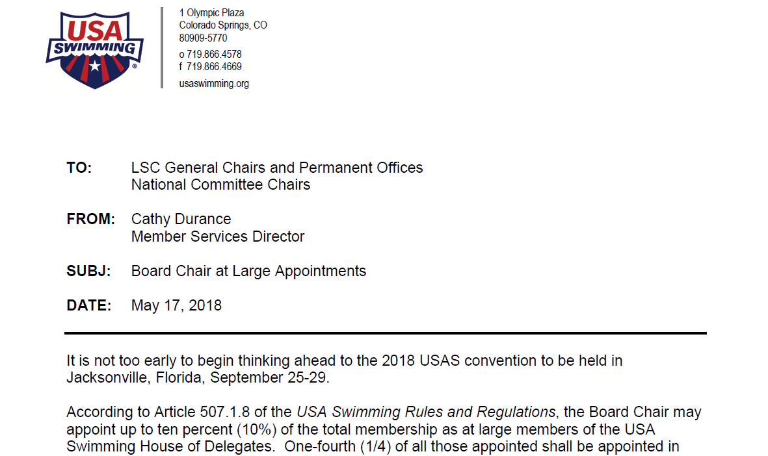
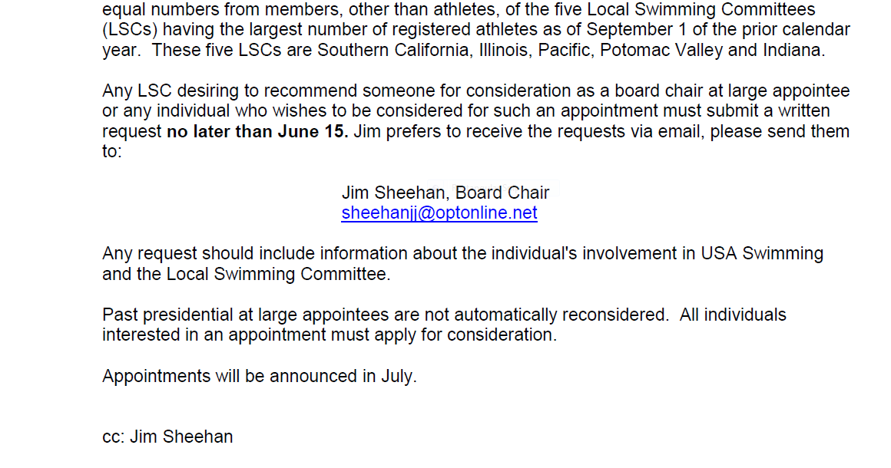

My Bright Idea

The Bridge Club

"The Bridge Club" meaning bridging the gap between the ages over water.
My idea is to have the age group swimmers reach out to the elderly people who do not usually get out and bring them to the pool. This might be a once or twice per month activity where instead of just sitting around playing bridge they get activity and interaction with the younger athletes in the water.
I picture the swimmers identifying the people needing attention then going to their home and asking them to come swim with them. "don't be afraid grandma, I'll help you"
The logo could be a young USAS swimmer reaching across the top of the water to the outstretched hand of a senior - forming a bridge across the water and across the ages.
This has many advantages including:
Community service
The elderly will love it
The young athletes will gain a better appreciation of older folks
It will bring attention to the good our athletes are capable of

Submitted by:
Mrs. Toni Popp

Montana Swimming – Guidelines for Submitting Proposals
Amended May 2018
Big Sky, Big Dreams, Big Success!

Proposals to amend, replace, or change MTS Policies & Procedures Manual shall be submitted to the MTS General Chair per the following guidelines:
- Note the deadline for submitting your proposal – Usually August 1st
- State your proposal clearly in a sentence or two
Proposal for Fall HOD 2018: I propose MTS provide pie and ice cream to officials and coaches at every championship meet.
- State your reason/rational for making the proposal
Rational: Officials and coaches need energy to perform their duties during meets as they often get very little breaks and spend serious time on the hard, hot pool deck. Homemade pie contains love and appreciation and ice cream just has to go with pie. The sugar contained in each (although cancer and other inflammatory disease causing) will help keep the officials and coaches amped up, so they can better conduct their duties of raising their hand or clicking their stop watches.
- State the section (if any) of the Policies/Procedure Manual which will be replaced
This will replace section XYZ.765-39 of the Policies and Procedure Manual providing greasy pizza to officials and coaches at championship meets
- State any other sections of the P&P which may be affected
This proposal will also affect section ABC.987 of the P&P manual requiring officials to wear white polo shirts
- State when you would like this proposal to go in to effect
This proposal should go in to effect beginning all MTS championship meets after State SC, 2021.
- State if you are willing to accept suggestions to amend your proposal
I am not willing to accept suggestions to amend this proposal. OR I will attend the Fall HOD meeting and may accept suggestions to amend this proposal.
- State your name, team, position held in MTS, date submitted
Respectfully submitted Dr Mickey Mouse, Super Duper Swim Team, USAS Official, 7/17/2020

If you submit a proposal, but do not attend the meeting, the proposal will be voted on as submitted without option of amending.
If these guidelines are not followed the executive board has the option to disqualify the proposal. The author will be notified of the missing section(s).

Meeting Attendance Sign-In Sheets:

