Deck Assignments

Meet: __________ _

Day: _________ __________ Session: ________ __________

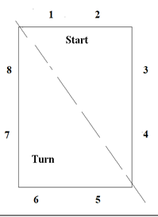
Deck Referees: 1. ______________________

2. ________________________
3._________________________
Starters: 1. _________________________ 2. _________________________
3._________________________
Chief Judge: 1. _________________________
2._________________________
AO: 3. _________________________

Stroke and Turn Judges

Start End Turn End

1. 5.______________________________
2. 6.______________________________
3. 7.______________________________
4._________________________ 8.______________________________
a. a.______________________________
b. b.______________________________
c. c.______________________________
d. d.______________________________

