WRITTEN PERMISSION FOR AN UNRELATED APPLICABLE ADULT TO PROVIDE LOCAL TRANSPORTATION TO MINOR ATHLETE

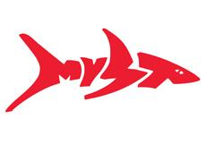
MISSOULA YMCA SWIM TEAM

I, , legal guardian of , a minor athlete, give express written permission, and grant an exception to the Minor Athlete Abuse Prevention Policy for , an unrelated Applicable Adult to provide local vehicle transportation to (minor athlete) to (destination) on (date(s))
at (approximate time), and further acknowledge that this written permission is valid only for the transportation on the specified date and to the specified location.

Legal Guardian Signature:
Date:

