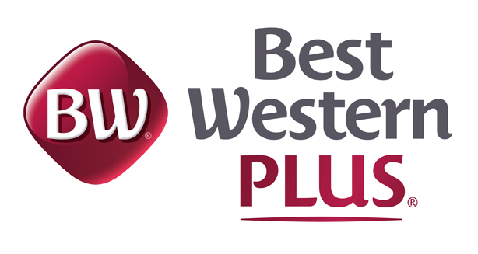
255 Montclair Drive Kalispell MT 59901
406-255-5255

Team Accountability Agreement

We are pleased to have been selected as the host hotel for the MISSOULA MYST SWIM TEAM. Most Athletes, Coaches, Chaperones and Parents understand the need for responsible behavior while staying in a hotel. Therefore, for the comfort and safety of all our guests, we have instituted the following policies:
- The guest signing for each room(s) will be the person responsible for that room’s actions.
- Please conduct yourself as ladies and gentlemen. Proper dress is required in all common areas of the hotel.
- Please refrain from congregating in the halls, lobby and walkways. Please remember we have other guests in the hotel that are not part of your group.
- When departing or returning to the hotel, please do so in a mannerly and quiet fashion.
- An Adult is required to always be with Minors in the hotel public areas, including pool and hallways.
- Coaches, Parents and Chaperones are responsible for the team member’s actions.
- The use of any athletic equipment is prohibited while inside the hotel. Any equipment seen being used will be confiscated by our staff.
- Pulling fire alarms is a felony offense and will not be permitted.
- Loud, obscene or boisterous behavior will not be tolerated and will result in only one warning.
- A curfew of 10:00 pm is in effect – please reduce your sound levels (talking, televisions, radios, etc.) to a low level at that time for the remainder of the night.
- If anyone in your party should cause the hotel to have to refund another guest's charges due to excessive noise, we will add these charges to your stay.
- No alcohol or food of any kind will be allowed in pool area for any reason, no guests under 18 allowed in pool area without adult supervision. This is a state and local health code.
We know that the vast majority of our guests realize that these rules are for everyone’s benefit, including their own. However, in the event that any person(s) or registered guest found NOT in compliance with any of the above rules, they will be subject to immediate eviction from the hotel by management or security.
___Kim Carson____________________11/14/2025__________
Hotel Representative Signature Date
_________________________________
Guest Signature Date

