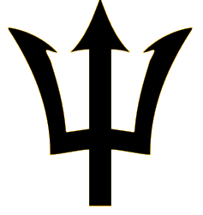
NEPTUNES
HEALTH CARE PROVIDER ONE-ON-ONE INTERACTION
PERMISSION FORM

I, ___________________________________, legal guardian of _______________________________, a minor athlete, give express written permission, and grant an exception to the Minor Athlete Abuse Prevention Policy for __________________________________, a mental health care professional and/or health care provider, to have a one-on-one interaction with
______________________________ (minor athlete) in conjunction with participation in the sport of swimming on ____________ (date) from ______________ am/pm to _______________ am/pm.

I acknowledge that this one-on-one interaction may be a closed-door meeting, provided that the door remains unlocked; another adult is present at the facility; and the other adult at the facility is advised that a closed-door meeting is occurring. I further acknowledge that this written permission is valid only for the dates and location specified herein.
Legal Guardian
Signature: ______________________________________
Date: _________________

