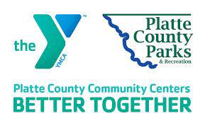
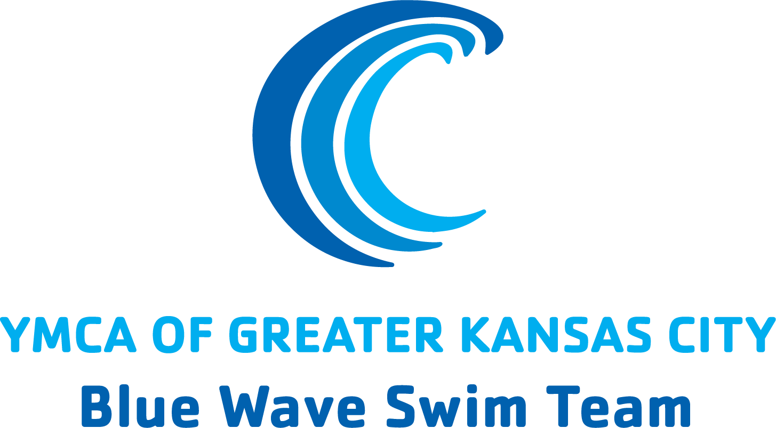

Dear [NAME],

On Friday, November 15, 2024, I will be participating in a Swim-a-Thon to raise funds for the YMCA of Greater Kansas City Blue Wave Swim Team

What’s a Swim-a-Thon? A Swim-a-Thon is a really fun way to combine something I love – Swimming – with a wonderful cause! Together with my teammates, I will commit to swimming for either 2 hours or up to 200 lengths of the pool. I am asking for the support of my friends and family to either make a flat donation to support my effort, or to pledge a certain amount of money per length. I’ve been training hard, and I’m going to do all 200 lengths!

You might be wondering why I’m committed to spending my Saturday swimming laps at the pool. For me, this is a great opportunity to give back to a sport that I love. Swimming has given me a lot – it has taught me skills like hard work, time management, and perseverance. The money I raise will support crucial programs for my swim team, and will allow us to continue working hard for the coming season.

I hope that I can count on you to help me achieve my fundraising goal for my upcoming Swim-a-Thon. Please consider mailing back a donation in the enclosed envelope, or donate directly online at [TeamUnify URL HERE]. to include "For [Swimmers First & Last Name] BWST Swim-A-Thon" in the Gift Notes Section and to select "Blue Wave Swim Team" as the Y Location/Program.

On behalf of myself and my team, thank you. Your support will give me the energy I need to complete my 200 laps, and it will truly make a difference!

Thanks again,
[Swimmers]

