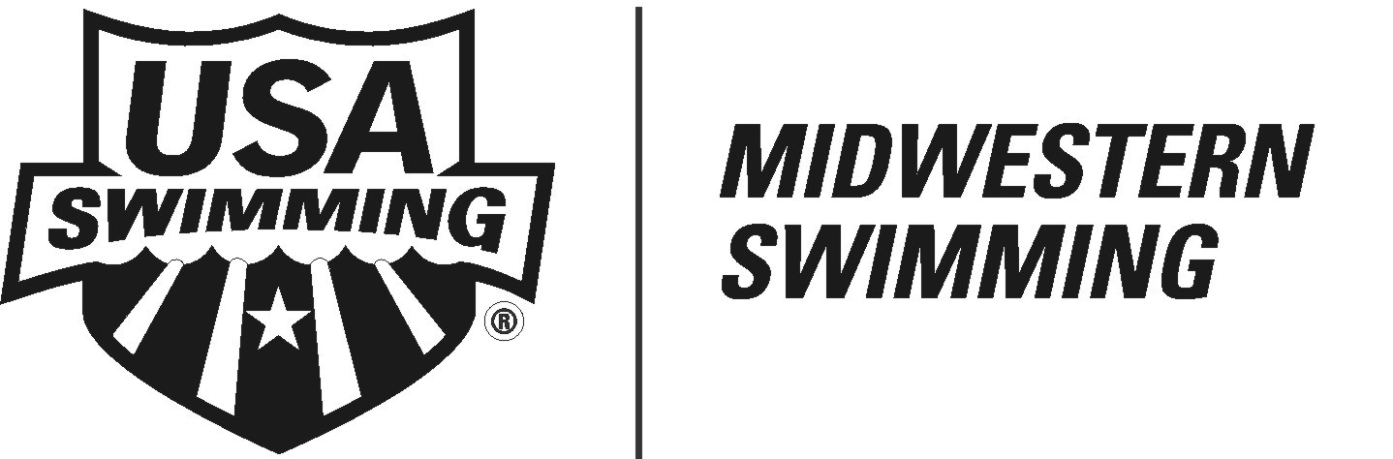
Midwestern Annual Celebration Banquet

Date: | Sunday, October 5, 2014
Time: | 3:00 p.m. Social; 3:30 Speaker, 4:45 p.m. Dinner; 5:45 p.m. Awards
Location: | Country Inn and Suites, 5353 N 27th St Lincoln NE (Exit 403 on I-80)
Cost: | $15.00/adults; $10.00 /12 & U
Menu: | All America Buffet to include:
 | Hamburgers, Hot Dogs, condiments, baked beans, pasta salad, potato chips and brownies

Reservation Form
Family Name |  | Adult Attendees (First Names) |  | 12 & U Attendees (First Names)
 |  |  |  | Total Cost

Day Phone
Evening Phone
Email

Complete document (you can type on the lines and save the document). Please email the document to the Midwestern Office – mwoffice@mwswim.org .
Also, please PRINT the document and MAIL with full payment to arrive by Tuesday, OCTOBER 1, 2014.
Betty Kooy
Midwestern Swimming
1429 N Webster Ave
Hastings NE 68901
(402) 462-5941
mwoffice@mwswim.org

