School Entry Information for Pool Clubs

Lincoln High
Enter Door #29 on the south side.

East
Enter through DOOR 12, which is the north side of the athletic concourse. To get to the pool or wrestling room: turn LEFT at the hallway by the clock and across from the concession stand. Go all the way to the end, and turn left. The pool is on the left, the wrestling room is on the far right.

Northeast
Enter door #38 which is located off of north 63rd street. As you enter you will see the pool on the right from the swim hallway.

Southeast
Enter door #9 – go straight ahead and down the stairs by the North Gym to the pool.

North Star
Use door #3 location for outside groups to enter the building.
Please drop off or park in the student parking lot down by the new aviation wing (East side of the building).
The custodial staff will have door 3 unlocked for you as well as the other doors leading to the pool.

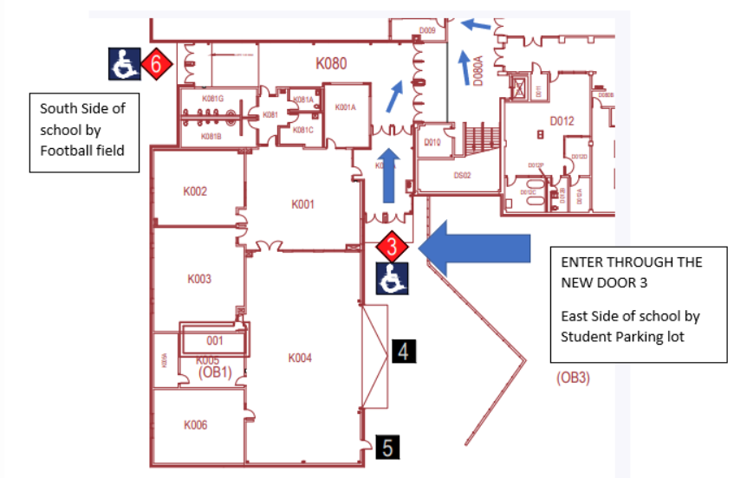

Southwest
Enter Door #3 on the SW corner of the building. Pool is just inside to your left.

Lincoln Northwest
Enter Door #18 on the south side of the building. Walk down the hall and proceed down the stairs to your left. You will see the entrance to the pool in the corner to your left marked "Natatorium."

Standing Bear
Enter door #18 located on the west side of the building. Proceed down the first hallway and take the left stairwell down to the lower level. The doors to the pool will be on your left-hand side. Once you enter the Natatorium doors, you will find the locker rooms available for use.

