You will find athlete protection training courses in the education navigation in your SWIMS account. Login in at www.usaswimming.org.
- Click on “Education”
- Click on “Course catalog”
- Click on the “All Courses” tab to the left.
- Select “Athlete Protection Training”
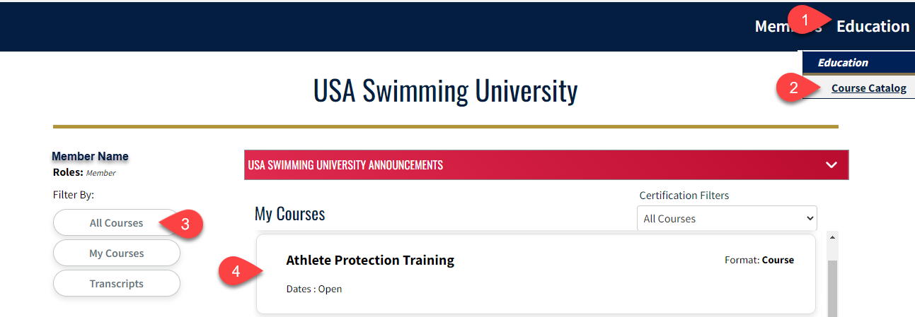
You will need to allow pop-ups in your browser for this course to work.

Please submit a help desk ticket if there is not an option for you to select “Athlete Protection Training” or you have any questions,

