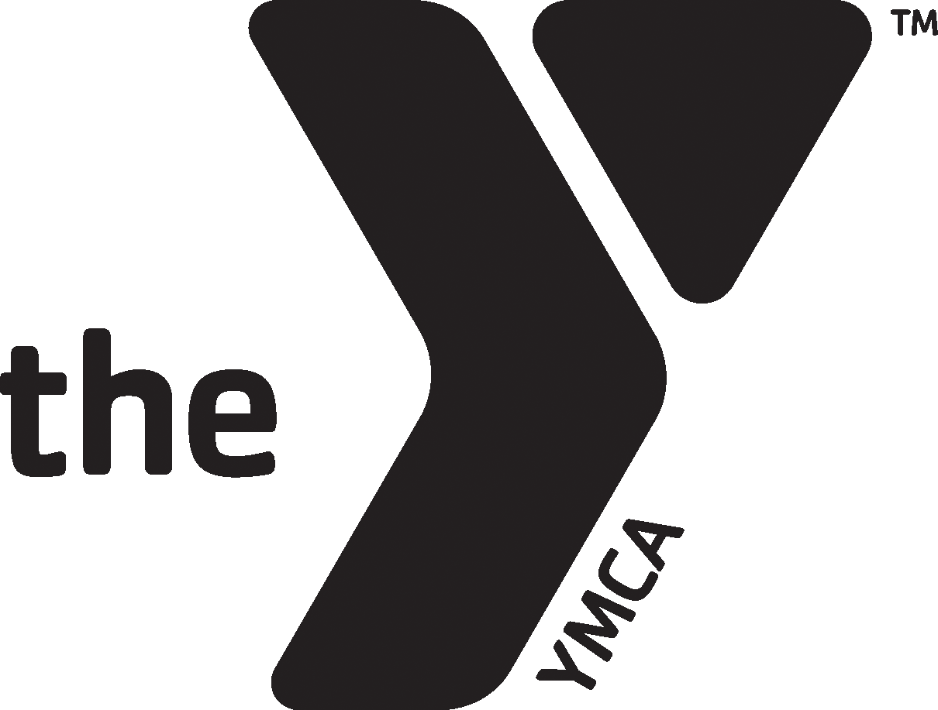
MetroWest YMCA Stingrays 2022-2023 Medical Release and Waiver

Swimmer’s First Name Middle Last Name Gender

Street Address Town Date of Birth

State Zip Code Home Phone

Parent/guardian First and Last Name Cell Phone E-mail Address

Parent/guardian First and Last Name Cell Phone E-mail Address

Emergency Contact: Phone Number: Relationship:_______ ____

Emergency Contact: Phone number Relationship: __________

Medical Release
I hereby give permission for the above-named athlete to be medically administered to in case of emergency: and, I will be responsible for any and all charges incurred for prompt medical treatment.

_______________
Parent/Guardian Name (print) Signature Date

Mandatory YMCA Waiver
I understand that the MetroWest YMCA assumes no responsibility for injuries or illnesses which may sustain as a result of my physical condition or resulting from my participation in any athletic activities, sports programs, the use of any equipment, exercise or other activities. I expressly acknowledge on behalf of myself and my heirs that I assume the risk for any and all injuries and illnesses which may result from participation in these activities. I hereby release and discharge the MetroWest YMCA, its agents, servants, and employees from any and all claims for injury, illness, death, loss or damage which I may suffer as a result of my participation in these activities. I understand that the MetroWest YMCA is not responsible for personal property lost or stolen while members and/or program participants are using YMCA facilities on YMCA premises. I give permission for the MetroWest YMCA to take photographs/video of myself/my child while involved in the daily activities of the YMCA programs or special events. I understand that these photographs/video may be used for media purposes or in MetroWest YMCA videos, newsletters, brochures, website or other promotional vehicles. I acknowledge the WAIVER set forth above.

_____ __________________________
Parent/Guardian Name (print) Signature Date

