MOR SPEEDO SWIMSUIT POLICY

Speedo Endurance | Speedo Aquablade | Speedo LZR Pro | Speedo LZR  Valor | Speedo LZR Intent
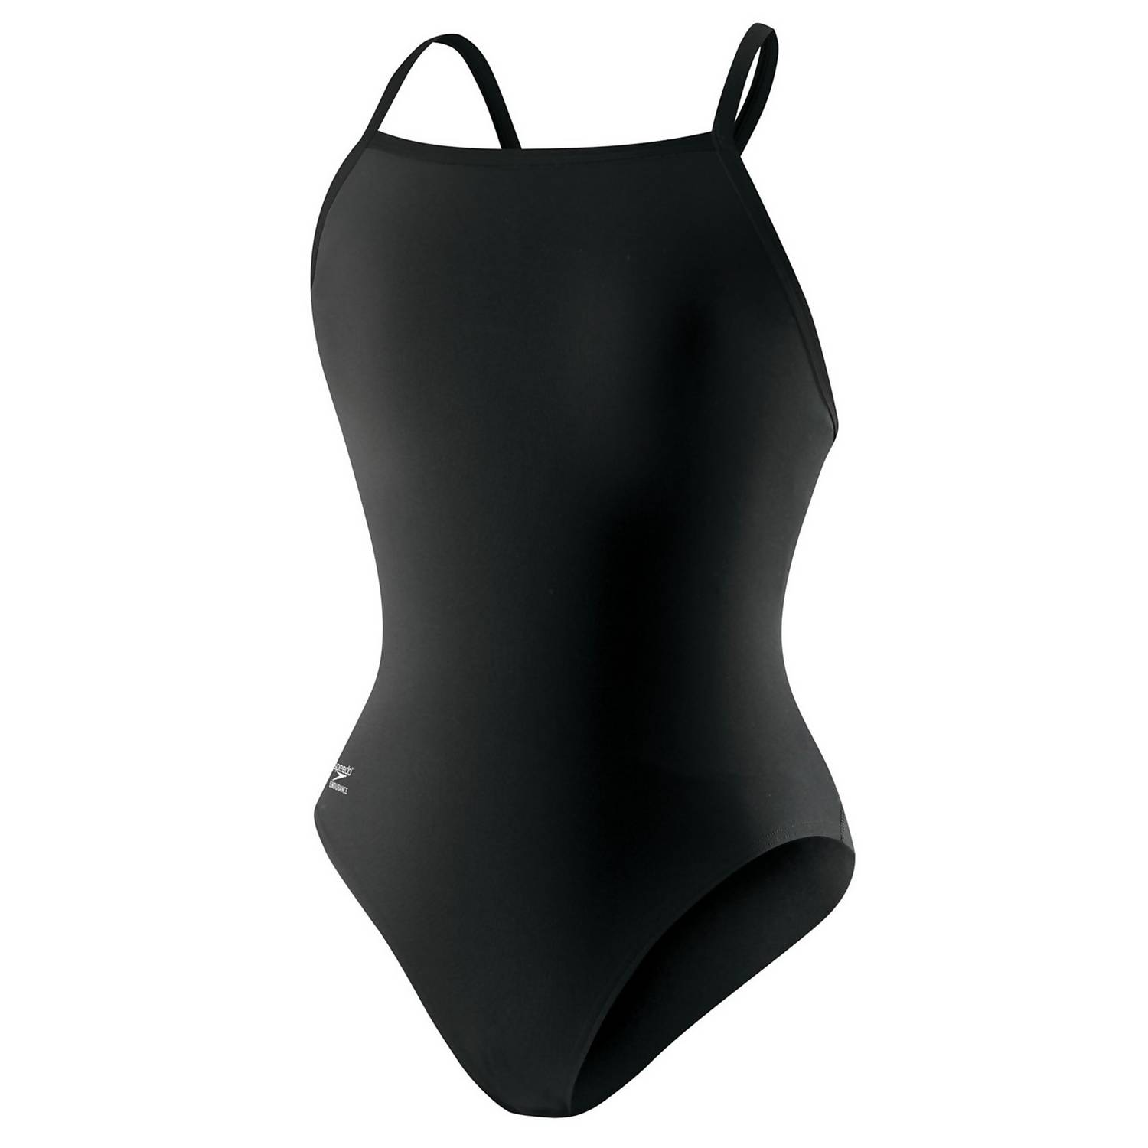  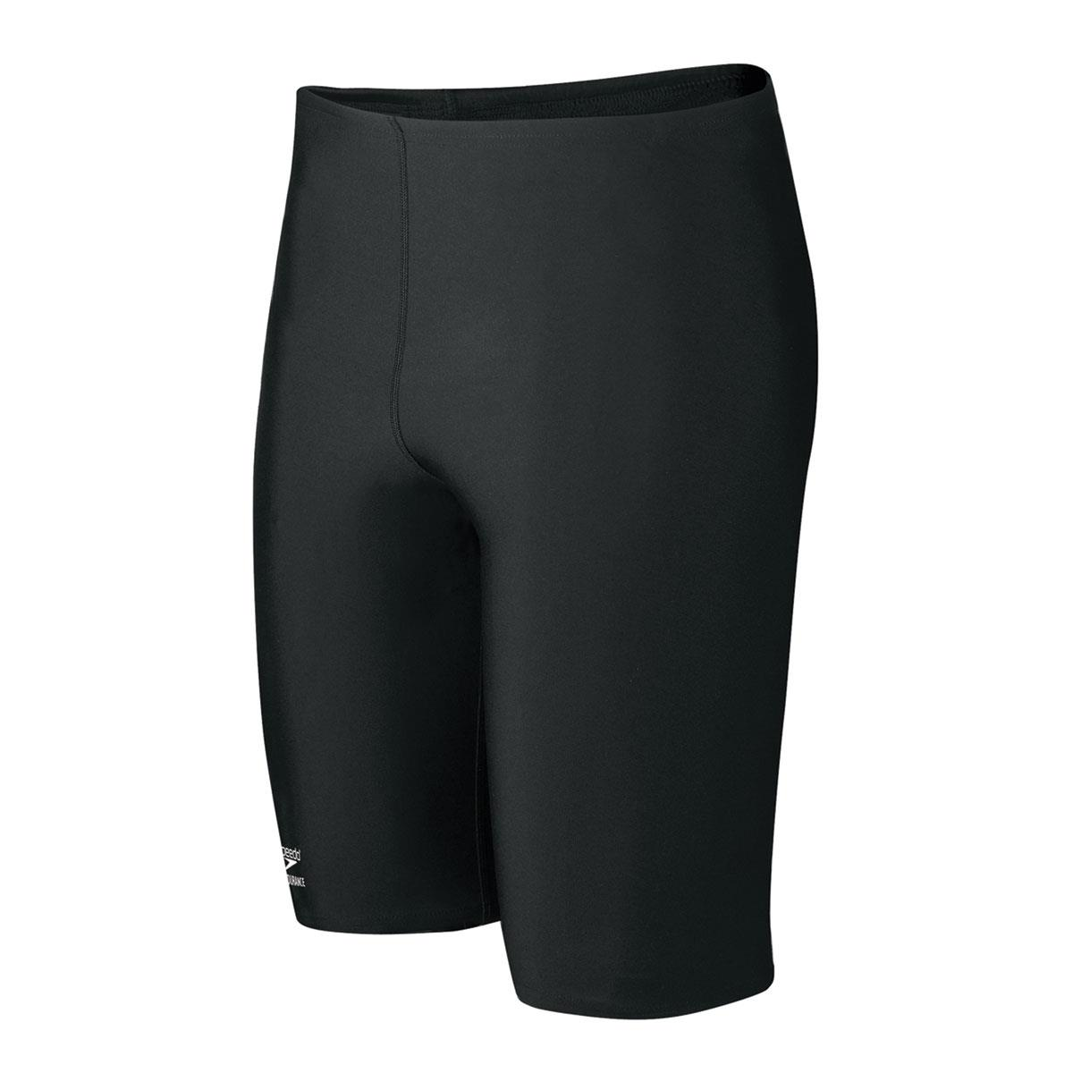 | 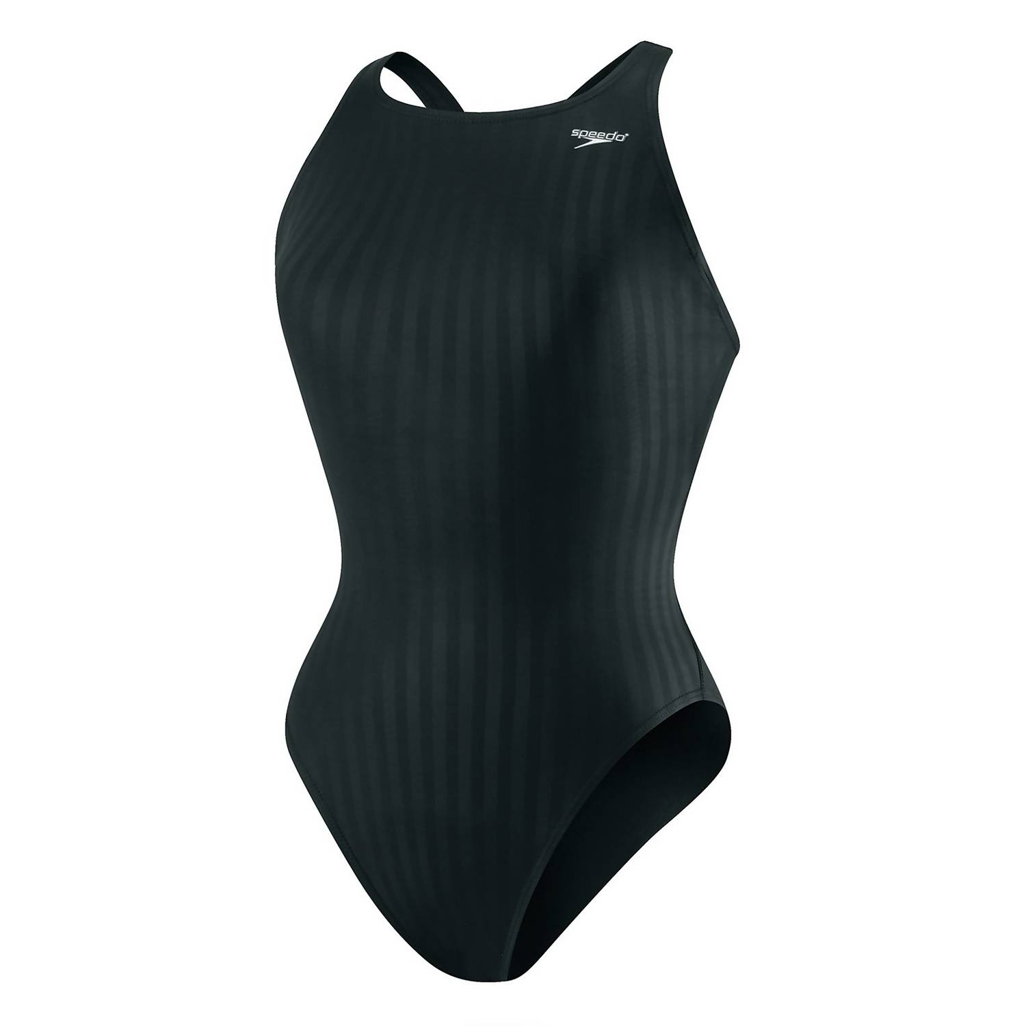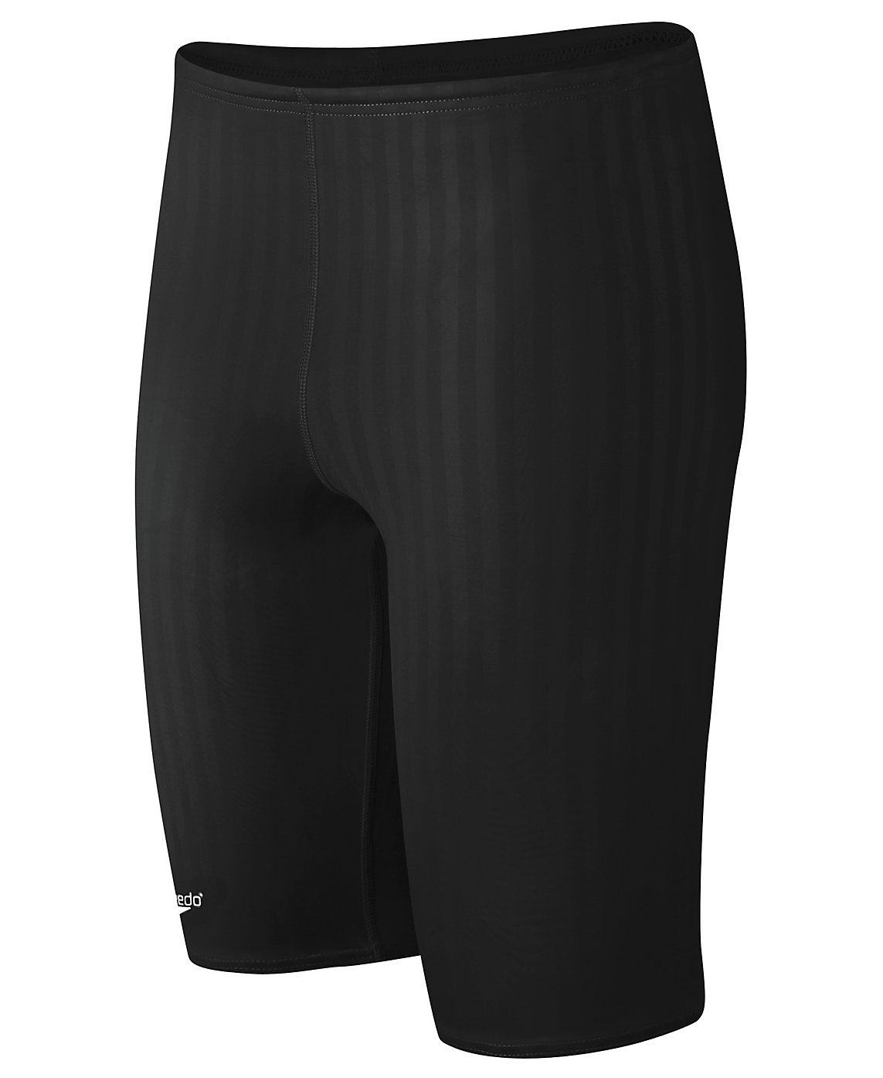 | 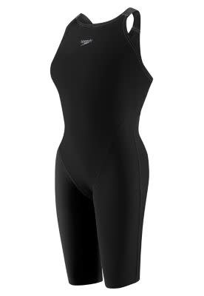  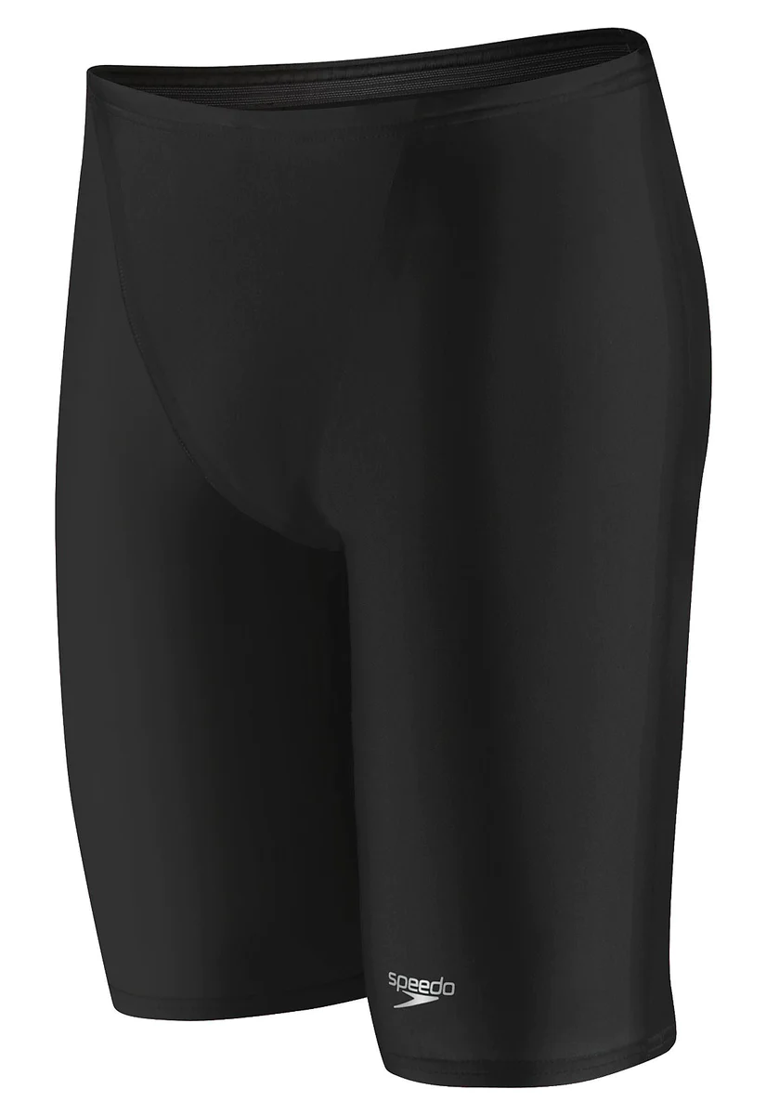 | 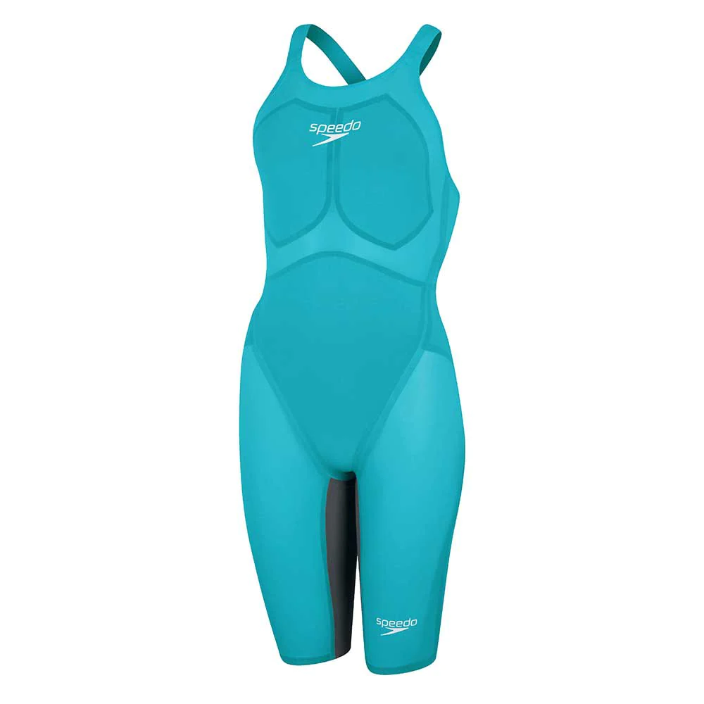  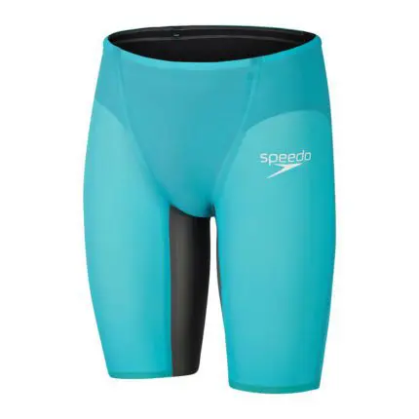 | 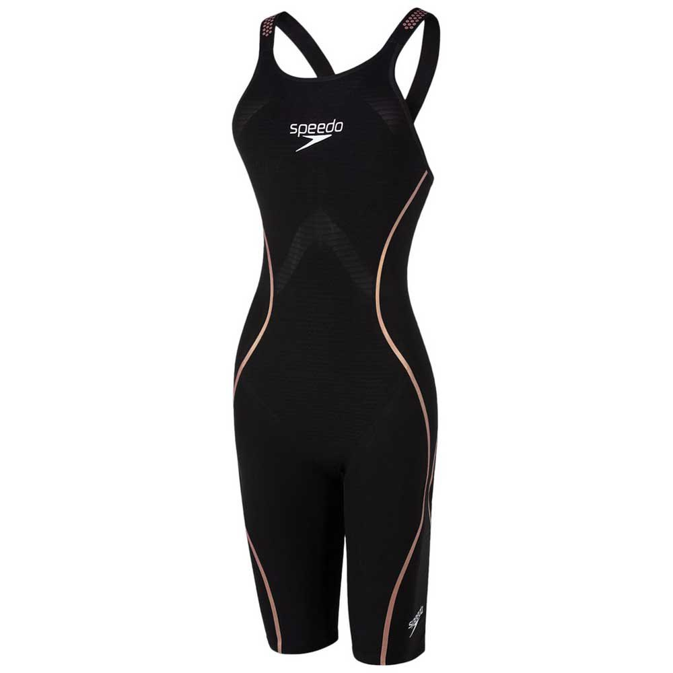  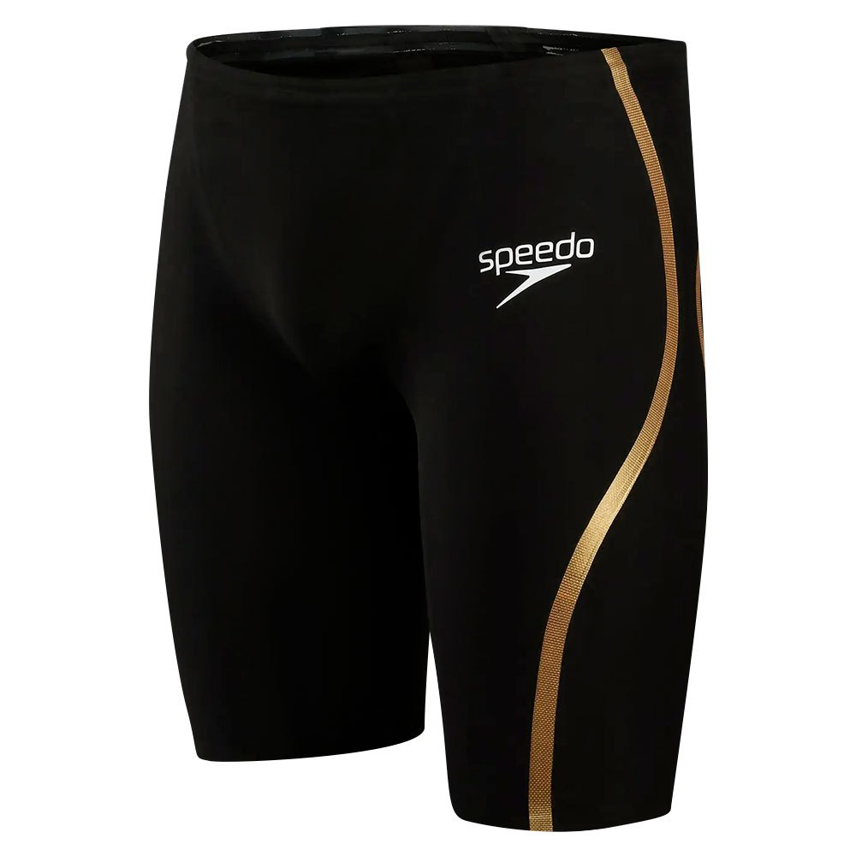
Who should wear:
-All 8-U, 10-U  -11-12, 13-14 in non-championship meets or state championship meets  -15-18 in non-championship meets | -11-12 in State Championship meets and above  -13-14 in state championship meets and above | -13-14 competing at 14-U JO’s, Sr. Champs or Sr. Sectionals or AG Sectionals  -15-Over competing in Sr. Champs, Sr. Sectionals, Futures, Jr. Nationals, Sr. National | - Swimmers competing at US Futures, NCSA Jrs., Nationals or Jr. Nationals, Sr. Nationals. | -Swimmers competing at US Sr. Nationals, Olympic Trials

- MOR’s Suit policy is designed to provide a progression of suits as the swimmer moves up the competitive levels allowing them to focus on technique and proper training. Please adhere to this policy that MOR has posted.

- Cost of Tech Suit Note: The Cost of High Tech swimsuits has become a part of the cost of swimming since 2008 for elite 13-Over. Buying 2-4 LZR Racer Pro Suits per year is a cost of swimming for many elite 13-O. If you have any questions, contact Coach Silver.

