Hockomock Area YMCA
(HAY Lightning) Swim Team
Handbook

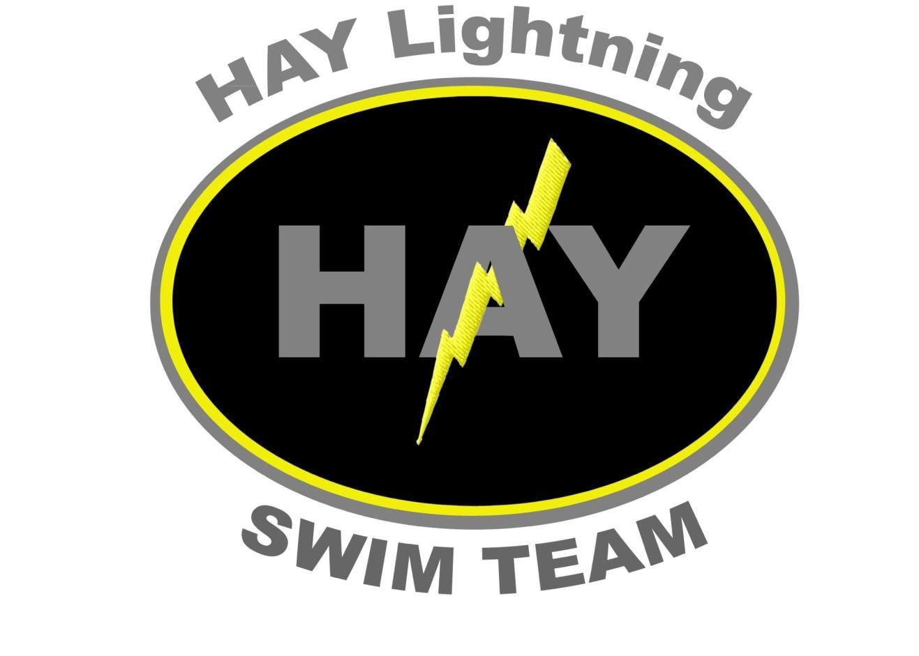

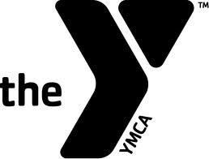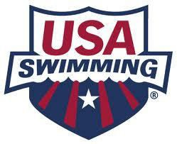

Updated 3.21.2024
Table of Contents

I Team Statements
- Mission Statement
- Vision Statement
- Objectives
II Team Structure
- Governing Bodies
- Seasons
- Tryouts
- Coaches
- Practice Groups
- USA Safe Sport
III Team Policies
- Anti-bullying
- Behaviour
- Grievance
- Locker Room
- Massage
- Minor Athlete Abuse Prevention
- Photography
- Social Media
- Travel
- Volunteer Commitment
IV Swim Meets
- Types of Meet
- Registration
- Expectation
V Booster Club

I Team Statements
- Mission Statement

The Hockomock Area YMCA is a not-for-profit charitable community service organization of men, women, and children of all ages, ethnic origins, religious affiliations and socioeconomic levels united in a common effort to positively influence the quality of life of its members, families, and community. Based on the foundation of Judeo-Christian values, our programs and activities emphasize the development of the whole person in spirit, mind, and body and are available to all individuals regardless of their ability to pay.

- Vision Statement
The vision of the Hockomock Area YMCA Lightning Swim Team (HAY Lightning) is to provide a competitive swimming program that allows all interested swimmers to develop their abilities in an environment that stresses the overall growth of the individual in a way that is consistent with the YMCA values and principles. HAY Lightning will follow the Hockomock Area YMCA's Child Safety Absolutes. HAY Lightning provides a program that meets the diverse needs of the beginners to nationally ranked swimmers. Our program is designed not only to facilitate each swimmer's development, but to provide an orderly progression from one level to the next. HAY Lightning offers a year round opportunity for competitive swimming in both YMCA and USA Swimming as well as seasonal clinics for aspiring competitive athletes. HAY is comprised of girls and boys from age 6 through high school.

- Objectives
The major objective is to offer a fun and challenging program that will aid the swimmer in developing a blueprint to succeed in and out of the pool. HAY Lightning coaching staff stress the importance of individual self-improvement as each swimmers’ primary goal. Training in stroke techniques, speed and endurance are customized to each practice group to help achieve their goals. All swimmers will train in all four competitive strokes and should get and remain in good physical and mental shape. We are aiming for a year-round program that caters to all levels and want each swimmer to learn the value of hard work, sportsmanship, respect, how to work with others and commitment to themselves as well as a group.
In addition to helping each swimmer attain their own personal goals, the program stresses the team concept. Each swimmer is a member of the HAY Lightning Swim Team and with that carries the responsibility, loyalty and dedication to each of the team members. Mutual support during training and competition are assets that attribute to a successful program. Parental support and involvement with the team as well as within the Hockomock Area YMCA community is highly encouraged and is a major incentive for many swimmers at all levels of competitive swimming
HAY Lightning wants to develop a lifelong love of the sport of swimming whether that be for lap swimming, open water swimming or into college and coaches will be happy to advise how to work on the swimmer’s goals for the future.
II Team Structure
- Governing Bodies
HAY Lighting competes as a member of both the YMCA Eastern Massachusetts League (EMASS) and USA Swimming.

At most YMCA meets, the age group the swimmer competes in is determined by the child’s age as of December 1st of that season. For USA swimming meets, the swimmer competes in the age group of his/her actual age on the first day of each meet.
- Seasons
HAY Lightning offers a competitive swim program on a year-round basis. The Short Course season runs September through March. Competitive meets take place in a 25-yard pool. The Long Course Season is April through July. Most competitive meets are held in a 50-meter pool, although we still practice at the Hockomock Area YMCA’s pools.
- Tryouts
For new swimmers interested in joining HAY Lightning tryouts are conducted at the beginning of each season, approximately one month prior to the start of practice. Dates and Times are posted on the team website as well as on Hockomock Area YMCA’s website.
- Coaches
All of our coaches, whether full-time, part-time or working on a voluntary basis are expected to display Caring, Honesty, Respect and Responsibility towards their swimmers, parents and fellow coaches.
- Practice Groups
Swimmers should only attend their assigned practice groups. If an extenuating circumstance arises, please contact the Head Coach.

Silver: Designed for athletes who are working on developing team skills while focusing on gaining legal strokes.

Black: Designed for athletes who have 4 legal strokes. Swimmers at this level are expected to attend at least one day of each meet offered as well as year-round participation. These swimmers are working to apply corrections quickly.

Junior: Designed for athletes aged 12 and under who are working on attending all meets, all practices and have their own goals

Senior: Designed for athletes aged 13 & up who participate in four to five practices a week, attend drylands and attend all sessions available to them at every meet, they are expected to participate year-round.

- USA Swim Safe Sport
The USA Swimming Safe Sport Program raises awareness about misconduct in our sport, promotes open dialogue, and provides training and resources. When we work as a team, we can build a plan to make swimming safe for everyone.
If you have any immediate concerns that you wish to raise to the team please contact Heather Plumb, Team Admin and Safe Sport Coordinator at Haylightning@hockymca.org

SAFE SPORT DOCS\BEST PRACTICE GUIDELINES FOR SAFE SPORT.docx

III Team Policies
- Anti-bullying
Bullying of any kind is unacceptable at HAY Lightning Swim Team (the “Club”) and will not be tolerated. Bullying is counterproductive to team spirit and can be devastating to a victim. The Club is committed to providing a safe, caring and friendly environment for all of our members. If bullying does occur, all athletes and parents should know that incidents will be dealt with promptly and effectively. Anyone who knows that bullying is happening is expected to tell a coach, board member or athlete/mentor.
SAFE SPORT DOCS\anti bullying policy.docx
- Behaviour
As with all YMCA programs, the HAY Lightning Swim Team emphasizes the Core Values of Caring, Honesty, Respect and Responsibility. The behavior of our swimmers, coaches and parents at practices and at meets should exemplify these values.

All Swimmers and parents will electronically sign a code of conduct at the start of each season. ..\SAFE SPORT DOCS\TEAM & parents CODE OF CONDUCT.docx

There will be NO WARNINGS. FAILURE TO COMPLY WITH TEAM RULES WILL RESULT IN A SUSPENSION FROM THE TEAM. To return to the team, the swimmer must set an appointment with the coaches. This meeting MUST be attended by a parent or guardian.
- Grievance
Should a parent or swimmer feel another swimmer, coach, parent or any individual working on behalf of the team displays conduct inappropriate or in violation of any Code of Conduct, the parent/swimmer should discuss these concerns with the appropriate person as listed in the policy document.
SAFE SPORT DOCS\GRIEVANCE POLICY 2023.docx
- Locker Room
..\SAFE SPORT DOCS\Locker Room Policy 2.docx
- Massage
..\SAFE SPORT DOCS\MAAPP Massage.docx
- Minor Athlete Abuse Prevention
Our YMCAs commitment to the protection of children is at the forefront of all that we do. We are proud that USA Swimming is also taking steps to help in this effort. Effective immediately, our YMCA swim team will be adopting an additional policy from USA Swimming that will continue to help in our efforts to protect the children we serve.
Please click sections you are interested in for further details and permission forms as required.
Hockomock Area YMCA Minor Athlete Abuse Prevention USA
Travel to Competition
Permission to provide Local Transport
Adult Sharing Same Hotel Room
Health Care Provider Permission
Massage Provider Permission
Adult Athlete Training Requirements
- Photography
..\SAFE SPORT DOCS\Photography policy.docx

Photography Withdrawal of Consent Form
HAY Lightning Swim Team may wish to take photographs (individual and in groups) of swimmers under the age of 18 that may include your child during their membership in the club. All photos will be taken and published in line with club policy.
As the parent/caregiver of ___________________________________________________ I withdraw my consent to the following:
Taking photographs to use on the club’s website 
Taking photographs to include with newspaper articles
Taking photographs to use on club notice boards
Video for training purposes only

Signed: ________________________________________________________

Dated:

Please return this form to the swim team administrator at HAYlightning@Hockymca.org at the start of the season.

- Social Media
..\SAFE SPORT DOCS\SOCIAL MEDIA AND ELECTRONIC COMMUNICATIONS POLICY.pdf
- Travel
..\SAFE SPORT DOCS\MAAPP Travel to Competition.docx
- Volunteer Commitment
Each registered family is required to volunteer 8 hours between February and January. (Swim meets, fundraisers, club activities...) Families who do not meet their obligation will be charged $10.00/hour not worked at the end of January. We would ask that all parents meet the required hours as your time is more valuable to us than your money
Why is swim parent volunteering different than other club sports in town?
Volunteer support by our club parents is critical to the overall success of the club. As with many club organizations parent volunteers are needed for a variety of activities. Unlike some of the other club sports in town, we do not need parents as coach volunteers. Our coaches are paid and well qualified to help the swimmers reach their goals and full potential and most importantly have fun in the water! However, we do need parent volunteers to help support a variety of fundraising activities that support the club.

IV Swim Meets
HAY Lightning usually attends anywhere from 6 to 8 meets during each season and the coaching staff will select those meets for the team to enter. Swimmers are expected to attend each meet offered, for the silver and black practice groups it is expected they will attend one day and for junior and senior groups it is expected they will attend every session offered.

For most meets’ swimmers select the events they wish to swim however for Championship meets coaches reserve the right to amend any entries made. All swimmers at championship meets will swim the maximum number of events they have qualified to swim.

- Types of Meet
YMCA Meets

The YMCA EMASS League has 5 divisions consisting of approximately 30 teams located in Eastern Massachusetts. HAY Lightning is a Division I team. Each YMCA team has a boys and girls’ team competing in five different classes of swimmers. Class is determined by the age of the swimmer on December 1.

Class E | - 8 and Under
Class D | - 9-10
Class C | - 11-12
Class B | - 13-14
Class A | - 15-18

YMCA Invitational Meets

The team will attend YMCA Invitational meets. These meets are hosted by a YMCA and last 2-3 days. Swimmers can usually swim 3-5 individual events per day. The hosting team charges an entry fee for each event, as well as a fee per splash (race). These entry fees are paid by the swimmer as soon as the team admin submits the entry to the host team.

YMCA Championship Meets

EMASS District Championships are held in late-January/February for all swimmers who attain a qualifying time. These times MUST be attained at Y Meets. To swim at Districts you must have swam 1 YMCA meet.

New England Championships are the next level of YMCA championships and are held in March. The qualifying times for this meet are significantly faster than those for the District meet, and you must have swam at 2 YMCA meets to enter.

The highest level of YMCA Competition is the YMCA National Championship held each spring. The qualifying times for this meet are significantly faster than those for the District meet, and you must have swam at 3 YMCA meets to enter.

USA Swim Meets

USA Swimming is the largest swim organization in the world. It is the governing body for competitive swimming in the United States. New England Swimming, Inc. is the regional division of USA Swimming.

USA meets are held on weekends and can sometimes include Thursday or Friday night events. The meets we attend are usually within an hour drive of the Hockomock area (i.e. Seekonk High School, Wheaton College, Framingham Technical High School) but can be as far away as the University of New Hampshire. At USA meets, a swimmer can usually swim up to 5 events per day. Because of this, USA meets give the swimmers the opportunity to swim events that they might not be able to swim at a YMCA meet. Like YMCA meets, swimmers would be competing against other swimmers of the same age and sex. But unlike YMCA meets, swimmers are placed in heats according to their times and therefore are racing against swimmers of comparable ability.

USA Championships

As with YMCA swimming, there are different levels of USA Championships available at the end of the season. Qualifying times, dates and locations will be made available as soon as they have been determined and can be found on the HAY Lightning website

Regional Championships are held in February for all swimmers who attain a qualifying time. These times can be attained at USA Meets only.

Age Groups Championships are the next level of USA championships and are held in February/March. The qualifying times for this meet are significantly faster than those for the Regionals meet.

Sunkissed Championships In late March or early April, HAY Lightning travels to Charlotte, NC. To attend this meet, swimmers must be at least 10 years old and have attained the qualifying times. Once a swimmer has qualified for an event the coaches ask that notification be given on intentions to attend within 3 days. Most of the expenses of this trip are paid by the swimmer’s family, if this would exclude your swimmer from attending, please reach out to team admin.

Meets not supported by HAY Lightning:

At the start of each season the Head Coach determines which meets we will attend and which we decline. All meets are selected to give our swimmers the best opportunity to swim, develop their skills and perform at their highest level. We do not permit our swimmers to attend meets not selected for our calendar. The only exceptions to this rule are the possibility of a swimmer attending a Zones meet; any swimmer who qualifies to attend Zones should discuss this opportunity with the Head Coach; swimmers who are also swimming for their High School should also discuss this with the Head Coach.
- Registration
Swim Team Admin will notify all families via email when each meet is available for registration, in that email will be details of the deadline for registration.
In order to register, families will need to log into their team unify accounts and click on the meet. Once there, families can decide on the days or sessions they wish to attend. For most meets swimmers and families are able to select the events to swim, for swimmers new to the team they may wish to speak with the Head Coach for guidance for the first two meets.
Once the meet file has been submitted to the host team by the team admin no changes can be made.
- Expectation
It is imperative that swimmers arrive on time for warm-up. Swimmers who are not checked in with the coaching staff on deck WILL be scratched from the day’s events. All times are sent to families and listed on the meet page.
If you are aware that you are no longer able to swim it is expected that you will email team admin or use the Remind App on the day to notify the Head Coach.
Try your best and swim hard it is ok to be nervous, many swimmers have pre-race jitters; After your race see a member of the coaching staff for feedback; Sit with the team; Swimmers should ensure that they have plenty of healthy snacks and water to keep them fueled during the meet; Support and encourage your teammates; Swimmers should remain until the end of the meet session; Wear HAY Lightning uniform at all meets. Caps and Suits from other teams are not permitted
For all meets, only parents who are timing or officiating are permitted to be on the pool deck. This is a standard regulation for all swim meets, and breaking this regulation could result in the removal of the swimmer and parent from the meet and/or fines.

V Booster Club

The Booster Club is a volunteer organization of parents who assist with various functions in order to support HAY Lightning. All parents on the team are automatically part of the Booster Club and the fees paid at the start of Short Course season are used to finance social activities such as cook-outs, pizza parties, pasta dinners and the end-of-season awards night as well as the purchase of equipment needed to enhance the swim team program.
The Booster Club meets on a monthly basis and all parents are encouraged to attend the meetings to give their input.

The Booster Club cannot support the team without the cooperation and commitment from every family. As volunteers are needed, parents will be contacted via e-mail noting the particular needs for the upcoming meet or event.

