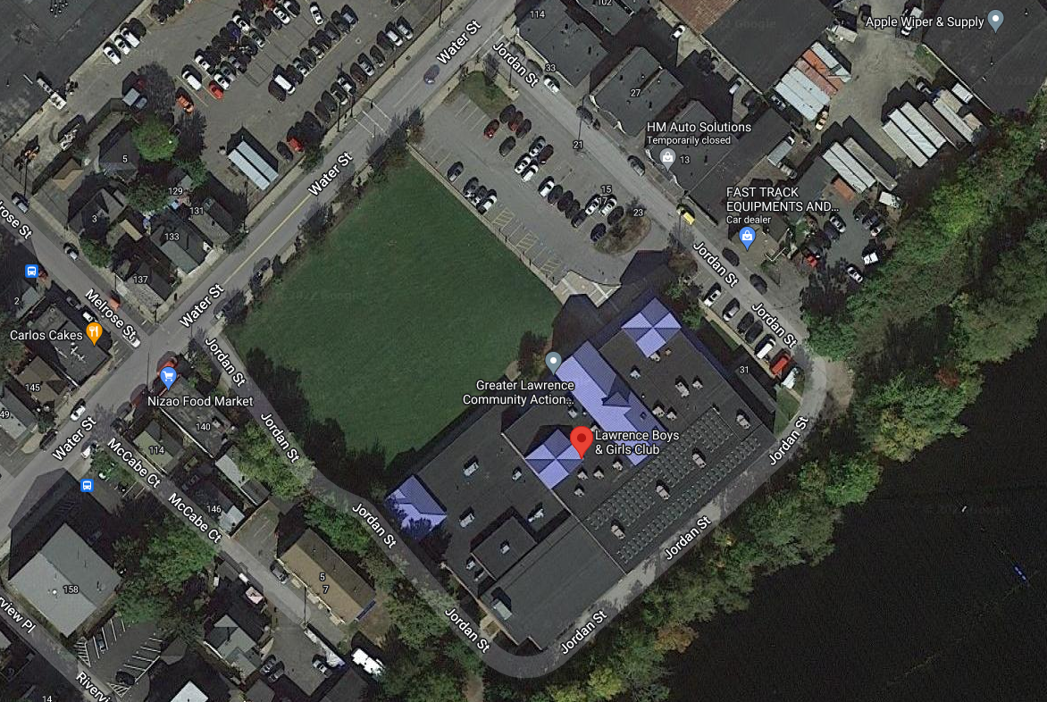

- The Roadway around the Lawrence Boys and Girls club is a one-way system as seen using the Green Arrows.
- The Blue Stars are where Coaches, Officials and Timers are allowed to park on site. NO OTHER PARKING is allowed. Swimmers MUST be dropped off for this meet
- The Lawrence Boys and Girls club is not affiliated with this meet. Please DO NOT Call the club about the meet, they will not know anything. Also please do not enter any part of the club outside of the designated areas.
- All swimmers, coaches, officials and timers should enter the pool from the back door. Either the door to the pool or the doors to the large gym will be open for entry. This area is marked with a SMILEY FACE. All the areas marked with the are DO NOT ENTER or DO NOT PARK areas.
- As a Reminder there is NO Onsite parking for anyone not at the meet. This means anyone not coaching, timing or officiating should not park in or around the meet. Timelines will be attached for reference to pick up swimmers. Also, when picking up swimmers please do not block any roadways or park near the pickup doors to allow traffic to flow.

