WRITTEN ACKNOWLEDGEMENT OF POLICY

HAMILTON Y AQUATIC CLUB
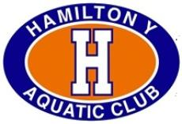

I acknowledge that I have received, read and understood the Minor Athlete Abuse Prevention Policy and/or that the Policy has been explained to me or my family. I further acknowledge and understand that agreeing to comply with the contents of this Policy is a condition of my membership with Hamilton Y Aquatic Club

Name: ______
Signature:
Date: ______

