TO CREATE A PARENT LOGIN USERNAME/PASSWORD

In a new browser click on the link below:

PTAC OMR Registration Link

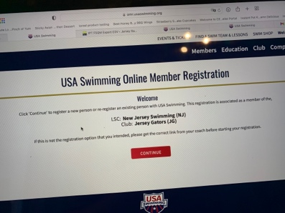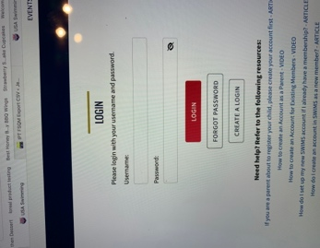
Click “create a login”
Click “continue”

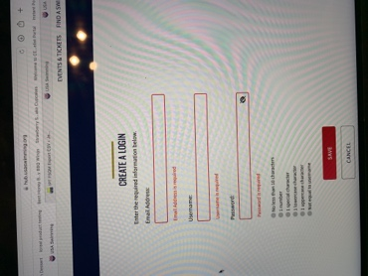
Fill in Email address
Username
Password

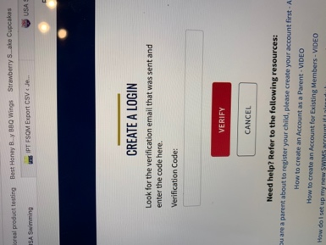
Enter the verification code that was sent to your email
Click “verify”

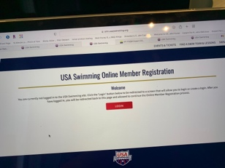
Click “login”

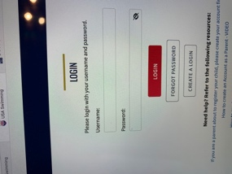
Enter: Username
Password
Click “Login”

Click “no”
Click “Yes” if you are an official or coach
Do not read the resources at the bottom
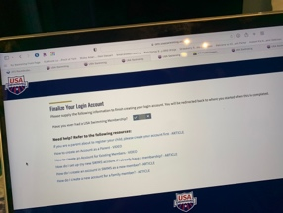

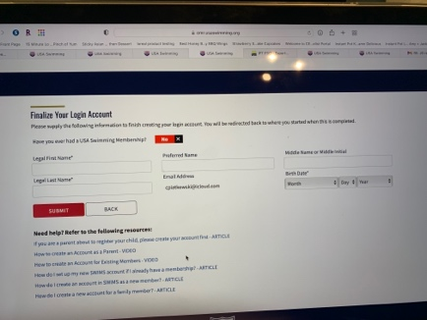
Enter: First name
Last name
Birthday
Click “submit”

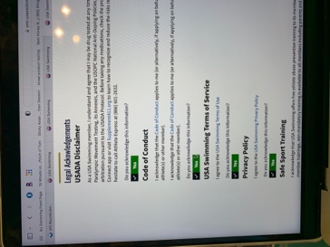
Click “yes” or “no” to each
Click “Continue”

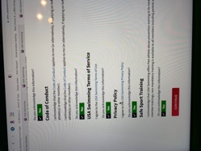
Enter: your signature
Click “sign the document”
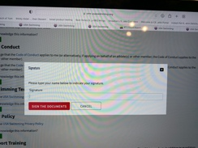

USE A – to register a returning swimmer
USE B – to register a NEW SWIMMER

- To register a returning swimmer:

In a new browser click on the link below:

PTAC OMR Registration Link

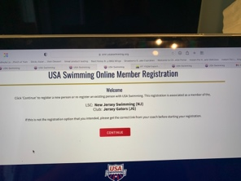
Click “continue”

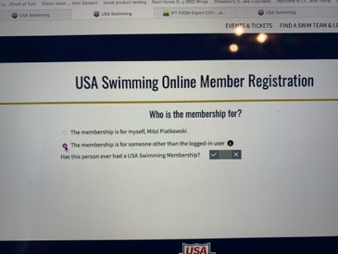
Click “this membership is for someone other than the logged in user”
Click “yes” to register a RETURNING swimmer

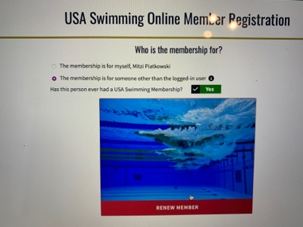
Click “renew member”

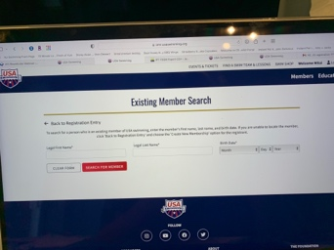
Enter: Legal first name
Legal last name
Birthday
Click “continue”

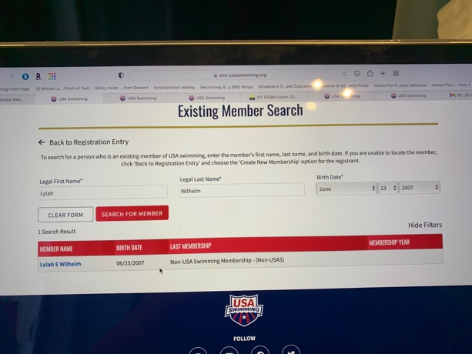
Click on the members’ name

Click in the little box on the premium athlete row
Click “continue
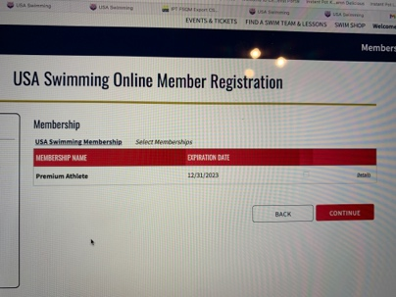

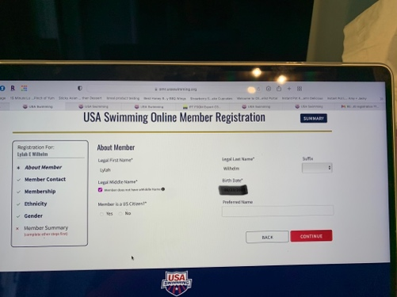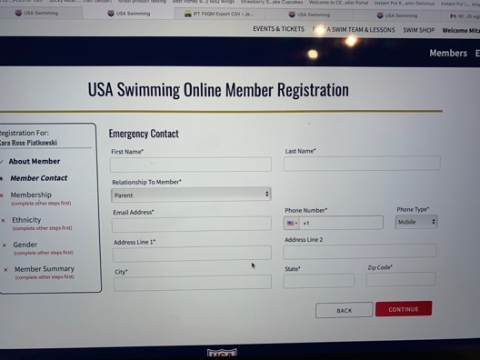
Enter: Member is a US citizen “yes” or “no”

Click “continue”
Enter: First name
Last name
Relationship to member
Email address
Phone number
Address
City – State – Zip
Click “continue”
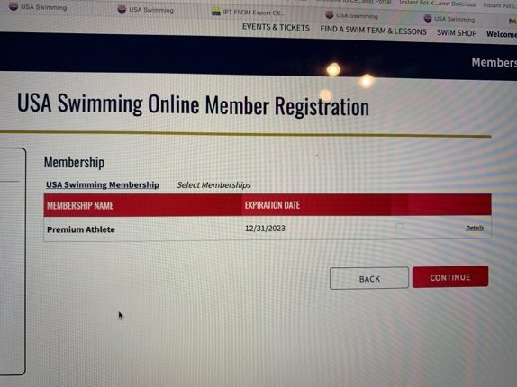
Click “continue”

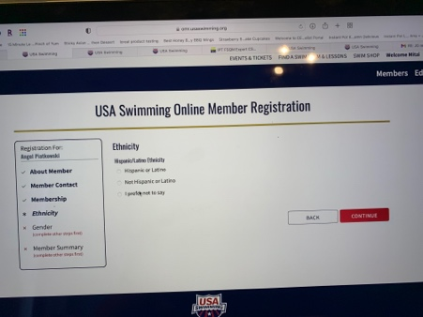
Enter: a choice of ethnicity
Click “continue”

Enter: a competition category
Click “continue”
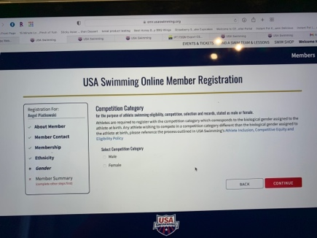

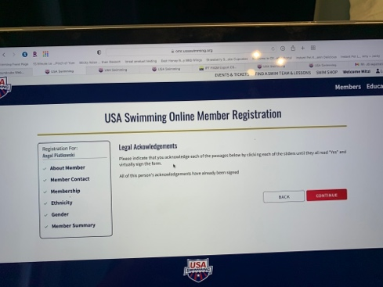
Click “continue”

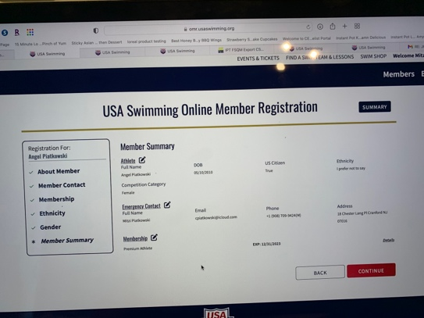
Edit any incorrect information

Click “continue”

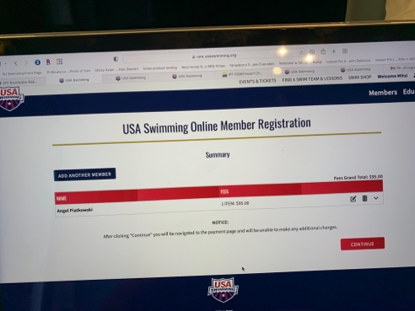
Click “continue”

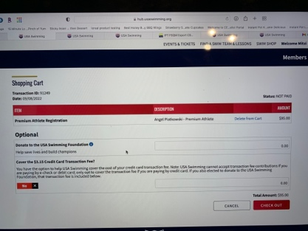
Click “checkout”
Complete the checkout process

- To register a NEW swimmer:

In a new browser click on the link below:

PTAC OMR Registration Link

Click “continue”

Click “this membership is for someone other than the logged in user”
Click “no” to register a NEW swimmer

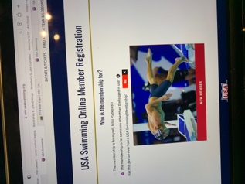
Click “new member”

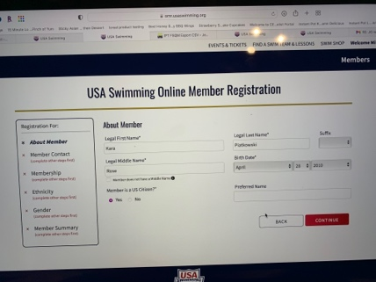
Enter: Legal first name
Legal last name
Legal middle name
Birthdate
Click “Continue”

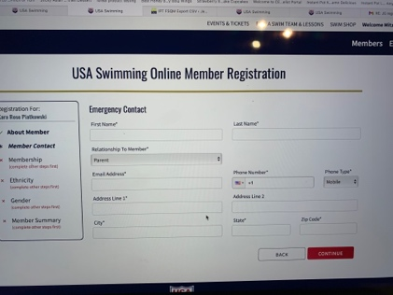
Enter: First name
Last name
Relationship to member
Phone #
Email address
Address – City – State – Zip
Click “Continue”

Click in the little box on the premium athlete row
Click “continue

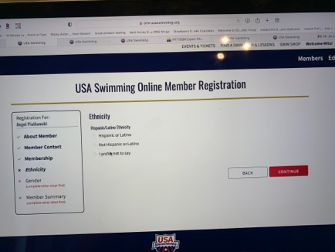
Choose ethnicity
Click “continue”

Choose: Competition category
Click: “continue”

Click “continue”

Edit any incorrect information

Click “continue”

Click “continue”

Click “checkout”
Complete the checkout process

