WRITTEN PERMISSION FOR AN UNRELATED APPLICABLE ADULT TO TRAVEL TO COMPETITION ALONE WITH MINOR ATHLETE
North Texas Nadadores
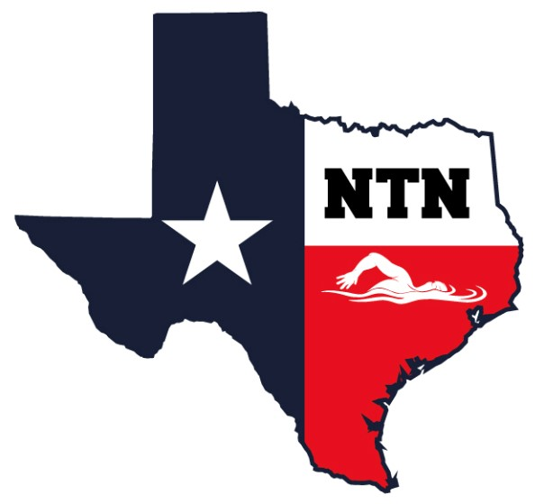

I, , legal guardian of , a minor athlete, give express written permission, and grant an exception to the Minor Athlete Abuse Prevention Policy for (minor athlete), to travel with (Applicable Adult), to travel from (point of origin) to (destination) to attend the (name of competition)
from to (dates of travel to competition).
I acknowledge that (minor athlete) cannot share a hotel room, sleeping arrangement or other overnight lodging location with (Applicable Adult) at any time. I further acknowledge that this written permission is valid only for the dates and location specified herein.

Legal Guardian Signature:
Date:

