We encourage each family to read through the information below. This is an introduction to basic information about swim meet navigation, time standards and meet levels. There is a wealth of information to learn for families and swimmers new to USA Swimming which will come with time and experience! Our coaches are here to guide you along the way.
General Information:

HOW TO FIND THE MEET SCHEDULE?

The .pdf meet schedule from Texas Ford Aquatics TeamUnify website https://www.gomotionapp.com/team/ntsfa/page/usa-swimteam1/competition-schedule >> go to the Competition Schedule information …. or …. the OnDeck app.

  - Option 1- to get to the TFA events page: Log in >> click on top of right of the page >> same place, click on back office if you are not there already >> on the left click on Events and Competition >> click on Team Events and find the meet you're looking for
  - Log in to OnDeck app. Under menu tap (top left – 3 lines, also called “hamburger” >> Events & Jobs >> Events & Meet Entries. Find the meet you are looking for from the list.
HOW TO SIGN UP FOR A SWIM MEET?
Sign up is available from TFA TeamUnify website or the OnDeck app:

  - Link to instructions from OnDeck and type: How to Commit/Sign Up for a Meet/Event – this page can help with so many things
  - Please note the registration deadlines. No late entries are allowed and meet fees are non-refundable once that deadline has passed.
HOW TO FIND SWIMMER’S EVENT ENTRIES (What is my child swimming?)

Note: most teams are finalizing entries, heat sheets, meet program and timelines between Wednesday and Friday, the week of the meet. Please be patience as one of the coaches will send that info when they get access to it. Many teams will charge for heat sheets, either at the venue or in MeetMobile app.

Event entries are available from TFA TeamUnify website or the OnDeck app:
  - From our site you can go to the same place where found the meets to sign up and click on the rectangle “Edit Commitment” and the events should be there( On a sanction meet, you will find the events posted usually the week of the meet, for our (Intra-Squad) meets you will most likely see the final list of events a day or two before the meet starts-it will most likely be the same events you and your swimmer picked originally)
  - OnDeck instructions: Top left (hamburger - 3 lines) Under menu tap >> Events & Jobs >> Events & Meet Entries to begin. Find the meet and tap >> Commitment or entries and to the right of the swimmer’s name, tap > Events, events assigned should have a green check mark.

HOW TO FIND THE “MEET DOC” AND WHY IT’S IMPORTANT?

Every meet can be a little bit different in terms of format, facility guidelines, venue, and host team. The "Meet Doc" will include dates, location, registration deadline (for coaches), qualifying times, entry fees, order of events and more! PLEASE never send money to the host team or contact the host team, we’ll take care of that for you and charge your acc.
The “Meet Doc” can be found on the meet page where you see the meet events. Click/tap the name of the meet you want (example: TFA Fall - BB & faster Meet).
It is the attached .pdf document at the bottom of the page under Forms/Documents. Open and read all the detailed information so you are fully informed! Most of it is for coaches and the people running the meet.

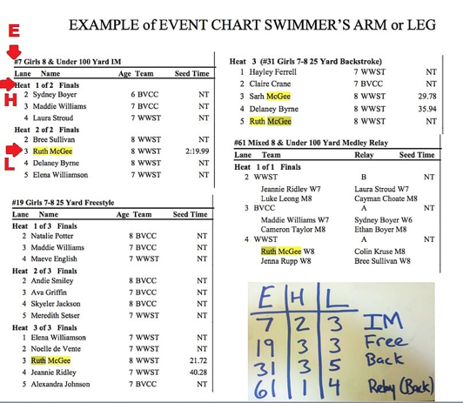
Please make sure that you have the events written on their arms with a sharpie BEFORE your child arrives for the warm-ups at the swim meet. Swimmers should always bring a “sharpie pen to meets.
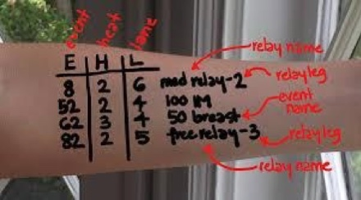

I also have a sample video on what to pack for a swim meet as well as what you swimmer needs to get ready for the meet.
We will send you the information you will need to write their events, heat and lanes the week of the meet if it is available to us.
WHAT TO BRING TO A SWIM MEET?
Its highly recommended swimmers pack their bag the night before the swim meet.
- 2 sets of goggles
- Swim Caps (2 of them) with TFA logo
- ARENA suits with TFA logo from XtremeSwim
- Extra suit
- 2 or 3 Towels
- Healthy snacks & water bottles
- Something warm to wear during the meet
MUST HAVE APPS FOR SWIM MEETS:
 Load OnDeck - This app is easy to use and it's free! It is a duplicate of your TFA-TeamUnify account website. You can access your account balance, sign up for meets, find your swimmer event entries, sign up to volunteer, check your swimmers’ times and more. Use your Texas Ford Aquatics TeamUnify username and password to log in.
I also have a sample video on what to pack for a swim meet as well as what you swimmer needs to get ready for the meet.
We will send you the information you will need to write their events, heat and lanes the week of the meet.

HOW TO FIND EVENT, HEAT, LANE ASSIGNMENTS AND MORE? Please check the MeetMobile app to find this information the day before or morning of the swim meet. Most hosting teams use MeetMobile instead of paper copy heat sheets. You may have to pay for it.
 See Meet Mobile intro video.
HOW TO FIND MY SWIMMERS TIMES? this is for sanction meets only.
USA Swimming Times (SWIMS) Database - times search which contains all times that have been swam in a sanctioned USA Swimming meet. View all your swimmer's times and corresponding time standards. New swimmers with N/T (No times) are consider C swimmers and are not on the table.

HOW TO FIND AGE GROUP MOTIVATIONAL TIME STANDARDS? USA Swimming uses time standards to provide a benchmark for goal setting as swimmers progress through the sport. Many coaches utilize this system to encourage and track improvement. Each age group has a set of varying times starting from B (slower) to AAAA (faster) based on speed within an age group. New swimmers start with N/T (no time) and can work their way up to AAAA level times. Link to 2021-2024 National Age Group Motivational Times. Classification of the time standards are also noted: Long Course Meters (LC), Short Course Yards (SCY), and Short Course Meters (SCM).

HOW TO VOLUNTEER FOR A SWIM MEET: USA Swimming is a non-profit organization made up of many very dedicated volunteers across the country. TFA swim meets are run 100% by volunteers, and we cannot host a meet without our TFA Families! To sign-up for a timer please click on the “job Sign-up” link

Here are a couple other apps you might consider having:

- USA Swimming
- Swimmetry

