ACC JANUARY “FLIPTURN”

Happy New Year to ALL! We at ACC hope you had a Blessed Holiday with friends and family. We want you to know how grateful we are to work with you and to help guide you through your recruiting process.

A reminder how very, very important that you stay in touch with your advisor on a regular basis with updates of all kinds…academic, swimming times, questions, advice, anything and everything you need. Remember you signed an agreement to keep us updated and current. We can’t help if we do not know what you need. Each grade has different timelines and needs, so DO NOT NEGLECT YOUR RESPONSIBILITY IN THIS PROCESS!

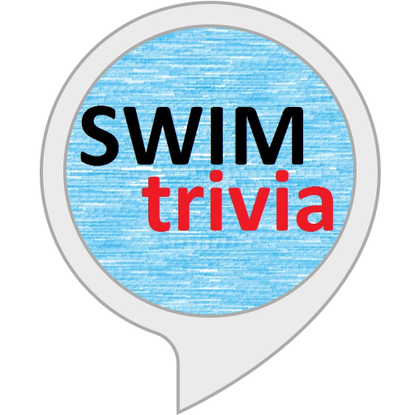SWIMMING TRIVIA: WHICH SWIMMING STROKE WAS INTRODUCED INTO COMPETITION IN 1952?


FEW IDEAS
The holidays are fun, exciting, and exhausting. You’ve conquered doubles and are now back in the school/ training mode. How do you manage getting back in the groove?

- Employ a “buddy system”…promise to hold each other accountable
- “Seize the Day” ….make each day count...DON’T WAIT. EVER!!!
- Feed your muscles…before, during and after each workout, and PLAN your meals !
- DO your pre-hab exercises to minimize the likelihood of of injury
- Take 5 min a few times a day to improve your flexibility
- Do 15 M/Y underwater dolphin kick to jump start the neural pathways in warm up
- Get ONE extra hour of sleep
- Consistently seek feedback for trouble spots, by attacking one weakness at a time, until they are no longer weak.
- Help create a positive training environment…Be the one that helps others get better
- Take ownership of your mental health, and do not be afraid to ask for help !
- Pick 3 habits that will have the biggest impact on your swimming career and focus on them day in and day out



What’s the Difference Between a Cleanse and a Detox?

“I’m ready to start fresh after indulging in so many holiday foods. Do I need a cleanse, or a detox?”
While both include an element of a diet of clean healthy foods, “cleanses” typically focus on digestive health and often refer to basically cleansing the colon, whereas “detoxes” are a systematic approach to toxin removal that helps your body align its own systems.
Think of what’s been going on in your life in just the last 12 months: Has your body take any “beatings”, so to speak?
Stress? Illness? Lots of medication? Using chemical cleaning products? Eating highly processed foods? Lack of sleep?
You might benefit from a detox if you are experiencing
• Chronic fatigue
• Strong cravings
• Get sick often
• Slow recovery after training
• A genetic predisposition to high inflammation
• Digestive issues
• Nutritional deficiencies
• Acne
• Disease/ a specific medical condition

My personal benefits from detox have been feeling great with my digestion and getting rid of my sugar cravings (really, I stand in front of the fresh donuts and love not feeling that I have to have 3! It’s wonderful to eat by choice, not because you feel that you can´t help yourself). For family members and clients, they have benefitted from clear skin (usually starting at about Day 12, getting up in the morning without grogginess “I´m good to go”, positive mental outlook, improved digestion/rid of bloating, diminished headaches, and great sleep).

Tips for getting the most out of your detox
1. Drink plenty of water
2. Reduce your intake of unhealthy foods: you are getting your body ripe for absorption, so put good things in it to be absorbed!
3. Be wise in choosing a good detox product. (Reach out to me if you have questions)!
4. Do not combine your detox program with a crazy crash diet that could result in lack of nourishment and messing up your metabolism
.


ACC REMINDERS:

- MUST stay in touch with your ACC advisor regularly to ask questions, get advice, updates on profiles and colleges, etc.

- ACC RECRUITING MANUAL:
  - Please read through it over the holiday
  - Recruiting tips included
  - Pay close attention to the ACC timeline for all graduate classes
  - Sign up for NCAA Eligibility Center

- COMMUNICATE with your club coach(often)
  - Reset goals
  - Go over goals with your coach
  - Just because we are helping you through ACC does not mean that you do not need your club and high school coach’s help

ACC RECRUITING TIP ( from Rick Paine, CEO)

- If you are a sophomore, embrace phone calls from D-III coaches. Our swimmers get a lot of recruiting practice by talking with D-III coaches.
- As you know, D-I and D-II coaches must wait until June 15 before they can call recruits.
- Many of the upper level D-III coaches are getting a jump on D-I and D-II coaches by calling early which they are allowed to do.
- A number of our swimmers eventually choose to swim D-III because those coaches were the first ones to show interest.

ANSWER TO TRIVIA: Butterfly

Don’t forget to tell your friends all about us ! Referrals are Welcomed!

