How To Use Meet Mobile
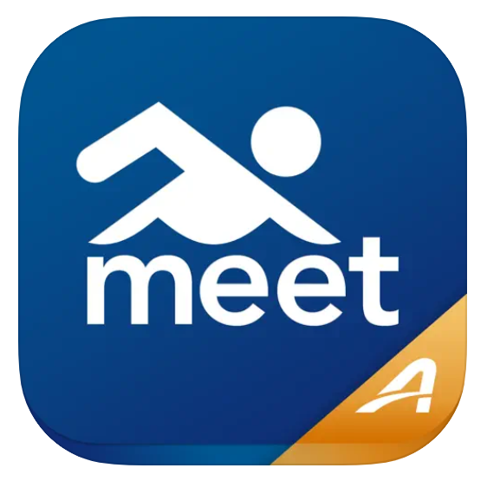
Meet Mobile is the app used for heat sheets and results during swim meets in both the summer and fall/winter seasons. While the app is free to download, you may not be able to use all functions of the app without a subscription ($6.49/month or $19.99/year).
How to Find Your Swimmers
Once you have downloaded the app, you can search for your swimmer’s name(s) on the home screen. Be sure to toggle to “Swimmers” instead of “Meets”. Once you click on your swimmer’s name, your swimmer’s upcoming and previous meets will be listed under their name. Click the star next to their name to save your swimmer to your favorites. Once you have saved your swimmer to your favorites, you can quickly access their heat information and results by clicking the star located at the bottom of the home screen.
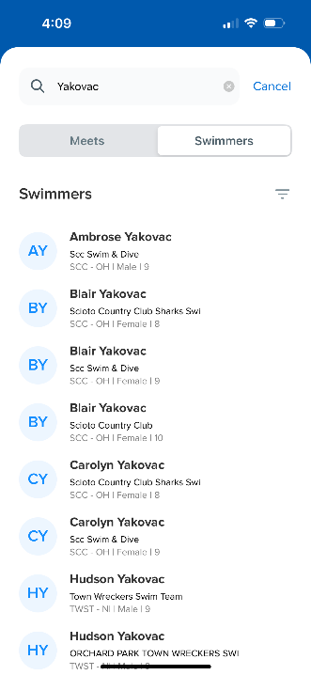
How to Find a Meet
From the home screen, you can search for individual meets. Type “SCC” into the search bar and any meet with “SCC” will pop up. They are listed from most recent to older meets. Please note that our summer swim meets are often loaded into Meet Mobile on Monday, the same day as the meets. Please look for communication from coaches prior to the meet if you are not seeing information in Meet Mobile. Similar to saving your swimmer to your favorites, you can save “SCC Swim and Dive” to your favorites.
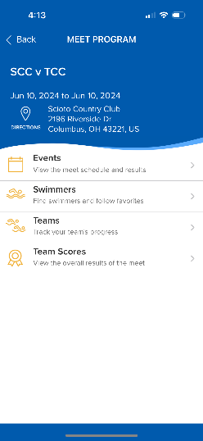
How to Use the Meet Information
Once you have selected today’s meet, you can click on “Events” and it will list the events in order. If the meet/event has not started, you can see the heat sheet information by clicking on each individual event. If the event has concluded, you can find results by clicking on the individual events.
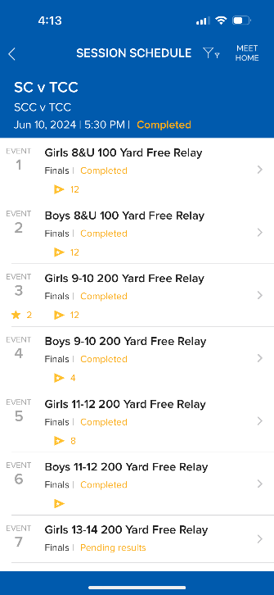
Important Information
Meet Mobile does not always update immediately. If there are Wi-Fi or connectivity issues, the results will not update. Additionally, if your swimmer is disqualified (DQ) for any reason or there are timing errors, this often does not update until the conclusion of the meet.

