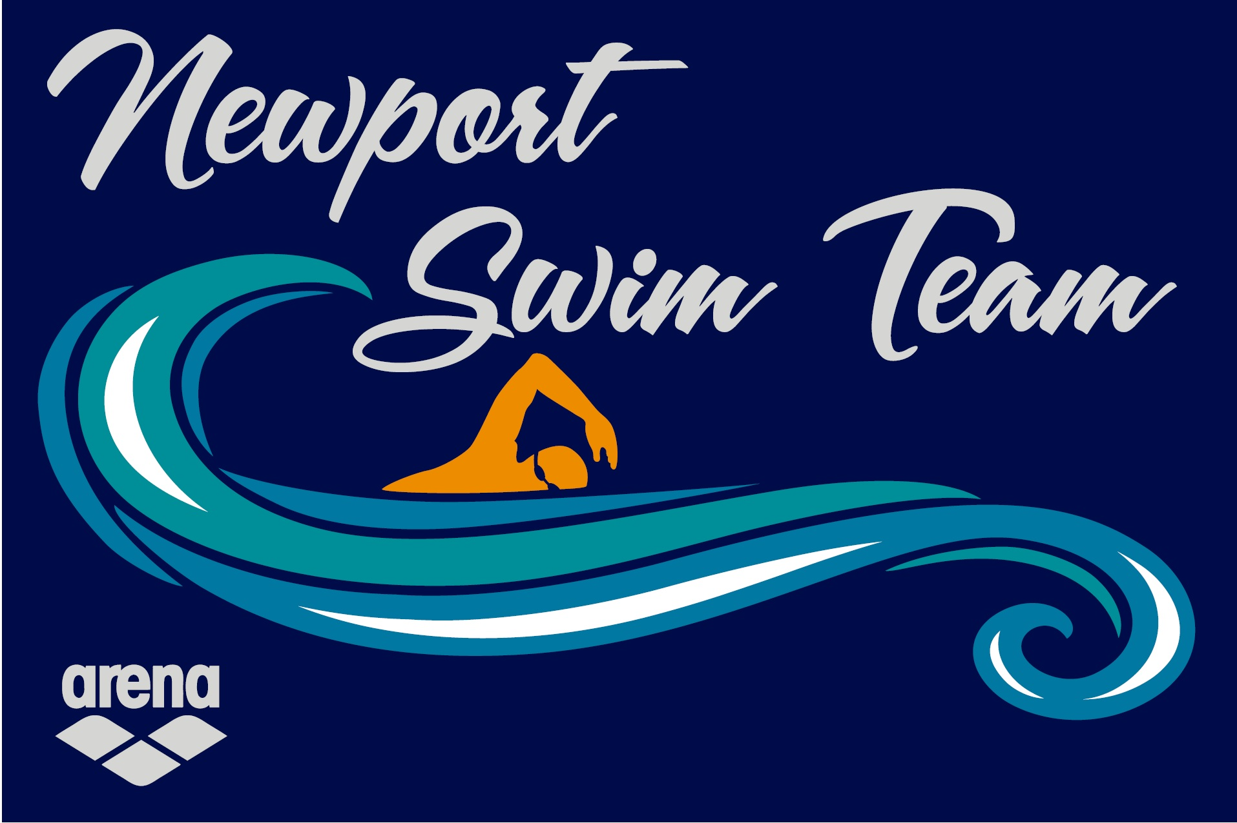

BOARD OF DIRECTORS MEETING AGENDA
Oct.7, 2025 / Newport High School / 6:00 p.m.

Members in attendance: John, Kelly, Kevin, Gavin, Kasey, Alicia, Amanda, Monica, Hana
General Membership: Hillary C
- Call Meeting to Order & Welcome New Members (John) Meeting called to order 6:02

- Meeting Minutes Review & Approval (John) Kelly made motion to approve, Amanda seconded, motion carried

- Questions from General Membership No Questions from Membership

- Meeting Format
- Time Allocation
- Side Conversations
- Staying on Agenda

- Financial Report
- Account Balances (Kelly)
- Main Checking- $30,749.60
- Money Market- $25,578.27
Vinny Memorial CD- $1054.26

- Profit Loss Review (Kasey) Updated Profit Loss Attached, Board will vote to approve at next meeting

- Fundraising Report (Hilarie) Approximately $11,350 raised not including Siletz Grant. Swim-a-thon will be Nov. 22nd 10:00 to 12:00

- Coaches Report (Gavin) Report Attached

- Volunteer Report (Kevin) – 90 Hours of Volunteer time reported, mostly from the Newport Triathlon

- New Business (John)
- Setting of BOD Goals for Season - Outline 2 to 3 goal items as objective goals for the year for the Board/Team
- Review of Possible Practice Time Changes - John and Gavin will work in sub-committee, present ideas in next meeting
- Team Manager/Bookkeeper – Kasey P will step down as Team Manager at the end of the year. Recommends USA Swimming Certification for all Board Members
- Team Representative- Coach Gavin recommended Hana Parker as Team Representative. Kevin made motion to accept recommendation, Amanda seconded, motion passes
- Community Impact Grant- 3-year Grant opportunity up to $3000.00, Required to specify use of funds, Due mid-November

- Old Business (John)
- Booster Auction Update – Hillary working on NST basket, Sarah H working NHS Boys and Girls Baskets, Baskets due in by Nov 5th
- Renew Vinnie Onestar CD – Gavin made motion to open for use to assist swimmers with swim meet fees, Kelly seconded, motion passes
- Vending Machine Idea – Tabled until Josh returns
- Replacement of Monitor at pool – Monitor purchased, given to Chloe for Rec Facilities to install
- Assistant Coach Recruitment – Amanda offered to serve as Ass. Coach, Kelly made motion to approve, Kevin seconded, motion passes

- Next Meeting: Nov. 11
2025-2026 meeting dates
DEC. 9, JAN. 13, FEB. 10, MAR. 10, APR. 7, MAY 12, JUNE 9, JULY 7

- Executive Session (John)

- Adjourn (John) Adjourned 7:25

2025-2026-9/1/25-9/30/25
Category | Income | Expense
Coaches Travel | $0.00 |  | $0.00
Coach Travel-Mileage |  | $0.00 | $0.00
Coach Travel-Lodging |  | $0.00 | $0.00
Coach Travel-Meals |  | $0.00 | $0.00
Coach Travel-Other |  | $0.00 | $0.00
Swim Dues | $2,716.00 |  | $2,716.00
Staff Payroll |  | $764.16 | -$764.16
Coach Training/Expense |  | $0.00 | $0.00
Payroll expense |  | $0.00 | $0.00
Taxes-IRS |  | $811.30 | -$811.30
Taxes-OR |  | $357.32 | -$357.32
Tax Filing Fees |  | $0.00 | $0.00
Pool Fee | $0.00 |  | $0.00
Pool Rental/Facility Rental |  | $3,938.05 | -$3,938.05
Insurances |  | $0.00 | $0.00
Website fees |  | $1,121.18 | -$1,121.18
State License |  | $50.00 | -$50.00
Background check |  | $0.00 | $0.00
Office supplies |  | $99.99 | -$99.99
Postage & PO Box |  | $0.00 | $0.00
Gifts |  | $0.00 | $0.00
Equipment |  | $0.00 | $0.00
Team Party |  | $0.00 | $0.00
Team Meeting |  | $0.00 | $0.00
Merchant Fees | $98.50 | $236.28 | -$137.78
Bank Charges |  | $0.00 | $0.00
Awards |  | $0.00 | $0.00
Marketing/supplies |  | $21.50 | -$21.50
USA Registration | $0.00 | $225.00 | -$225.00
Swim caps | $0.00 | $0.00 | $0.00
Arena Gear | $0.00 | $0.00 | $0.00
Team Apparel | $0.00 | $0.00 | $0.00
Entry Fees | $0.00 | $168.00 | -$168.00
 | $0.00 |  | $0.00
Swim-a-Thon | $0.00 | $0.00 | $0.00
Sponsorships/Donation Program | $3,000.00 |  | $3,000.00
Wray Open | $0.00 | $414.50 | -$414.50
Seahorse | $125.00 | $2,935.50 | -$2,810.50
Car Wash-PUD |  |  | $0.00
Dine Out | $0.00 |  | $0.00
Donations | $37.95 |  | $37.95
Bottle Drop | $0.00 |  | $0.00
Kroger/FM Rewards | $0.00 |  | $0.00
NHS Boosters | $0.00 |  | $0.00
Triathlon | $0.00 |  | $0.00
Siletz Grant | $0.00 |  | $0.00
Late Fees | $0.00 |  | $0.00
Bank Interest | $39.14 |  | $39.14
Volunteer Hours | $397.50 |  | $397.50
Social Service Grant | $0.00 | $0.00 | $0.00
 | $6,414.09 | $11,142.78 | -$4,728.69

MONTHLY COACHES REPORT INST BOARD OF DIRECTORS

DATE 10/17/25

- Current Swimmer Count by Group
Bronze,l : 4 swimmers
Bronze II: 6 swimmers
Silver : 4 swimmers
Gold : 7 swimmers

Seniors : 10 swimmers
Total 31 swimmers

- New Members
Mention those added in past month
Bronze 2 Emilia Swift
Bronze 1 Natalie Colton(Removed)
Seniors Zane Craver, Clyde Bretz,
Mention pending tryouts NIA

- Upcoming Meets and how many swimmers are attending
who is covering
10/18125 BOST Fall Invite Gavin
10/24/25 Team·s IMX/IMR challenge Gavin
11/1/25 AAA Turkey Dive Gavin 1117/25 SCAT open Gavin
11/14125 LC Pumpkin Sprint Gavin
12/05/25 Seniors Open {Springfield w/CAT) Gavin
01/02/26 CAT Open Gavin
01/25/26 CAT Tri Meet (Dallas} Gavin

- Practice Numbers from past 4 weeks
Bronze 1 50% attendance
Bronze 2 29% attendance
Silver 77% attendance
Gold 55% attendance
Senior 25% attendance

- Issues and Concerns
Lack of coaches applying for position
•
Building connections with other teams
Building connections with aquatic center

