JCT Memorial Scholarship

John Traube began his swimming career in Red Bud, Illinois swimming with his cousins, sister, and brother at a small community pool in a summer league. John soon began swimming year-round first with the Belleville, IL YMCA, then with The Oak Hill Seahawks Swim Team in Belleville, and his final stop before college on the Clayton Shaw Park Swim Team. John went on to attend Clarion University in Pennsylvania where he was a ten time All American and team captain. John went on to attend Clarion University in Pennsylvania where he was a ten time All America and team captain for the Division II Golden Eagles. During John’s swimming tenure, Clarion finished with a top 5 ranking at the NCAA Division II National Swimming Championships all four years, and his senior season they finished ranked second in the country.
By the mid 1990’s John had retired from collegiate swimming, but his contributions to the sport would continue for years to come. John married a swimmer, Jen, and they had two beautiful young swimmers of their own. John could be found on the pool deck as an official, timer, or starter. He served as a board member, committee member, and always the proud parent. John and Jen are proud to have their oldest daughter attend Duquesne University where she will continue her contribution to the sport by managing the Duquesne Swim & Dive Team and proud to have their youngest daughter continue her highly decorated swimming career with FAST.
On February 4, 2018 John lost his courageous battle with cancer and the swimming community lost a great ambassador too soon. John and his family want to ensure that his dedication to and love of the sport will continue on for generations to come. It is with this in mind that we are establishing the John C. Traube (JCT) Memorial Scholarship.
Any athlete from the Ozark Region committed to swimming in college, (NCAA, NAIA or Junior/Community College) is eligible to be considered for the JCT Memorial Scholarship. The total scholarship award may be up to $4,000.00 ($1,000.00 per year) and will be renewable each year. The recipient will be awarded $1,000.00 per year, renewable over a consecutive four-year period so long as the athlete is in good standing academically (as defined by their collegiate divisions) and is actively participating on the selected university’s swim team. There are no specific financial, GPA or test score requirements. Recipients will be awarded the scholarships solely based on the determination of the scholarship committee. The scholarship committee’s decision is final.
Applications are available for download at www.fast-swimming.com. Click on the About tab or the JCT Memorial Scholarship logo under sponsors to access the application download. Submit applications by email to jctms0204@gmail.com.
Donations to the JCT Scholarship can be made via GoFundMe https://gofund.me/b9fc15e1
Questions or inquiries regarding the JCT Memorial Scholarship, e-mail jctms0204@gmail.com.
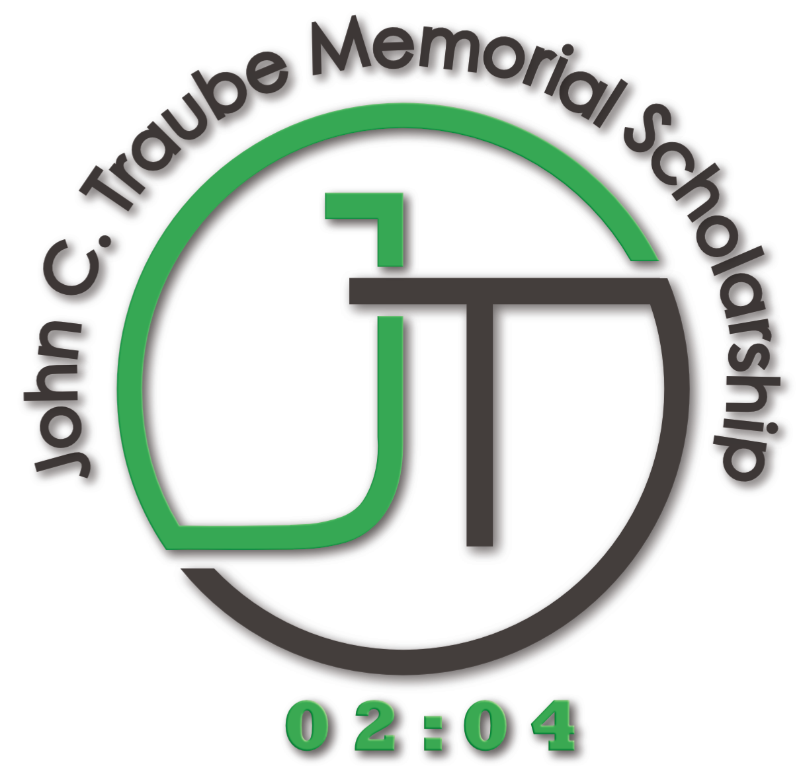
JCT Memorial Scholarship - Application Instructions

- Complete the Scholarship Application form.

- Provide Letters of Recommendation (guidance counselor, teacher, swim coach, etc.).

- Provide a copy of your high school transcripts.

- Provide a short essay on why you want to swim in college.

- E-mail all of the following items to JCTMS0204@gmail.com
- Application
- Essay (.doc or .pdf)
- Transcripts
- Recommendation letters

The selected applicant will be announced on or before the John Traube Memorial Meet.

JCT Memorial Scholarship - Application
Personal Information (to be completed by applicant)
Section I – General Information

First Name: ________________________________ Last Name: _________________________________ MI: _____

Applicant’s Date of Birth: _________________________________________________________________________

Address: ______________________________________________________________________________________

Best Phone: ___________________________________________________________________________________
E-mail: _______________________________________________________________________________________

Father’s Name: ____________________________________________ Best Phone: _________________________

Mother’s Name: ___________________________________________ Best Phone: _________________________

Section II – Scholastic Information

Cumulative GPA on a 4.0 scale: ____________________________________________________________________

Name of High School: ___________________________________________________________________________

Name of your Ozark LSC Team: ____________________________________________________________________

Name of the College or University attending: _________________________________________________________

Did you sign an NLI (National Letter of Intent)? _______________________________________________________

List your hobbies and interests outside of swimming:

_____________________________________________________________________________________________

List your non-school sponsored volunteer activities in your community:

_____________________________________________________________________________________________

Section IIII – Essay, “Why I swim”

Please, expand on our theme of the essay, “Why I swim”. Tell us why you swim and why you should be selected to receive the scholarship. The essay must be in a Word Document or PDF format and attached to the e-mail message with the application.

