

SMAC Board Meeting
July 16, 2025

Attendees: Doug A, Ken S, Cesilia C, Erik S, Steve W, Laurie R., Tanya Prieto, Dawn Dunn

The meeting was called to order at 7:59pm Quorum was met with 9 attendees.

1) President’s Report:
- New Officer: Steve Transition board officer position at the end of the month Shane motioned, laurie seconded. - 9-0
- Motion to approve the Board slate as voted on Ken motioned, steve seconded 9-0

2) Secretary Report:
- June Minutes: Shane motioned to approve, Erik seconded. Vote was 7-0 to approve. Minutes will be posted to the SMAC website soon. 2 abstentions

2) Treasurer’s Report:
- Reviewed June financials
- Strategic Planning

3) Marketing/Brand:
- No Report

4) Community Engagement Director
- No Report

6) Booster’s Report

SMAC Hosted Summer Classic June 27-29-Final hosted meet of the season, overall meet ran very well. 750 athletes with a decent timeline and some fast swims. It continues to be a good meet for our Silver swimmers, and times well for some champs cuts.
We continued to struggle with 12&U volunteers, despite over 120 SMAC 12&U swimmers in Sat and Sunday sessions. We ended up having a coach announce each 12&U session, with families with 13&O swimmers also coming in to assist.

Volunteer Policy Updates:
The Booster Club approved the following volunteer policy updates that will be live with registration next week:

Decrease hospitality donations for meets. Hospitality donated items will receive half the volunteer hours to hopefully move folks to on deck positions (we can always buy hospitality)

Volunteer Policy Review for 25-26 season
- Keep the $1,000 policy for not completing any volunteer hours. This is for
families who have been on the club for more than six months and in a group
that is not Catfish or Stroke Development.
- Keep the $50 per hour charge for each outstanding volunteer hour upon
resignation or the season ending.
- To support the 12&U meet sessions increase the minimum volunteer hour
commitment for Age Group and Stroke Development. Keep all other groups
the same.

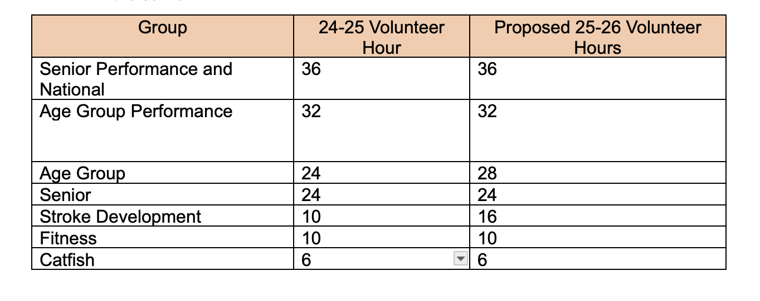
Our struggle continues to be with the 12&U families and engaging them, having them buy into the team culture. Many of the current messages we receive are “I have my hours already”. While increasing hours hopes to increase our ability to host meets, we will need a culture shift to continue to support and grow the team.

Hosted Meets for next season-SMAC will host the following. I will continue to support/run meets that my swimmer is in, and train others for the day of meet director role.

- Oct 4-5 Fall Invite- Snohomish
- Nov 22-23 Nov AGI- Snohomish
- Jan 17-18-SMAC Invite (IMR/X etc)- Snohomish. Run 3 sessions a day with CF/SD 25’2 and 50’s (we talked with Justin, thoughts are it’s better to run 3 sessions for one long weekend rather than additional meet weekend for a mini meet)
- Mar 27-29 Spring Showdown-Hazen
- April 24-26-Long Course Kick Off “A”-KCAC
- June 26-28. Summer Classic-KCAC

September 21st - fall kick off open house
- May 9th -Award Banquet

Booster Club team updates-Tanya Prieto is on the slate for the Booster President. The plan is to begin in July transitioning and also have me train/shadow incoming President all next season.
Other Open key positions:
- Membership Director (was Tanya Prieto)
- Social Director (was Lynn Kress, too much with coaching)
- Dry Side Meet Director (potential opening)
- Day of Meet Directors (2 12&U, 2 13&O)
- Meet Entry Chair (Fosters are moving)

These are some pretty large roles, if you have any folks that you think would be great candidates please send to Tanya and I. Ken, it would be great to have each coach provide a name or two.

PNS volunteer committee has kicked off, with a focus on officials and meet referees. We will reconvene in the Fall, with the hope to have an outline to present at the Spring HOD.

.
7) Head Coach Report

Coaches Report July 16, 2025

Team numbers
July 495 Actual 492 Budget 101%

Big drop off in July. Odd as saving the single month dues could potentially cost them a spot on the team in the fall.

Facilities of Note
Pool | Status - Relationship | Notes | Status
SU | Satisfactory | Contract for Fall Pending | Pending
MSC | Outstanding | Have Fall Contract. No rate increase | Have Contract
IMA Pool | Building | Revisit in Feb | Not Avail
KSTC | Satisfactory | Have Fall Contract. | Pending
MIBC | Outstanding | Have requested same pool time - Pending | Pending
ME, MR, Tuk, Evg | Outstanding | Normal schedules – Possible pull from Tukwila | Open
KCAC | Good | TBA – Have current pool time | Open
Lakeridge | Good | Unsure if there is need | TBA
MH & AAA | Good | Not currently in use | None
View Ridge | Outstanding | Contract Pending | Pending
Newport | Outstanding | Contacted – they will follow late July | Pending
Meadowbrook | Not in use | Can’t staff | Closed to us
Colman | Outstanding | Not relevant for all | Open

Staffing Changes:

Minimal turnover. When we are losing core coaches, staff who have been coming up are replacing. Some movement, but same faces. We’ll announce some significant changes on Monday July 21.

Other Items

Try Outs
In the past we’ve treated new swimmers as more of an evaluation with the intent to find room for all. With increased interest in the club, we’ve moved to a ranking system and a genuine try out procedure, especially for groups where we are at or near capacity.

Priority will be given to those who finish July. Registration for new swimmers (ranked) and returning swimmers who did not finish through July will open a few days after priority. For AG, AGP, SP and National Special consideration will be given for swimmers who will contribute on the competitive side of the program. Families who have critical volunteer skills, such as meet directors, officials and other areas of need will also be prioritized.

Get Wet
Get wet is scheduled for the first week in August at Evergreen. We currently have 32 swimmers signed up. Supplies from Speedo are on the way. Justin is heading up this effort.

Advertising
Derek & Shane have secured advertising in several post season programs. Coaches plan on making themselves available at post season meets.

Logistics:

Shane motioned to adjourn and Erik seconded. Vote was 9-0. Meeting was adjourned at 8:50 PM.

The next meeting will be scheduled on September 17, 2025 at 7:30pm

SPECIAL TOPIC

Vote on Salary: Laurie motioned to approve Ken’s annual salary raise. Shane seconded. Vote was 6-0

Vote on Bonus: Steve motioned to approve Ken’s bonus. Shane seconded. Vote was 6-0.

