
SMAC Booster Club
Tuesday, January 7, 2025, 7:30 pm meeting via Zoom
Meeting: called to order by President Laurie at 7:32pm.
Attendance: Jennifer, Kieran, Shawn, Tanya, Tiah, Lynne, Caroline, and Lisa
Approval of December minutes: Tanya motion to accept, Jennifer second motion, all in favor, no one opposed, approved the minutes, no objections.
Next meeting: Wednesday, February 12, 2025, at 7:30 pm via zoom.
Meeting Adjourned: Laurie concluded the meeting at 8:21pm.

Agenda:

7:30-7:40 Caroline-Meet updates, AGI income, Winter Invite, Spring Showdown updates.
7:40-7:55 Jennifer-Swim A Thon. Date options, shirt design.
7:55-8:00 Lynne. Banquet Planning.
8:00-8:10 Tanya-New Member Orientation. Pool rep updates. Holiday coaches giving.
8:10-8:20 Kieran-Coaches updates
8:20-8:30 Tiah-Volunteer updates
8:30-8:40 Laurie-President updates.
8:40-8:50 Lisa, Hotel updates (Wenatchee) meeting notes/meeting calendar

Event Schedule:

Dates | Event/Target Group | Location | Notes
1/12 | SMAC Mini Meet | Mt. Rainier Pool | CF, SD
1/16-19 | Washington Open | KCAC
1/18-20 | THSC Round Robin Inv | Oregon | Team Selection
1/19 | Snowflake Classic | Hazen | CF, SD
1/19 | 2025 BC January Mile | Hazen
1/25 | SMAC Winter Inv | Sno AC | CF, SD, AG, AGP, S
2/9 | SMAC Mini Meet | Mt. Rainier | CF, SD
2/14-17 | Lost Dutchman | Skyline AC Mesa AZ | Family Travel
2/14 | UPAC Fly-in | Curtis | AG, AGP, S
3/13-16 | 2025 Speedo Champ Series | Rochester, MN | S, SP, Nat
3/20-23 | NW Regionals AG | Boise, ID | AG, AGP, SP
3/29-30 | SMAC Spring Showdown | Sno AC | CF, SD, AG, AGP, S

Caroline, Meet Director Update

AGI – profit $14k
SMAC Invite – meet getting full, waiting on a few teams.
Spring Showdown – no update as of yet, working through a few logistics.

Jennifer, SAT Update

Working on setting a date for the SAT:
- choosing the shirt design/color. Hillary working on a design. Gold medal level design graphing on the shirt.
- getting ready to post the site leads.
- volunteer roles.
- Following up to determine if we have access to Seattle U.

Possible April issues are spring break and meets, looking at April 30th or May 1st.

Lynne, Socials Update

Banquet – narrow down the dates, possible weekend before Memorial Day.
- Have laurae pull the numbers differently.
- Check with Ken for meet conflicts.

Tanya, Membership Update

Pool Reps: Nothing new to report.
New Member Orientation: next one to be scheduled early March 2025
Holiday Coach Giving:
PayPal – 1,474.48
Venmo – 6,413.98
Total – 7,888.46
$2,422.31 Less than last year.

SMAC Northwest Harvest Donations:
Nine donation bins were filled, so much so that it took two people to carry each one! On top of that, we collected 776 diapers. Northwest Harvest was thrilled and shared how these contributions will make a big difference for so many people. I do not have an exact weight on the donations, but the pictures were impressive.

Kieran, Coaches Update

Shirts for champs were distributed.

Next shirts are for regionals and sectionals.

Coach Erin in charge of Round Robin.

Follow up with Ken on Dutchman shirts.

Tiah, Volunteer Update

- Upcoming volunteer positions I am working on:
- January Mini Meet – one position remaining
- SMAC Winter Invitational
- Swim-a-thon
- February Mini Meet
- Had a call with Mitzi Tan, the ribbon coordinator. It was an enlightening call. She feels overwhelmed by the amount of time the position is taking. We clarified specifics on how to get the ribbons to the pool reps. I will be checking back in with her after the SMAC Winter Invitational to see how the process went for our December champs meets and the SMAC meets.
- We have approximately 157 members who have no hours fulfilled yet. *Note this does include our leadership roles.
- Volunteer Hours Waived in December
  - One Swimmer – due to mental health, reviewed with Laurie.

Laurie, President’s Update

Big12 championships scheduled and posted 4 shifts per sessions per day for timing shifts.

PNS Canceled February AG meets, not enough hosts to support the meets. We will be attending Cascade meet. Prelims/finals meets. Will be updated soon.

Family support-The family we supported was very grateful!

From his mom:
Thank you so much for everything! C grabbed some photos of JJ with the swim cap. You guys made him cry (me too). What a great club to show such support for us.

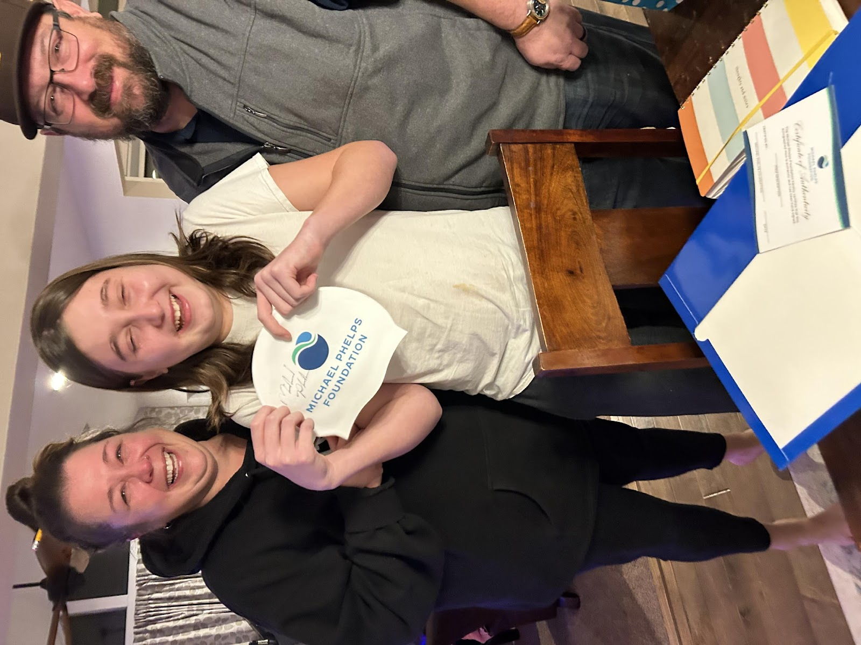

Updated Volunteer Policy

Updated on website, communicated out to families. How is it going?

**Storage Locker lead for 12&U/mini meets is now filled and transitioned. Their first event is the January Mini Meet.

We still need one more lead, ideally 13&O or, that can support the January, March, and June meets. If we can’t fill, I need a few of us to have keys and meet runners at the end of the meets (Jan 26 if we aren’t able to fill by then), as I will be still at the meet when the runners arrive.

Apparel
White cap orders will open again in a week or so for SMAC caps, long hair caps and personalized. We have a lead in place to do this with DJ sports but want to fully transition this to the secretary position next season.

Lisa, Hotel Update

Round Robin (THSC) – hotel is set. AC hotel in Beaverton. There were a few rooms provided to traveling families, information sent to the families from Coach Erin.

Lost Dutchman – AZ. This meet is strictly family travel, no hotel information provided. Families will have to make their own reservations.

Speedo Championship Series (Sectionals) – Rochester, MN. Susie is close to booking block rooms for team travel. Ken approved the block, finalizing contracts now.

Age Group Regionals – Boise, ID. Currently in contract creation for team travel and should be signed tomorrow.

Apple Capital – Wenatchee. We have two hotels for this meeting totaling 72 rooms.

