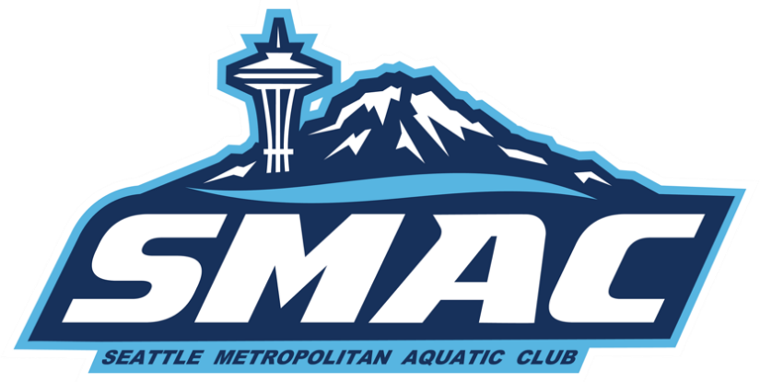

SMAC Booster Club
Tuesday, September 6, 2022, 7:00pm meeting
Zoom Videoconference

Meeting: called to order by President Laurie at 7:20pm.
Attendance: Laurie, Carl, Tanya, Lynne Allison, Lisa present at the meeting.
Approval of July Minutes: Motion to approve July minutes Alison, Carl second. All approved. No Objections.
Next meeting: Wednesday, October 12, 2022, at 7:30 pm via Zoom.
Meeting Adjourned: 8:23 pm.

Agenda:
7:00-7:20 Welcome and Review the budget-Laurie.
7:20-7:35 Finalize the details for the Kick Off-Allison
7:35-7:45 SMAC Oct hosted swim meet-Laurie (see report)
7:45-8:00 New Parent meetings, handbook-Tanya
8:00-8:15 Volunteering/Lead positions-Echo
8:15-8:30 Coaches updates
8:30-8:45 Open
8:45-9 Next meeting. Meeting schedule moving forward etc.

Event Schedule:

Dates | Event/Target Group | Location | Notes
9/10 | Western Open Water Zones | Glorietta Bay Park, CA
9/18 | Fall Kick-off Open House | Federal Way Community Center
10/1-2 | October Challenge | Snohomish AC | SD/AG
10/15-16 | Fall Kickoff | Snohomish AC
10/21-23 | THSC Fall Invitational | Beaverton, OR
11/8 | Mini Meet | Tukwila | CF/SD
11/13 | IST Fall Distance Meet | Snohomish AC
11/13 | PAC “Q” Meet | KCAC
11/19-20 | November AG Invite | Curtis AC
12/1-4 | Husky Invite | KCAC | Senior, SP, Nat
12/3-4 | Fall Divisionals | Snohomish AC
12/7-10 | SPEEDO Winter Junior Champs |  | SP, Nat
12/9-11 | PNS 14U Champs | KCAC
12/15-18 | WA State Senior Champs | KCAC
1/12-15 | Washington Open | KCAC | SP, Nat
1/15-16 | IMX/IMR | Snohomish AC
1/14-16 | THSC Round Robin Dual Meet | Beaverton, OR | Team Selection
1/28-29 | Winter Challenge | ? | All age groups
2/17-20 | Lost Dutchman Invitational | Chandler, AZ
2/24-26 | February AG Invitational | ?
3/9-12 | SMAC Senior Sectional | KCAC | AG, AGP, Senior, SP, Nat
3/16-19 | NW AG Regionals | KCAC | AG, AGP, Senior, SP, Nat
3/25-26 | Spring Showdown | KCAC | Qualifiers
7/7-9 | SMAC classic | KCAC

Laurie, President’s Report:

General Updates

October hotels-Fall Invite in Oregon has been booked, just waiting the correct link to send to membership
Wenatchee-Hotel booked, will put link up as we get closer.
Will work with Ken to have a coach Rep beginning our next meeting.

Meets
Meets Awarded for next season
- Oct 15-16-Fall Invite SAC
- Nov 6 Mini Meet (CF/SD/AG NT) Tukwila
- Jan 14/15 -IMX/IMR SAC
- Feb 5th-Mini Meet (CF/SD/AG NT) Mt Rainier
- March 9-12 Sr Sectionals co-host with VAST
- July 7/8/9 SMAC classic KCAC
**Meets at SAC may not have spectators. This is due to needing space for swimmers
(very limited deck space at SAC) Meets will be livestreamed. Space tight because of the size of the club.
Will have key volunteer list to Echo within a week.
Head timers with experience only and can support the officials to run a meeting.
Lead Meet Marshall/Safety Lead for each session. Set the deck with meet marshals.

Other Updates
- Still need a Dry side Meet Director, Fundraising Boosters
- Swim Outlet lead is filled, getting up to speed.
- Annual confidentiality email will be sent out the next few weeks.
- USA swimming email, complete for self and swimmer(s).
- Reviewed the budget that club approved in May 2022.

Allison, Socials Report:

Fall kickoff, Federal Way Community Center, September 18, 2022 at 2pm-6pm.
- Swim Outlet present for shopping but items to be purchased later.
- Shave ice stand.
- Volunteer opportunities and tabling.
- Tanya, new member table.
- Pool Reps have table to get to know there families.
- QR and URL codes to pull up information that will be at the kickoff.

Tanya,
- Pool Rep meeting with Allison and Laurie.
- Informational letter from Ken.
- Need roster from Larae to send letters to families.
- New parent meeting, zoom, September/October, before 1st meet after the kickoff.

Echo, Volunteer Report:

- Pool reps staying the full kickoff to take shirts back to the pools.
- Opening up new positions for parent leads
- Planning to make it to every Catfish/SD practice to reach out to the parents.

Carl, Safe Sport/Officials Report:

Officials
- Referees 3 - 1 Training
- Starters 6 - 4bPotential that have asked to step up to starting this season
- AO 4 - 2 that need to finish observed certification
- All officials’ certifications are up-to-date, will have them work on non-athlete membership, good till 12-31-22.
- Goal would be to add at least 30 more officials this season. Tanya any new member meetings please let me support.
- PNS has done a great job adding clinics to schedule this season and how system will work.
- Clinic Link:https://www.teamunify.com/team/pnws2/page/officials/clinics
Is awesome new clinic sign up.

Safe Sport
- Would like to see a Coaches list of all new coaches/and removed coaches.
- List Certification Log up-to-date
- Review New non-Athlete membership
- Talk about Parent/Athlete hours doing Safe Sport do we continue? USA has released a statement that we will be able to pull direct names to find information if members have conducted Safe Sport clinics. Parent and Athletes can renew every 18 months. Do we set a goal % what we have for the Club?
- Position Safe Sport Coordinator - Will support in conducting hours for Clinics online (at home), tables at meet when doing, APT support for 18 swimmers when needed.
- Waiting to send in SSRP renewal Application for second review, we had 4 issue we had to fix from USA, we have fixed 3 of the 4, waiting for all Coaches to have current certifications up-to-date before sending back in.
- Volunteer hours for the training.

Fall Kick Off
- Will like two Tables one for Safe Sport One for Officials
- Can the Boxes from Storage be brought up for the event?

Questions for Laurie:

