College of San Mateo
Pool Information

LOCATION
College of San Mateo Aquatic Center, 1700 West Hillsdale Boulevard, Building 5, San Mateo, CA 94402
Phone: (650) 378-7383 Website: www.smccd.edu/accounts/smccd/athleticclub/aquatics/index.asp

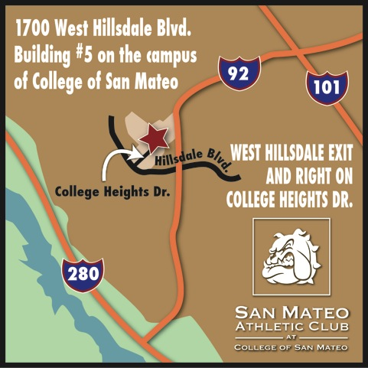

PARKING
Ample parking is available on campus in Beethoven Parking Lot. Park in the visitor spaces marked with
numbers. Please pay at the kiosk located right by the parking spaces. $2 cash is needed per day.
Please do not park in the Olympian Lot 12 or in any staff or student spaces as you will be ticketed.

ENTRANCE
Please enter through the front doors of the San Mateo Athletic Club and sign a guest waiver. Our staff will direct you to the pool deck. You will have access to our Olympic pool during your dedicated practice times, but are not granted access to our health club or to lap swim when you want. Guest Passes are available at our Courtesy desk to purchase if you want to use the health club or swim when your team in not here.

LOCKER ROOMS
Once you enter the pool deck, please use our men’s and women’s locker rooms located in Building 8 under our scoreboard. The locker rooms adjacent to the health club are reserved for members only.

AVAILABLE LANES
We have other rental groups, teams and lap swimmers working out at the same time as your practice. Please respect all other swimmers.

If you have any questions please ask our lifeguards for assistance or contact our Aquatics Director, Katie Elgaaen at (650) 378-7381 or elgaaenk@smccd.edu.

Thank you!

