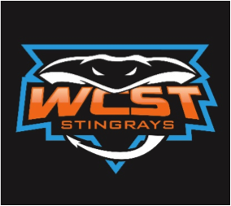
Walnut Country Swim Team
Annual Lap-A-Thon

June 28, 2022

Swimmer’s Name:_______________________________________________Age Division:________
I am participating in my swim team’s annual Lap-A-Thon. You can sponsor me per lap or you may make a flat pledge. Payments are due by July 13, 2022.
We accept cash, checks (payable to WCST), GoFundMe, and PayPal donations. https://gofund.me/3db29816 Place swimmer’s name in comment section. PayPal to wcsttreasurer@gmail.com “Sending to a friend”, place the swimmer’s name in the notation.

Sponsor’s Name  (Please Print) | Flat  Pledge | Pledge per Lap | Total Amount | Method of Payment | Date  Paid
Cash Check
GoFundMe PayPal
Cash Check
GoFundMe PayPal
Cash Check
GoFundMe PayPal
Cash Check
GoFundMe PayPal
Cash Check
GoFundMe PayPal
Cash Check
GoFundMe PayPal
Cash Check
GoFundMe PayPal
Cash Check
GoFundMe PayPal
Cash Check
GoFundMe
PayPal
Cash Check
GoFundMe PayPal
 |  | Grand Total
Age Group | Minutes Swimming
6 & Under | 10
7/8 | 20
9-18 | 30

Laps Completed: _____________

Thank you for supporting the Walnut Country Stingrays!!

Walnut Country Swim Team
Annual Lap-A-Thon Prizes

June 28, 2022

Swimmers and lap-a-thon sponsors get ready, it is time for our annual lap-a-thon one of our biggest fundraisers of the season!

On Wednesday during practice the swimmers will have a chance to swim as many laps as they can while raising money for the team and don’t forget the chance to win prizes!

Go out there and support the Stingrays!

Questions? wcstfundraising@gmail.com

PRIZES
Amount Raised | Prize
$200 | - Invitation to WCST Ice Cream Party
$500 | - Invitation to WCST Ice Cream Party  - WCST Cooling Towel
$1,000 | - Invitation to WCST Ice Cream Party  - WCST Cooling Towel  - WCST Large Tote Bag  - Swimmer fee waived for next year*
Winner: Highest Funds Raised | Free 30-minute Mini Lesson with Coach Sienna
*One swimmer fee waived for next year
* Total amount raised includes lap-a-thon and sponsorship funds raised

