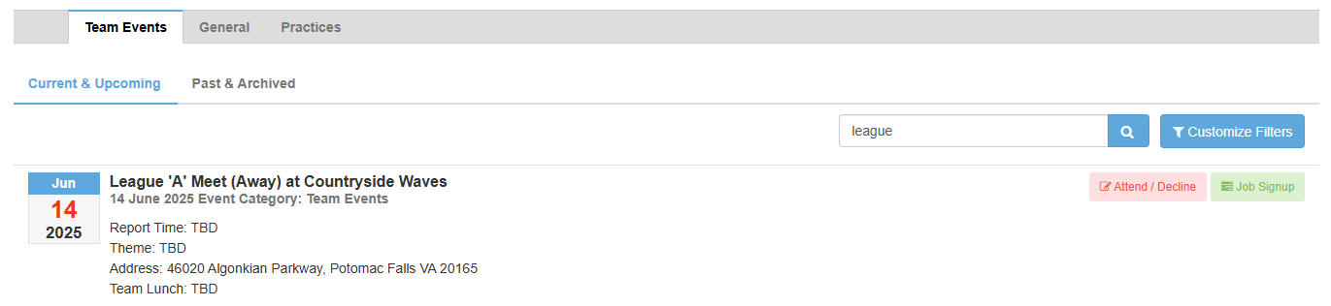
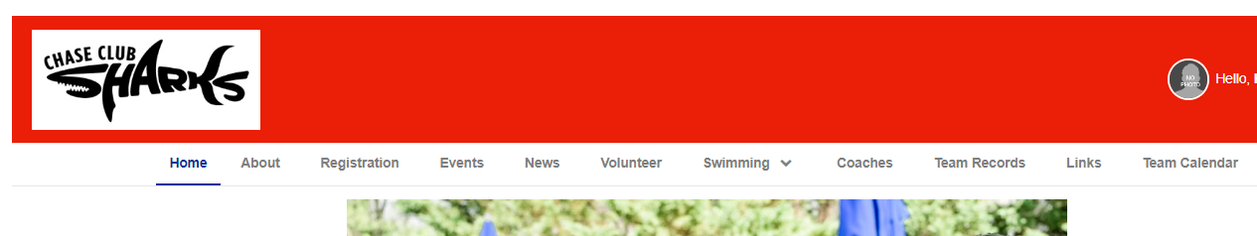
If you are NOT logged in, you will need to click “Attend/Decline”. The next screen will have ask you to login.

Click “Events”

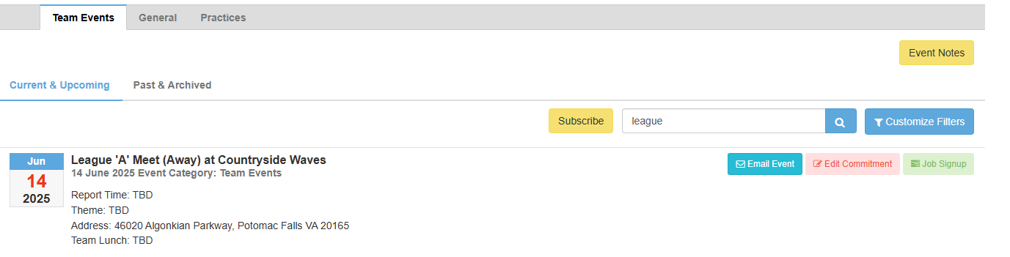

If you are logged in already, you won’t see “Attend/Decline”, you will see “Edit Commitment”. Click “Edit Commitment”

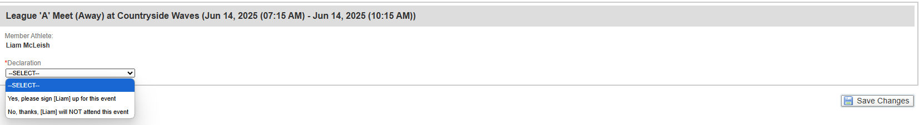
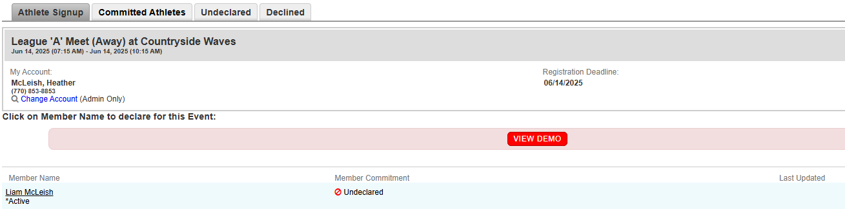
Select the correct commitment for that meet.

Make sure you click on “Save Changes” after your selection is made.

You will see if your child is declared or undeclared here.

Click your child’s name to update their commitment for that meet.

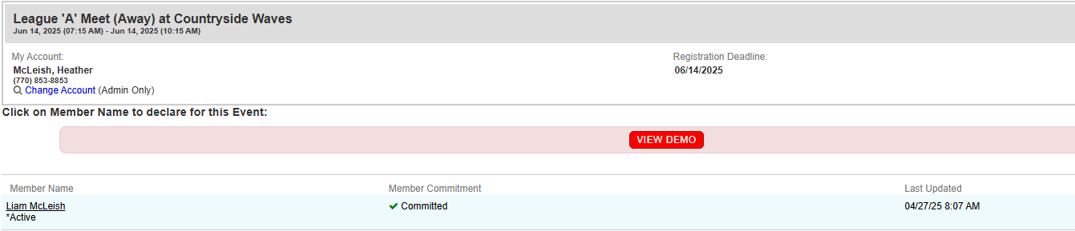
It will say “committed” if you selected that your child is available to swim.
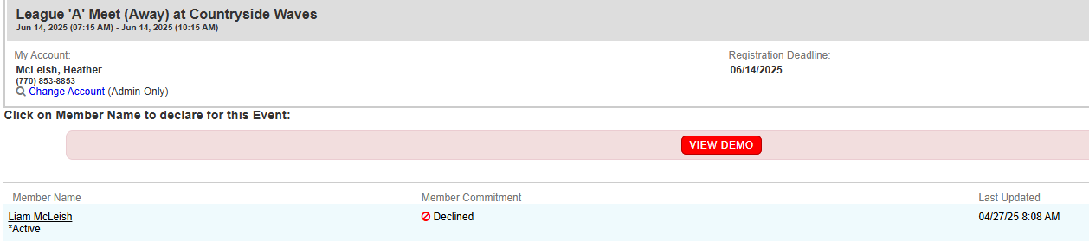
It will say “declined” if you selected that your child is NOT available to swim.

- You can modify your child’s commitment anytime by clicking on their name and going thru the steps again.
Select the correct commitment for that meet.
Select the correct commitment for that meet.
- You will need to do this for every meet for each child and meet.

