New Family Registration:
Step 1: Start Registration. To get there, click either of the yellow highlighted sections below.
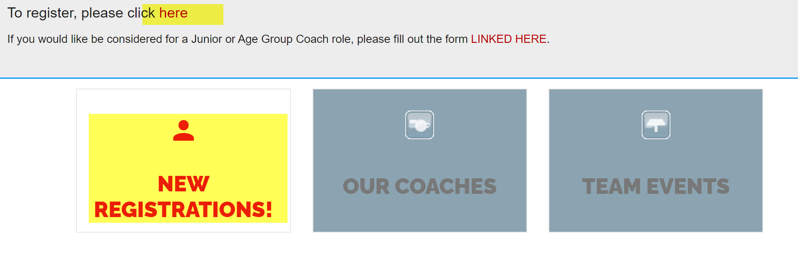
Note: DO NOT CLICK on the sign-in button at the top of the Wellington Sharks homepage until you have completed registration following the steps below.
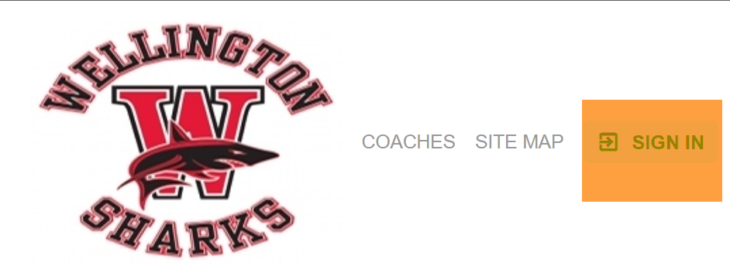
Step 2: Start registration process, add age fields that you need. Once you go to “check-out” you will be prompted to create an account (step 3).
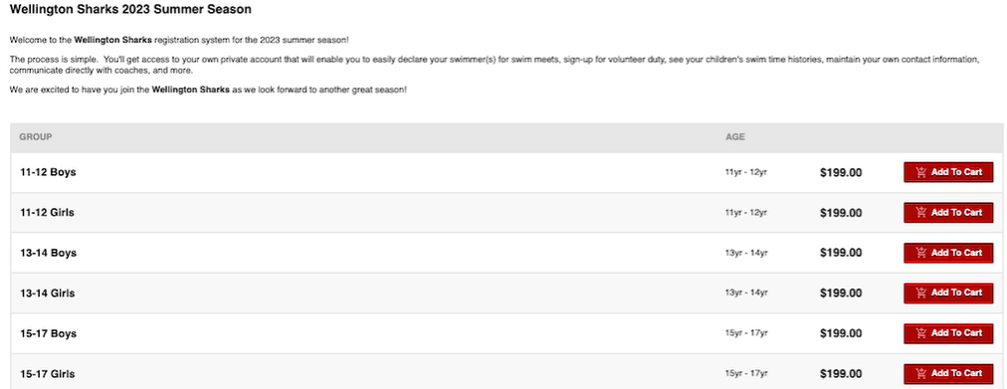

Step 3: You will be prompted to sign/in or create a new account w. Sportsengine. Continue to create a new account. Go through all the steps to complete creating an account.
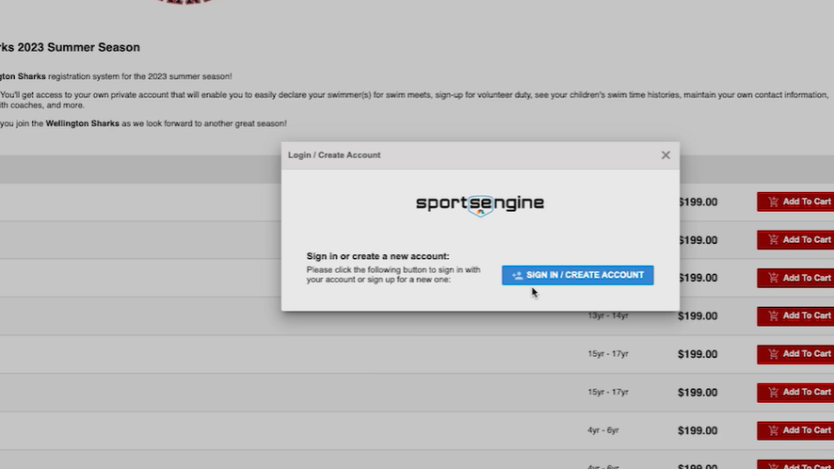

Step 4: Once you complete the account set-up, you will receive an Account Verification Email. Check your email and follow those steps.
Step 5: The account verification email will take you back to our Team site, log-in using that username and password information that you just created and verified. Complete creating an account and complete registration.
