Returning Family Registration:
Step 1a: Start Registration. To get there, click either of the yellow highlighted sections below.
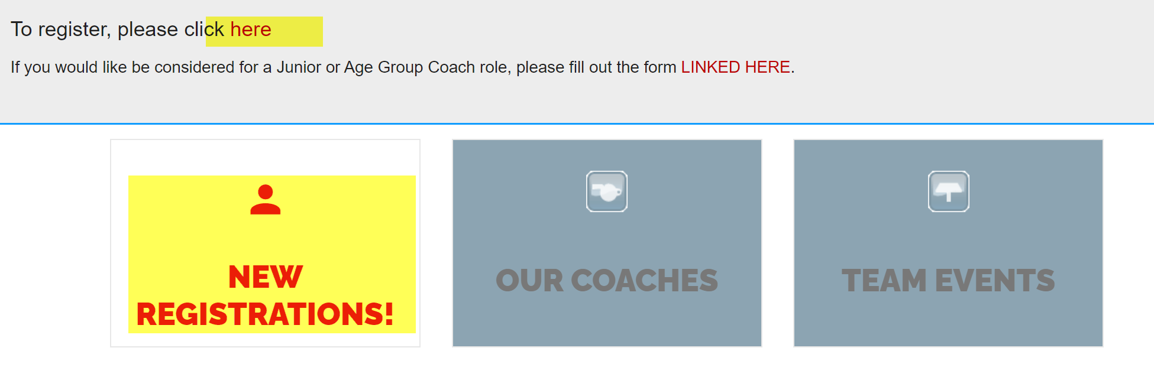
Step 1b:
Or sign-in (using your credentials from last year).

Then click on “My Account” and click on “Team Registration”
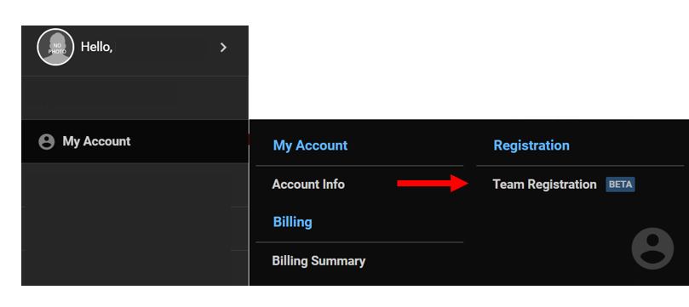

Step 2: Start registration process, add age fields that you need and go to your cart to check-out!
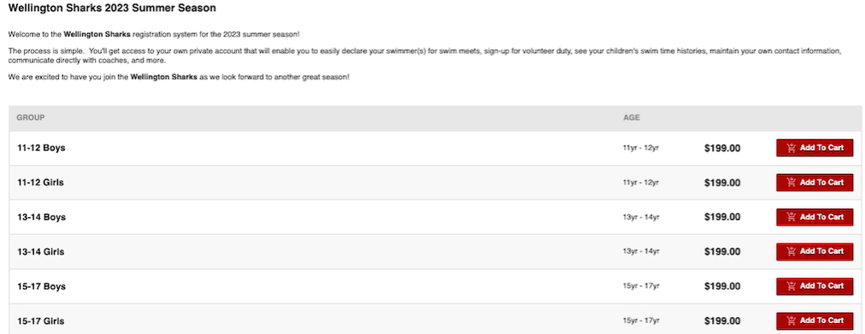
Step 3: Assign your swimmers to the right age group and complete payment and registration!

